**Google Analytics**

**3.2.2 Google Analytics Sign-In**

1. To begin Google Analytics, go to the web page:

[www.google.com/analytics](http://www.google.com/analytics)

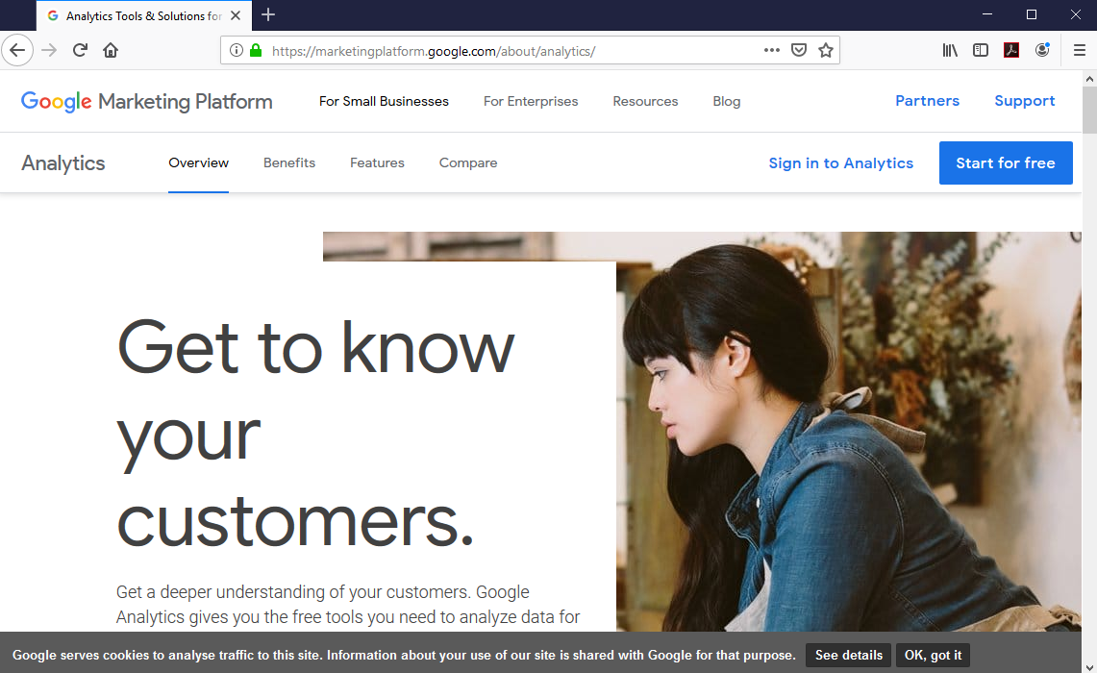

1. Click on Sign in, then Analytics.
2. Enter your Syracuse email address with g. before the syr.edu.

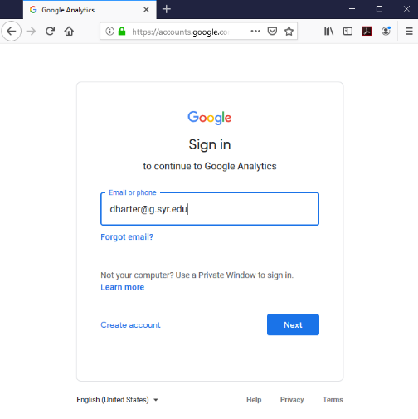

1. Click next.
2. Enter your SU Username and Password.

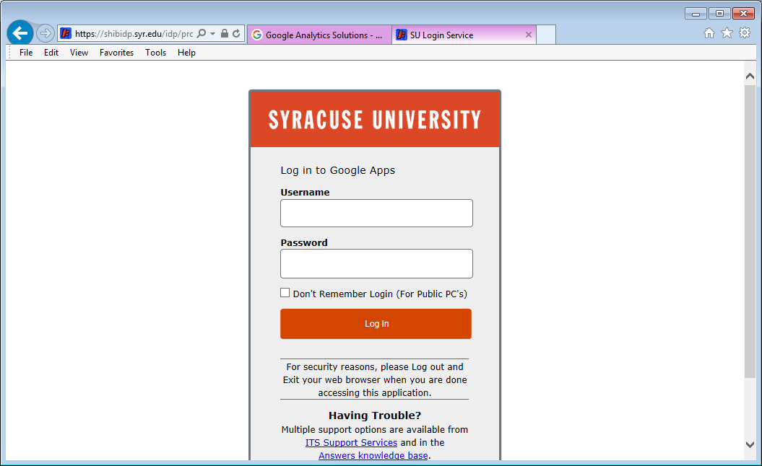

1. In the upper left corner, click on the drop-down arrow at All Web Site Data, select:
   1. whitman.syr.edu under Analytics Accounts
   2. <http://whitman.syr.edu> under Properties & Apps
   3. whitman.syr.edu (exclude SU) under Views

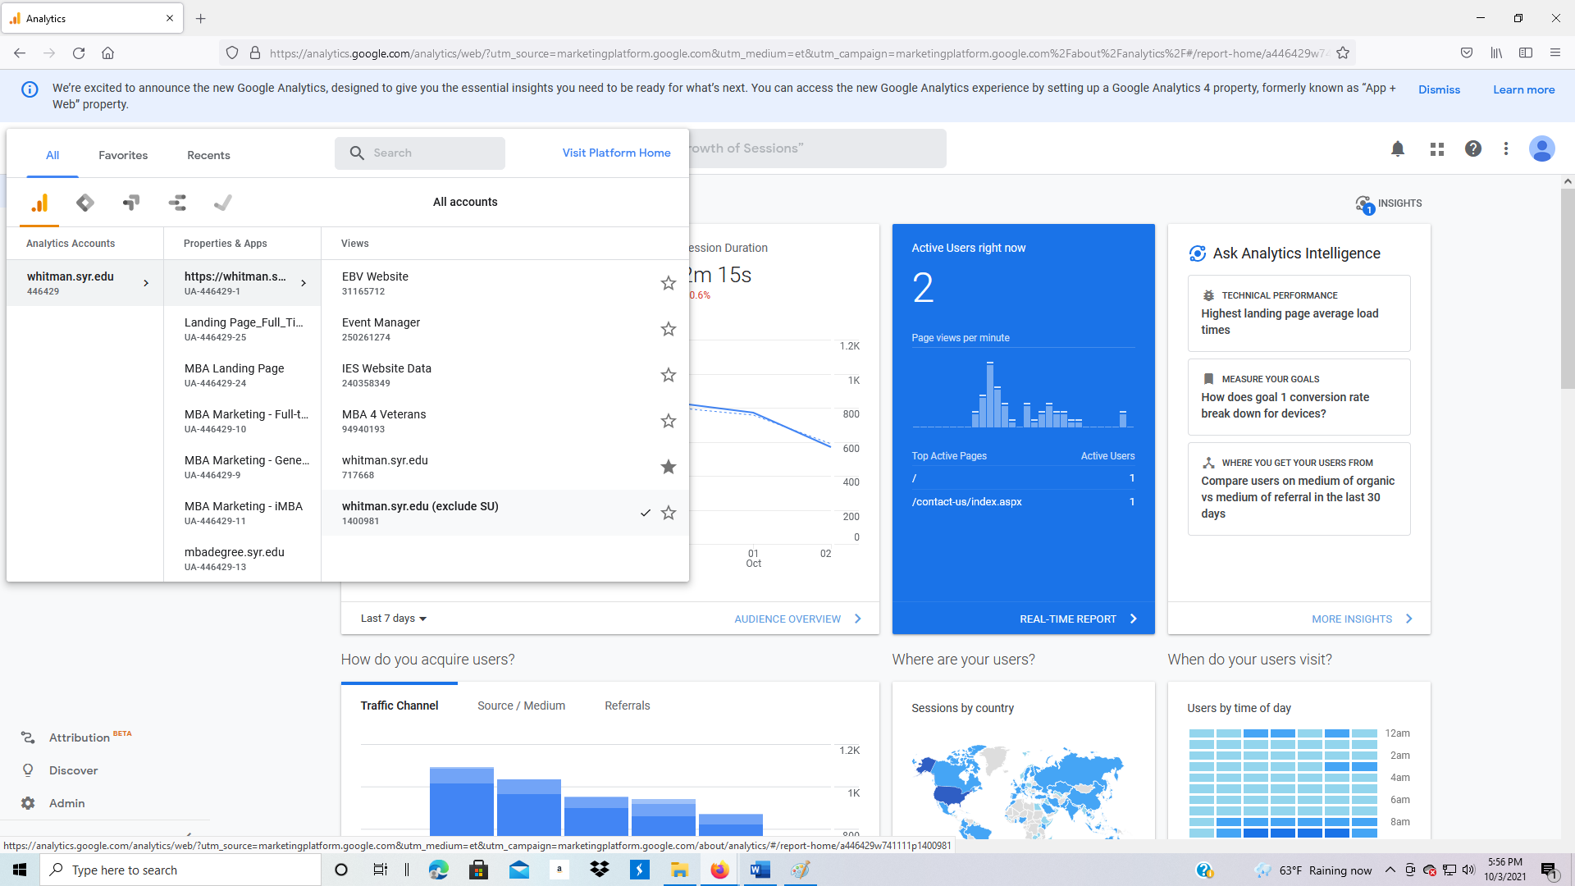

1. You should see a page like the one below. Note: The data is updated daily; your page will have a similar format but different data.

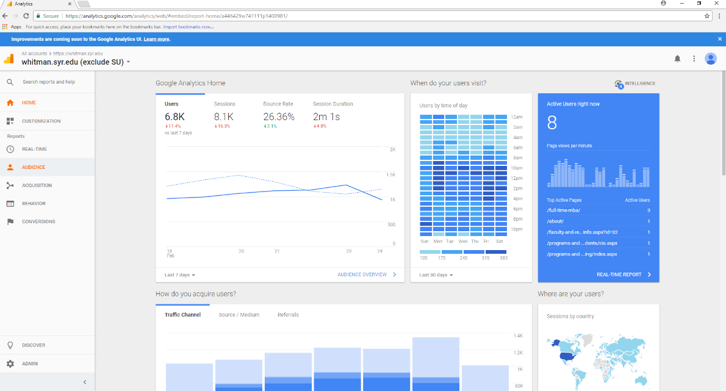

1. To change to a different website, go to the upper left corner and use the drop-down menu to change websites.

**3.2.3 Audience: Overview**

1. To view Audience data, click on Audience, Overview.

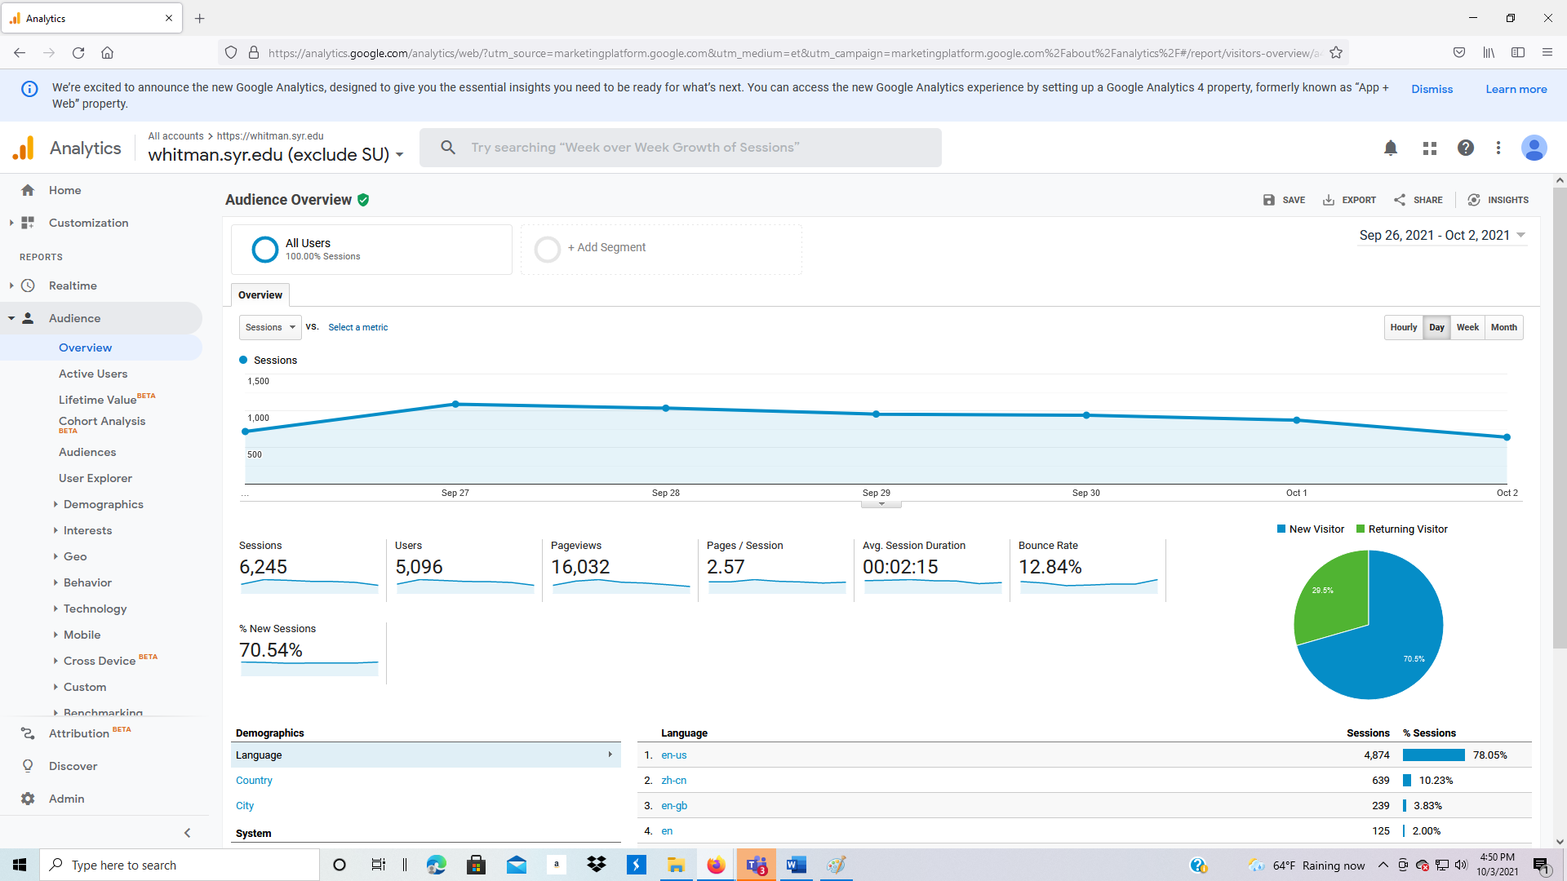

**Definitions**

* Sessions: number of times the site was visited (does not count pages)
* Users: number of unique users identified by IP addresses
* Pageviews: number of individual web pages viewed
* Pages/Session: average number of pages viewed in a session
* Avg. Session Duration: time spent on website before leaving
* Bounce Rate: percentage of visitors who do not visit a second page
* % New Sessions: percentage of sessions with new users

**Timeframe**

The timeframe is shown in the upper right part of the screen. To change the timeframe:

1. Click on the drop-down arrow for the timeframe
2. Change the starting date to 1/1/2011, then click apply
3. You should see a screen like the one below

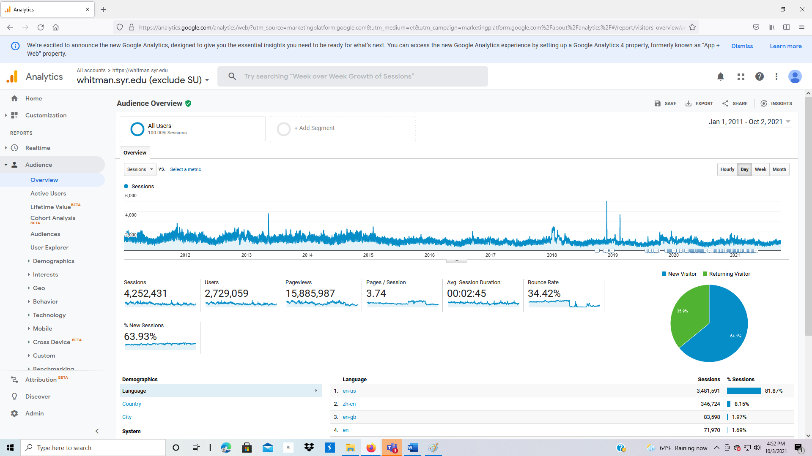

1. Change the starting date to one month before today’s date, then click apply

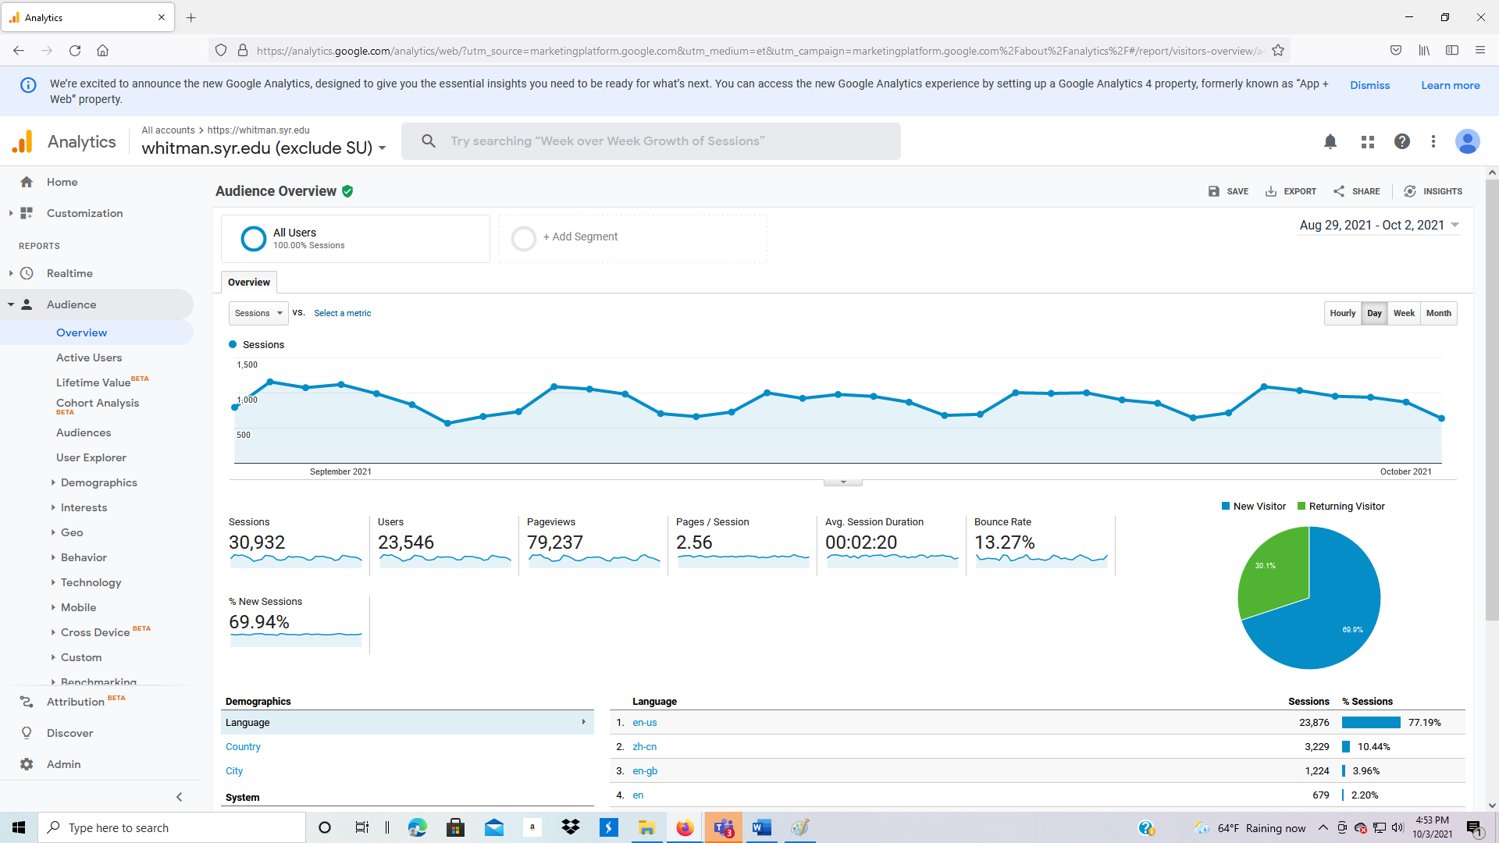

**Audience: Overview**

1. Option to view different categories of data. Click the drop-down button below Overview
   1. Default is Sessions
   2. Change to % New Sessions, Avg. Session Duration, Bounce Rate, Pages/Session, Pageviews, Sessions, Users

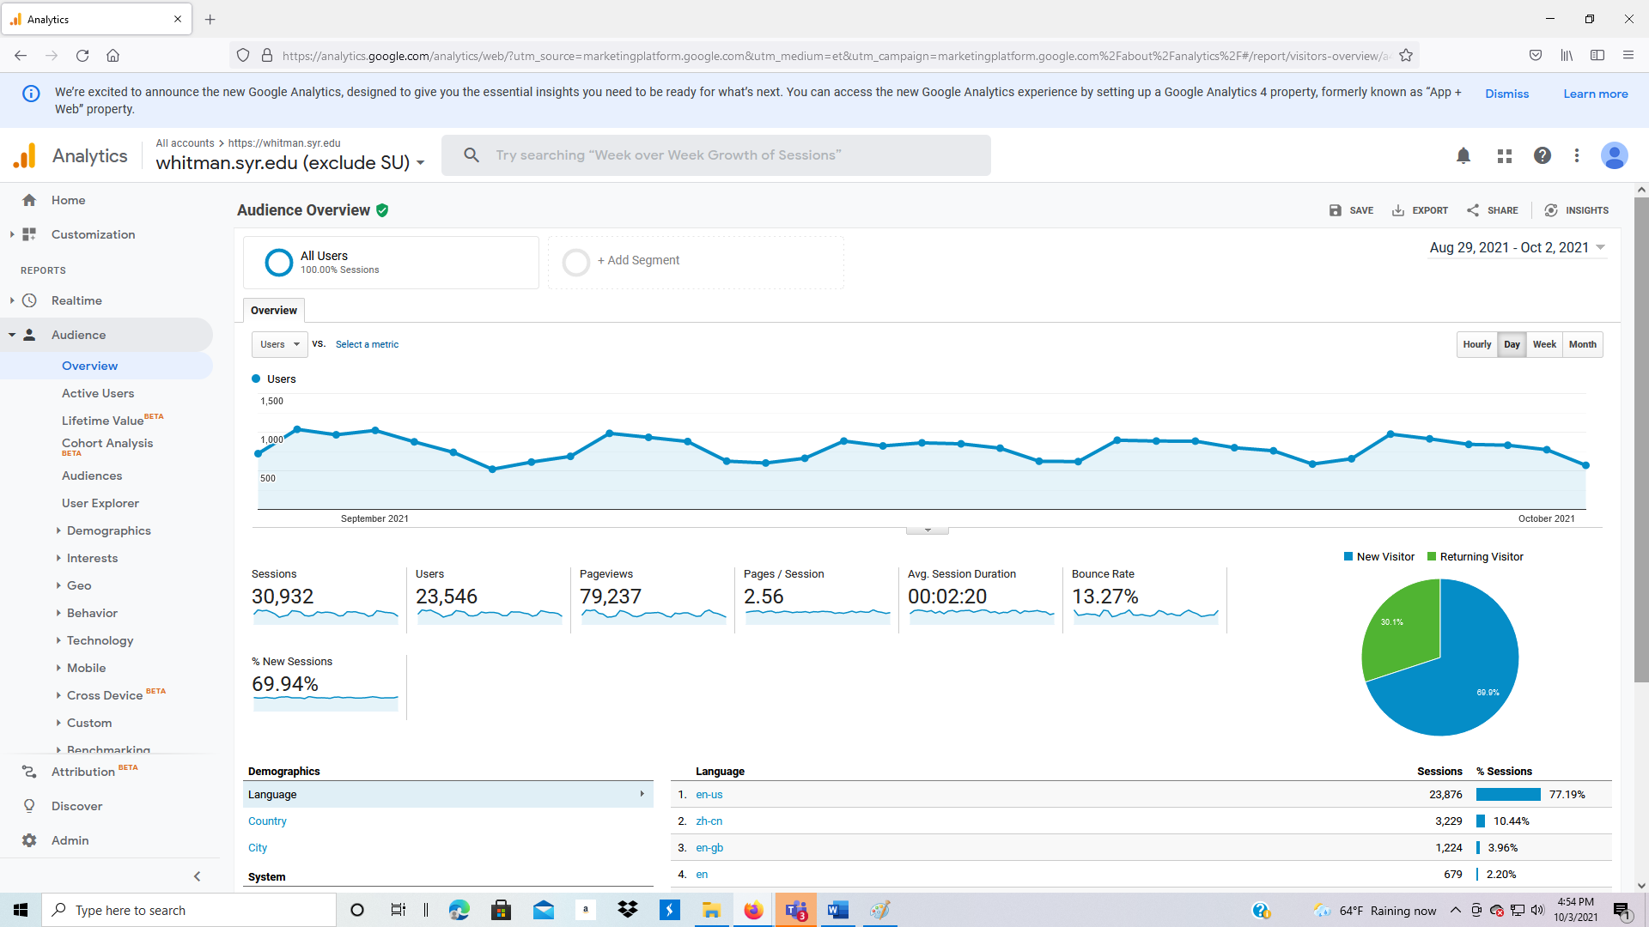

1. Option to change to hourly, daily, weekly, and monthly graphs (to the right and above the graph). Change to weekly to observe the smoothing of data by week to see trends?
2. Pie chart of New Visitor versus Returning Visitor percentage

**Audience: Overview: Demographics (see data at bottom of Audience: Overview screen)**

Below the data is additional demographic, system, and mobile information. The default is language. In this example, can you identify Taiwan, Korea, India?

1. To view the entire report of all languages, click on “view full report” in the lower right corner.
2. Use the left and right arrows in the lower right corner to scroll through all the languages.
3. Click on Country. This presents the data in a format that is easier to review than languages.

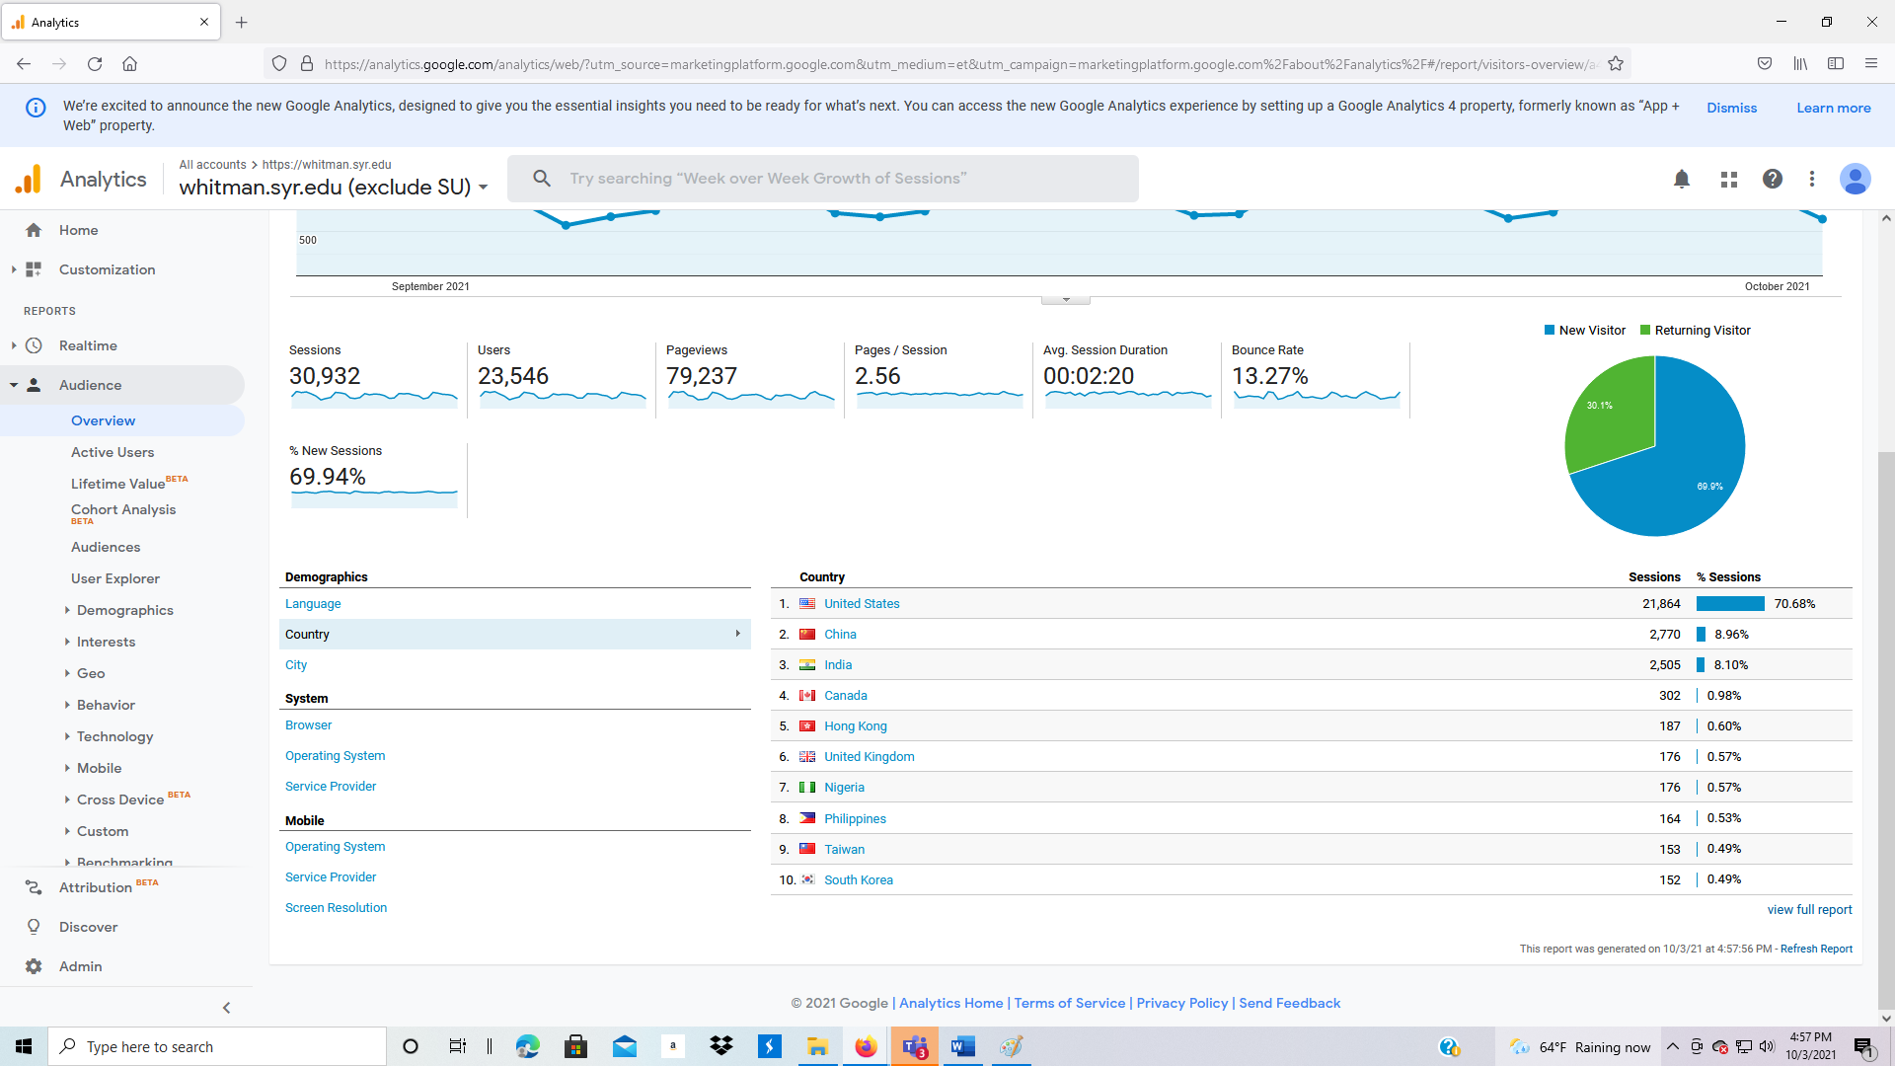

1. Why would you sometimes want to see Languages, other times Countries?
2. Next try City. Would this information help you in developing your recruiting strategy? Why is the Syracuse traffic so high since we already excluded university and student computers on campus?

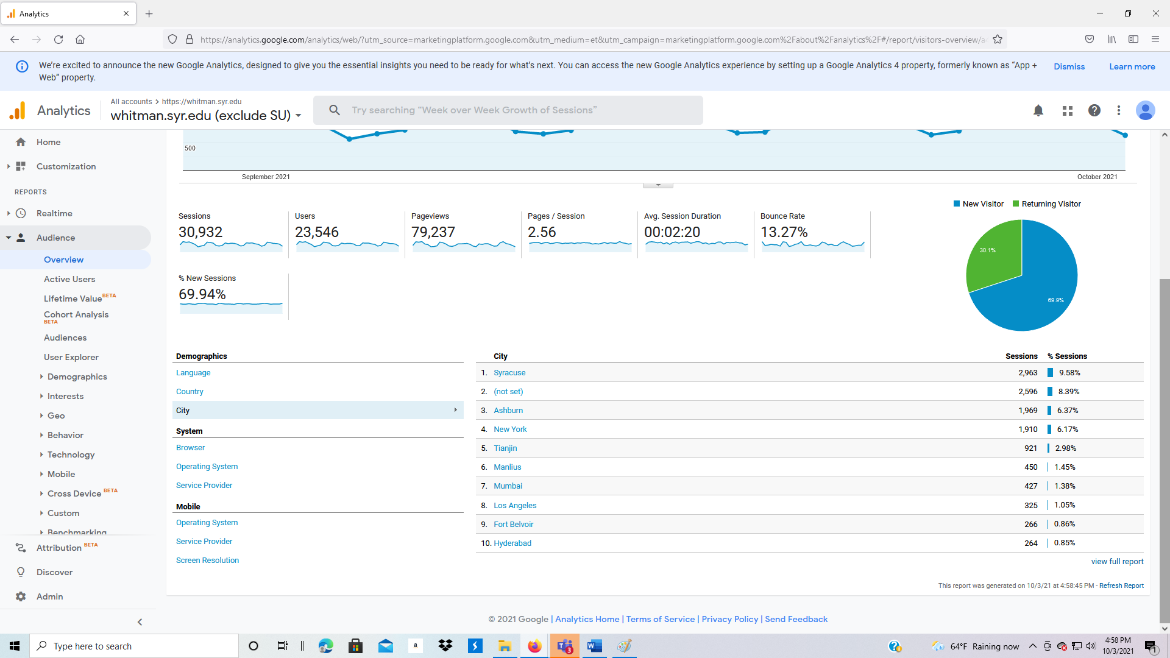

**Audience: Overview: System (data bottom of Audience: Overview screen)**

You can also view what computer system characteristics for visitors to the website. Browser identifies the web browser being used. Why is this important?

1. Click on Browser.

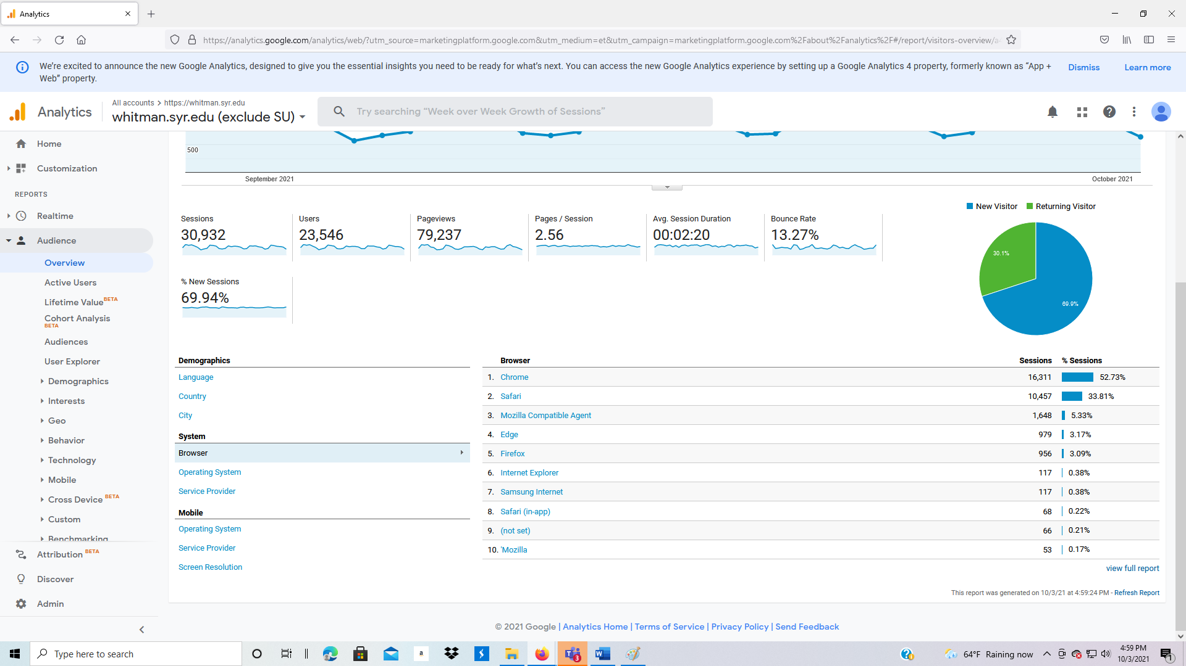

1. Operating system is next:

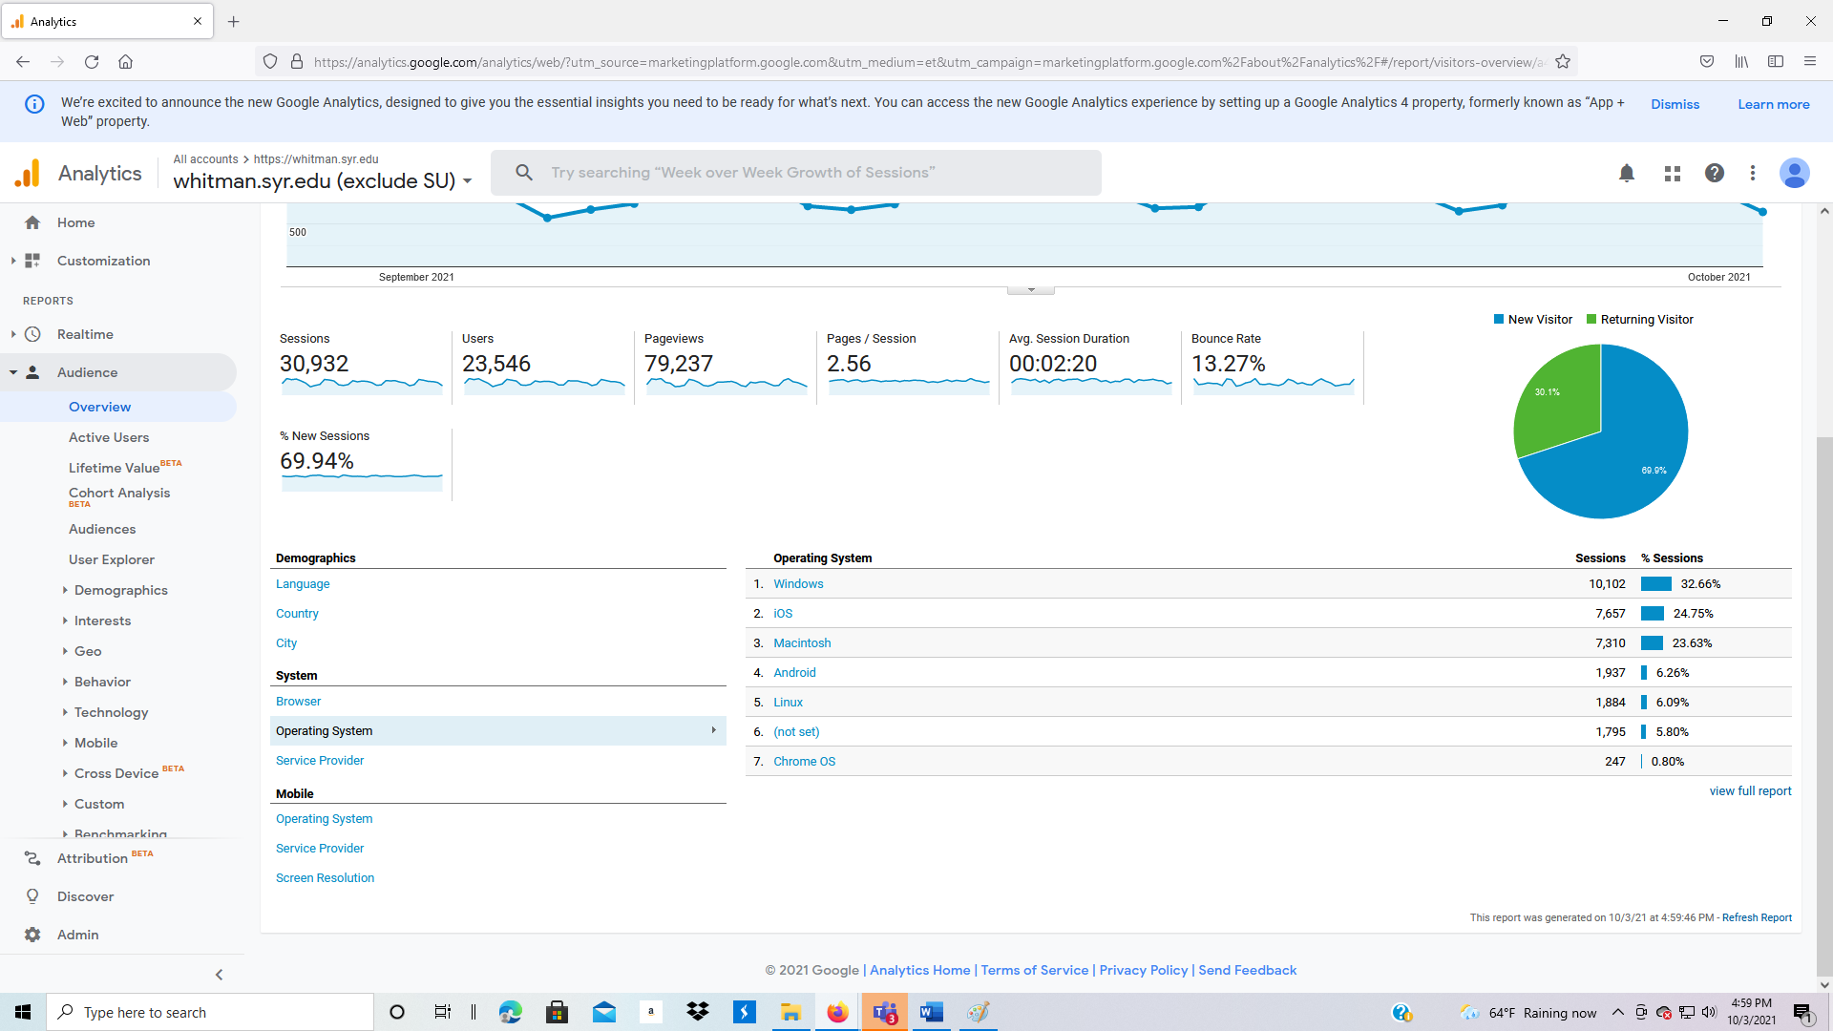

**Audience: Overview: Mobile (data bottom of screen)**

1. View the Mobile characteristics by first clicking on Operating System.

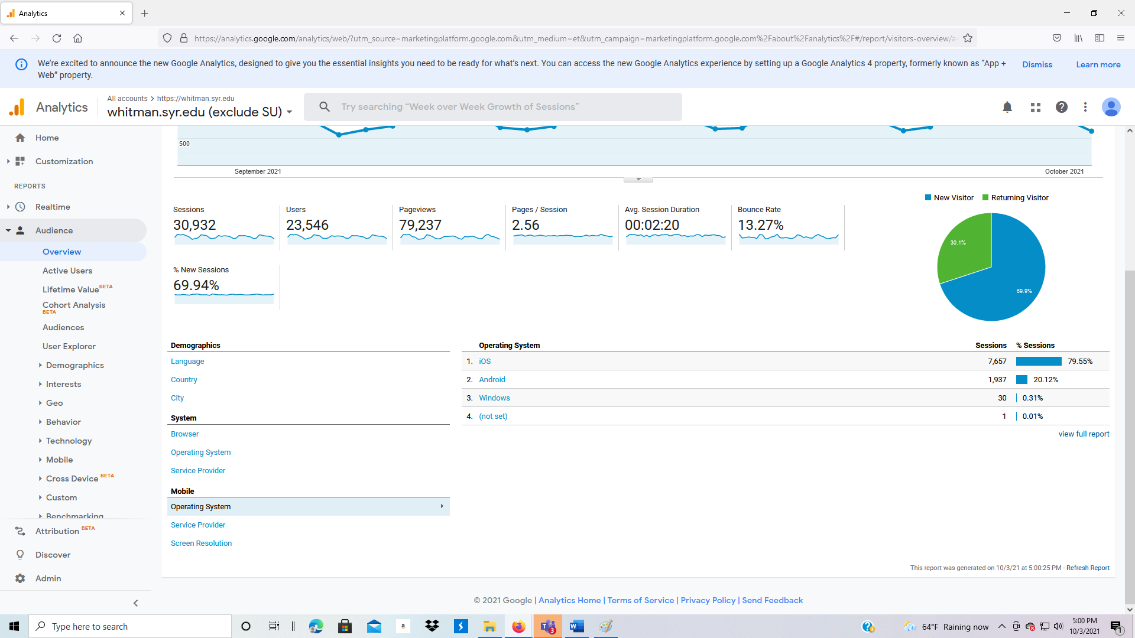

1. Finally, click on Screen Resolution. Why is this important? Does this change over time?

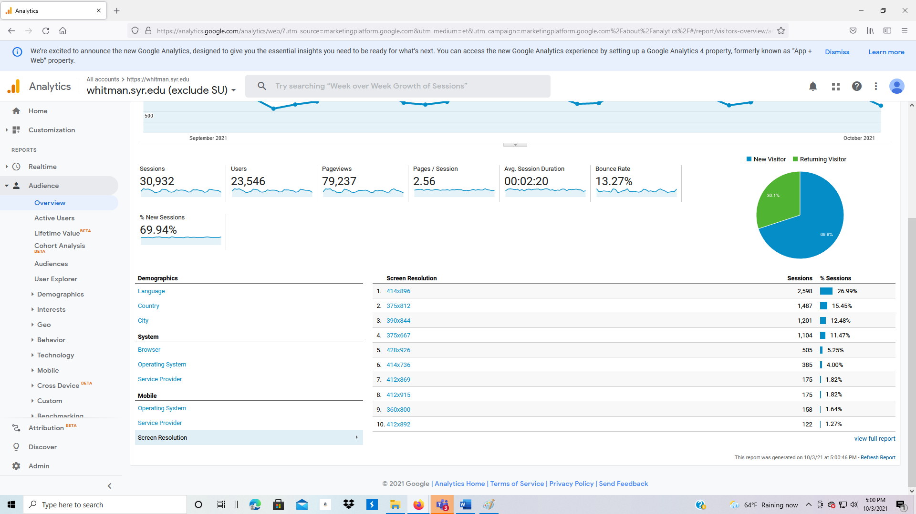

**3.2.4 Audience: User Explorer**

User Explorer allows you to track individuals (anonymously).

1. Click on Audience: User Explorer.
2. Each line is a user identified by IP address.
3. Click on the first Client ID, then drill down. The system allows you to track what an individual viewed, page by page (your screen will be different, the data changes day-to-day).

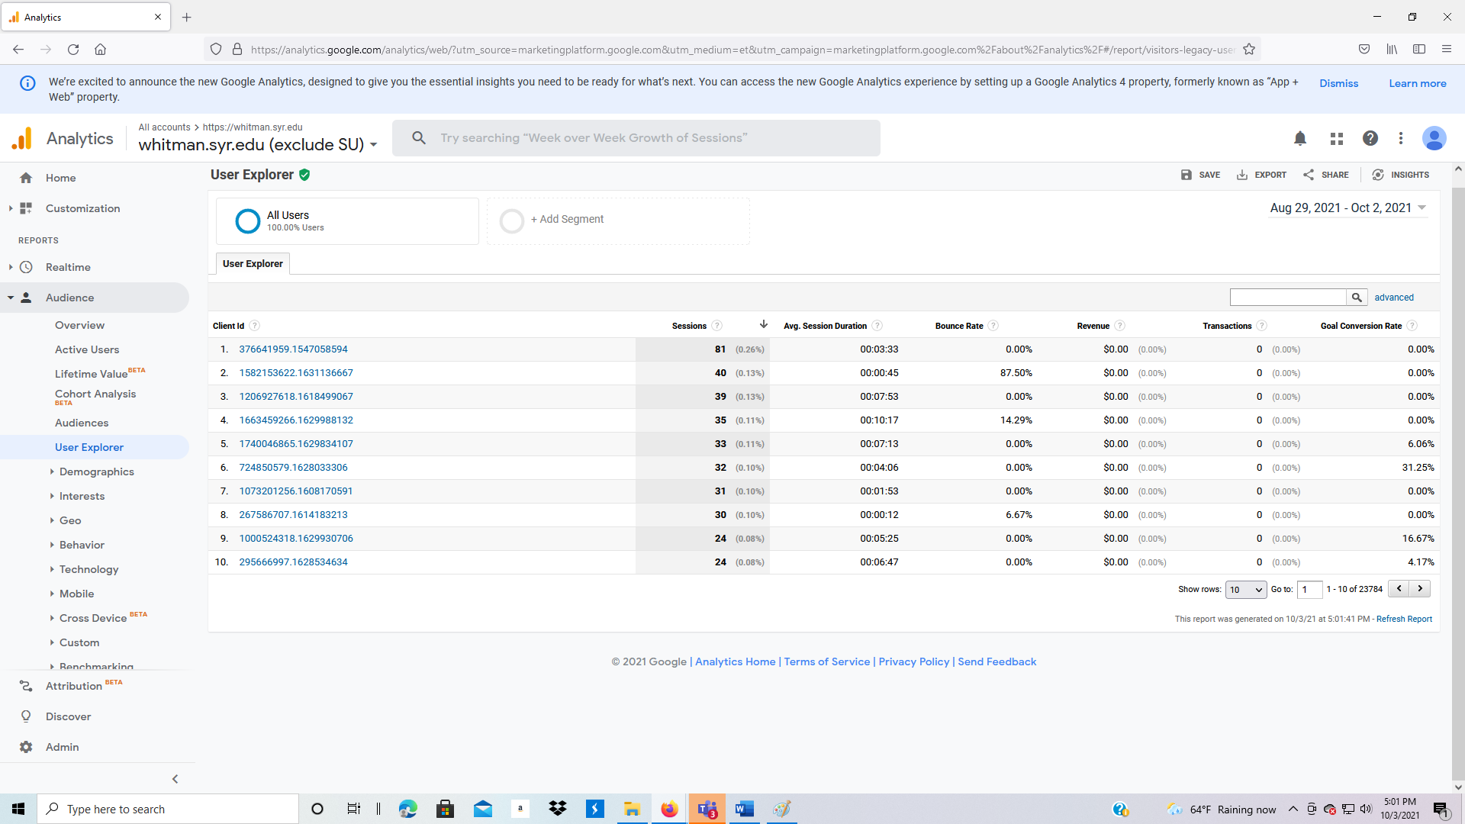

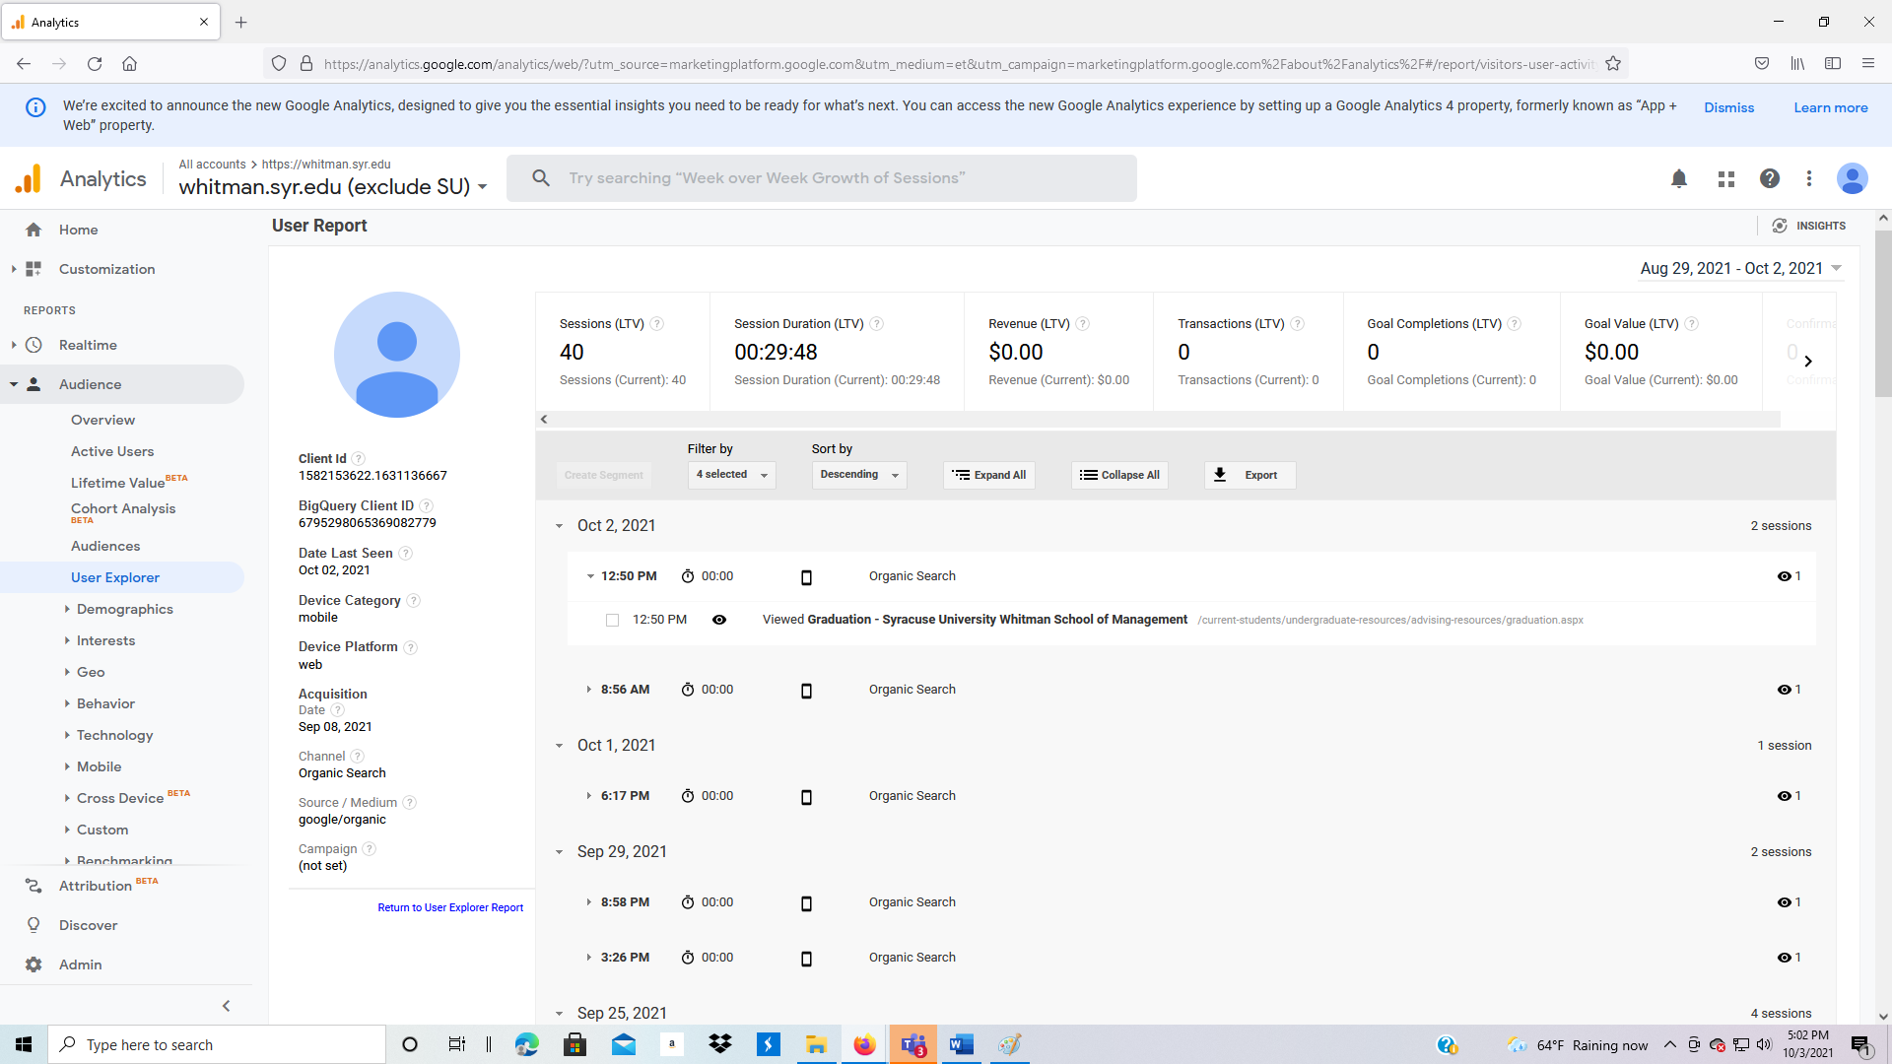

**3.2.5 Audience: Demographics**

1. Demographics presents summary information on age and gender of users visiting your website.
2. Click on Audience: Demographics, then Overview.

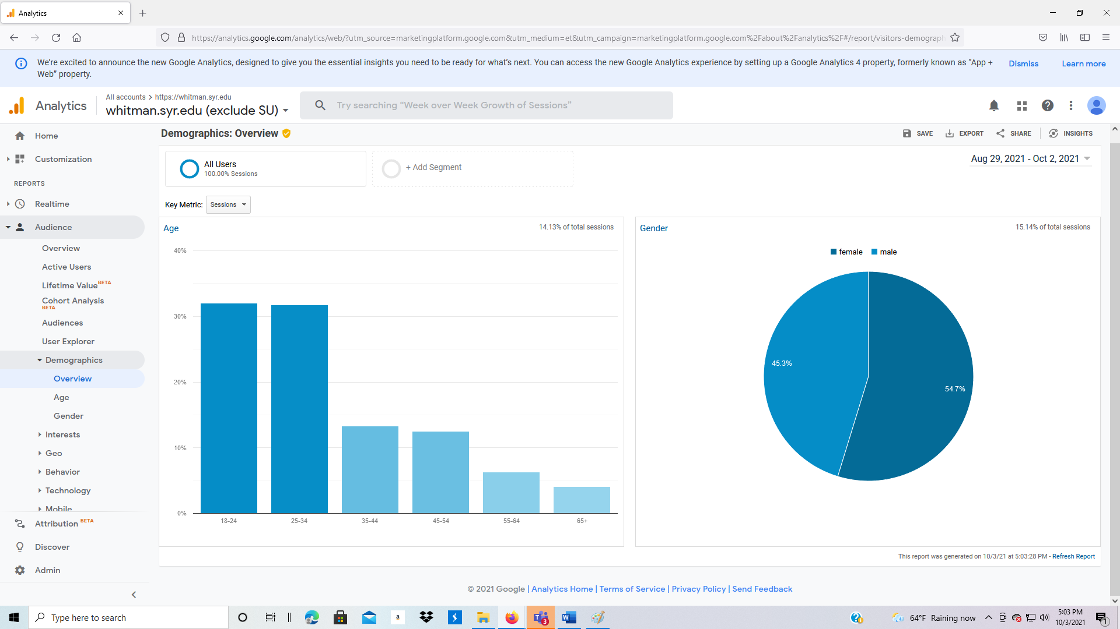

1. Click on Audience: Demographics, then Age.

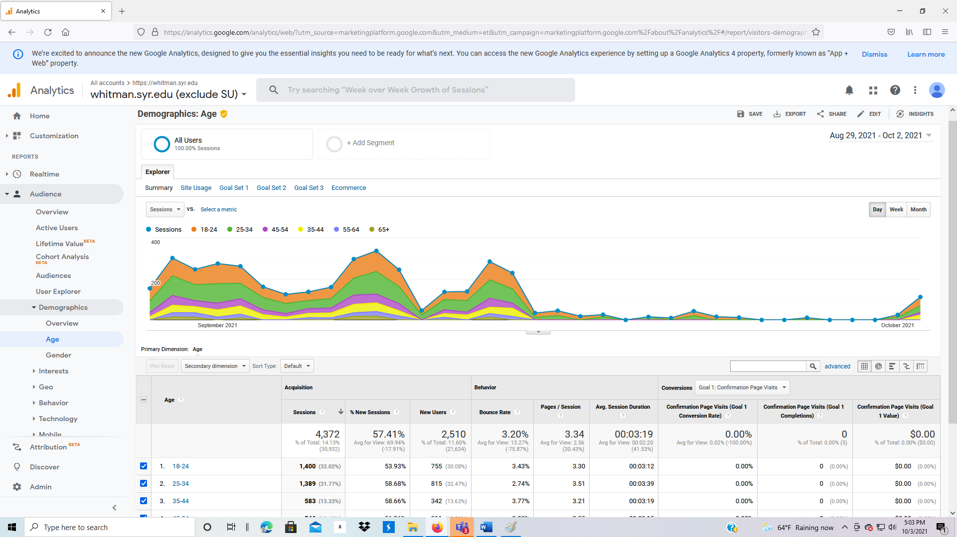

1. Click on Audience: Demographics, then Gender.

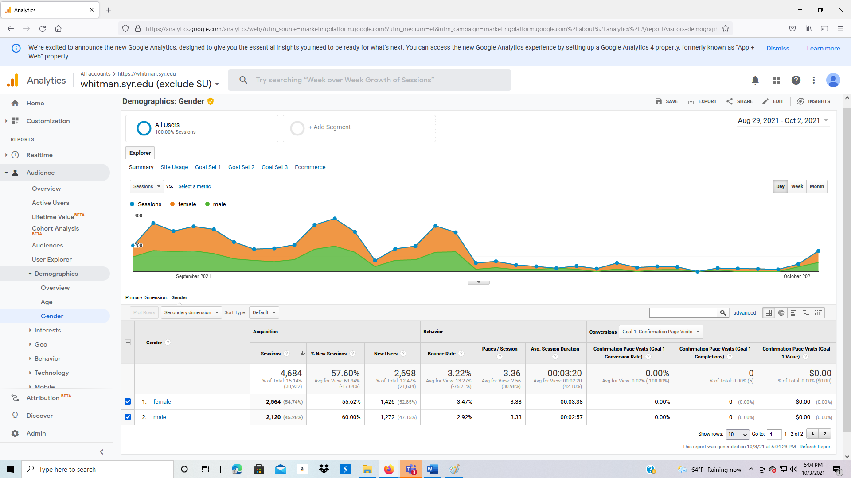

**3.2.6 Audience: Interests**

1. Interests presents summary information on the interests of users visiting your website.
2. Click on Audience: Interests, then Overview.

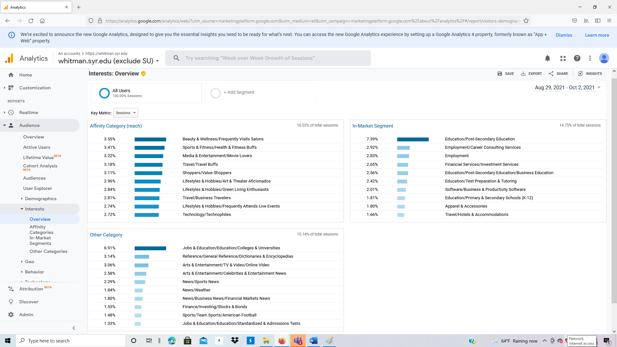

1. Click on Audience: Interests, then Affinity Categories.

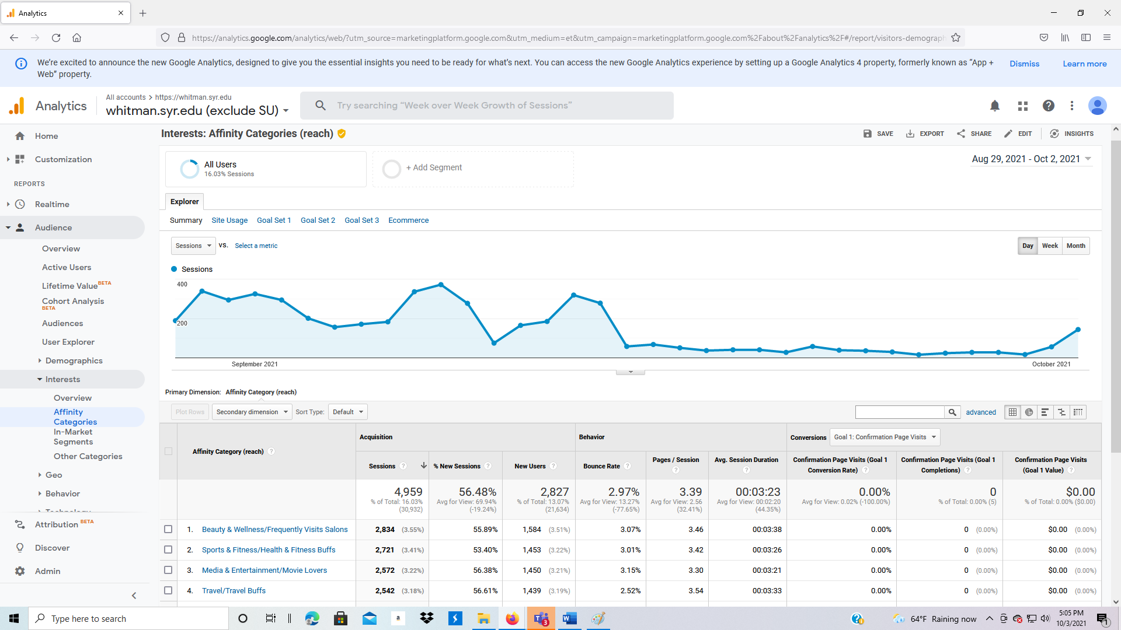

1. Click on Audience: Interests, then In-Market Segments.

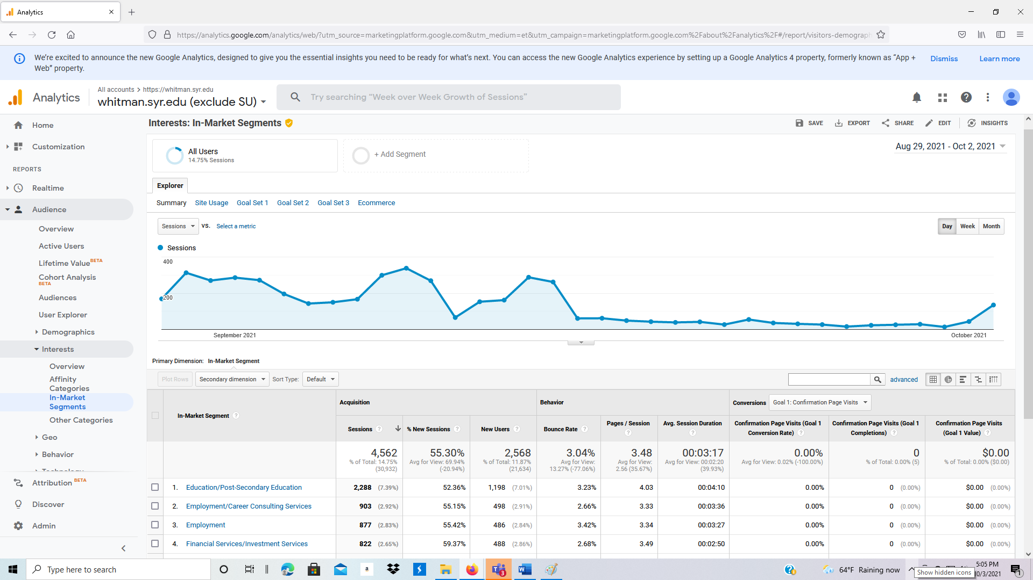

1. Click on Audience: Interests, then Other Categories.

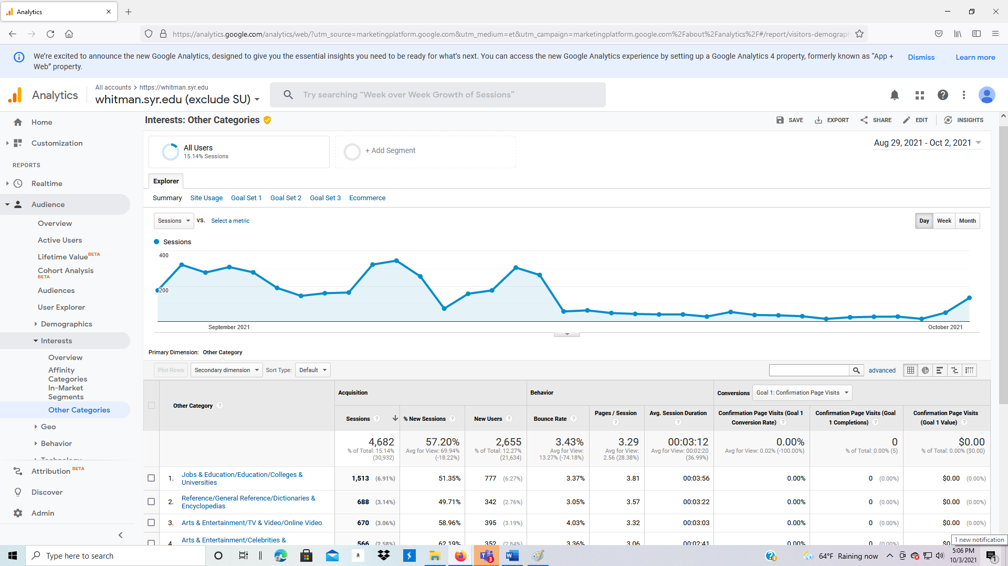

**3.2.7 Audience: Geo (geographic data)**

1. Within Audience, click on Geo, then Language.

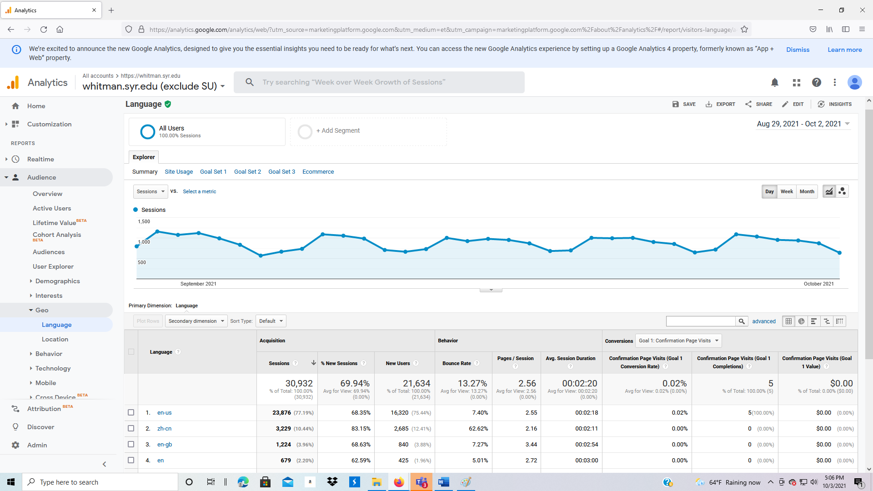

1. Under Audience, click on Geo, Location. This displays traffic on a Map Overlay (notice the tabs Map Overlay and Explorer above and to the left of the picture).

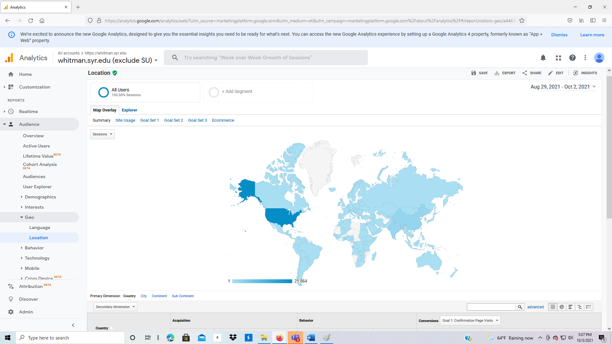

1. Move your cursor over Brazil. What happens? Next, scroll down to see the detailed data. It includes Acquisition, Behavior, and Conversion data.
2. Scroll back to the top of the page. Under Map Overlay, click on Site Usage, then scroll to the bottom. The view is now Sessions, Pages / Session, Avg. Session Duration, % New Sessions, Bounce Rate.

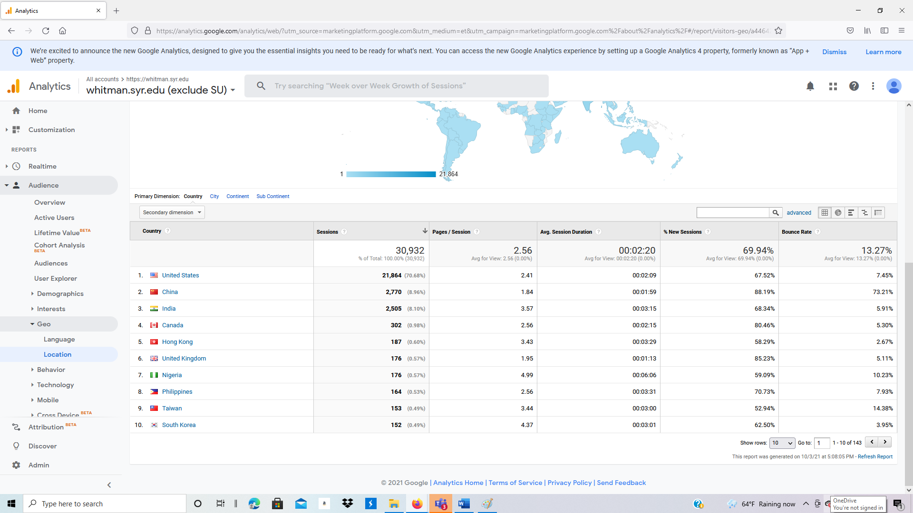

1. Scroll back to the top. Under Map Overlay, click on Summary. Scroll down to just below the map and click on Continent.

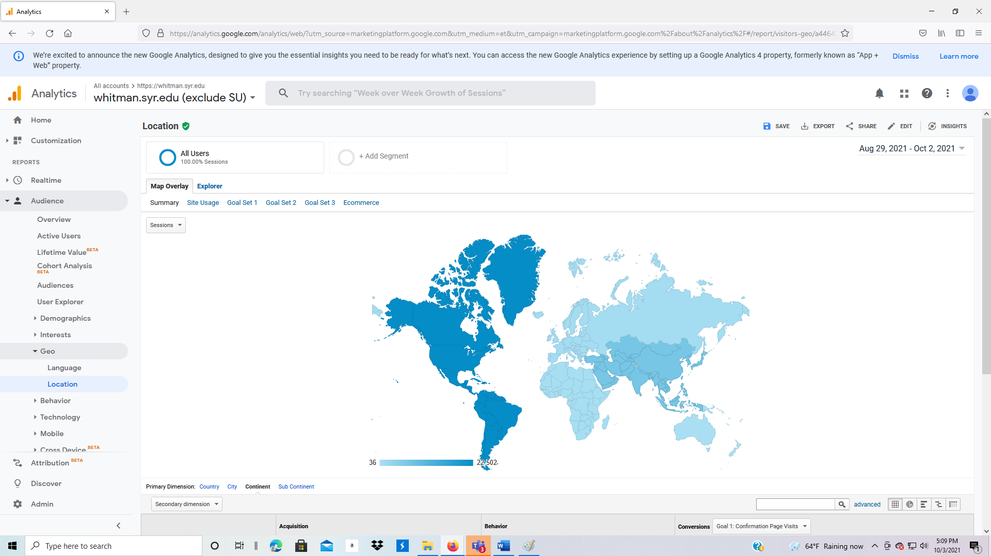

1. Click on Sub Continent. How is it different?

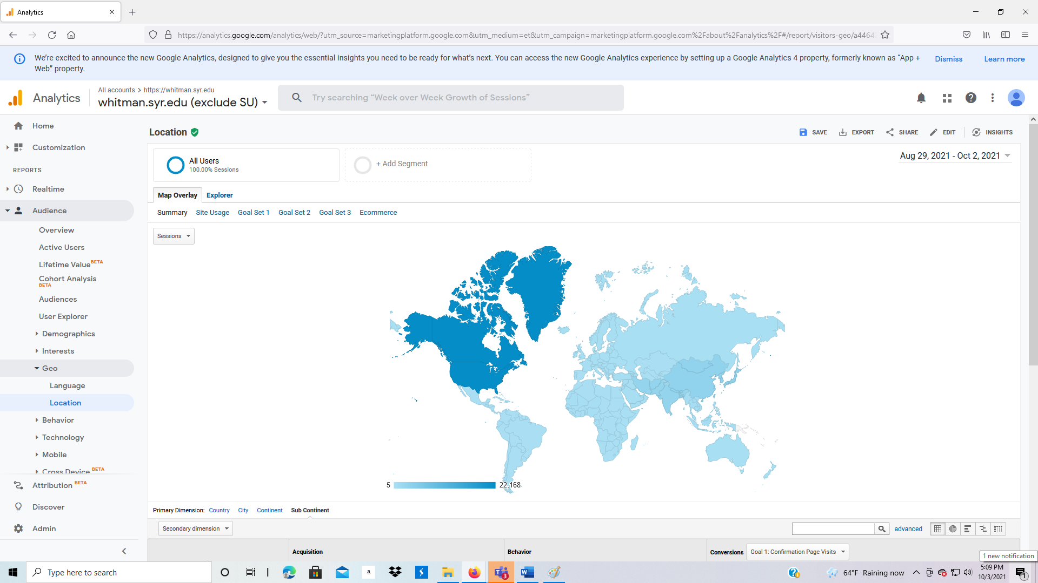

1. Now click on City. Scroll down to see the traffic by city. Put your cursor over a city.

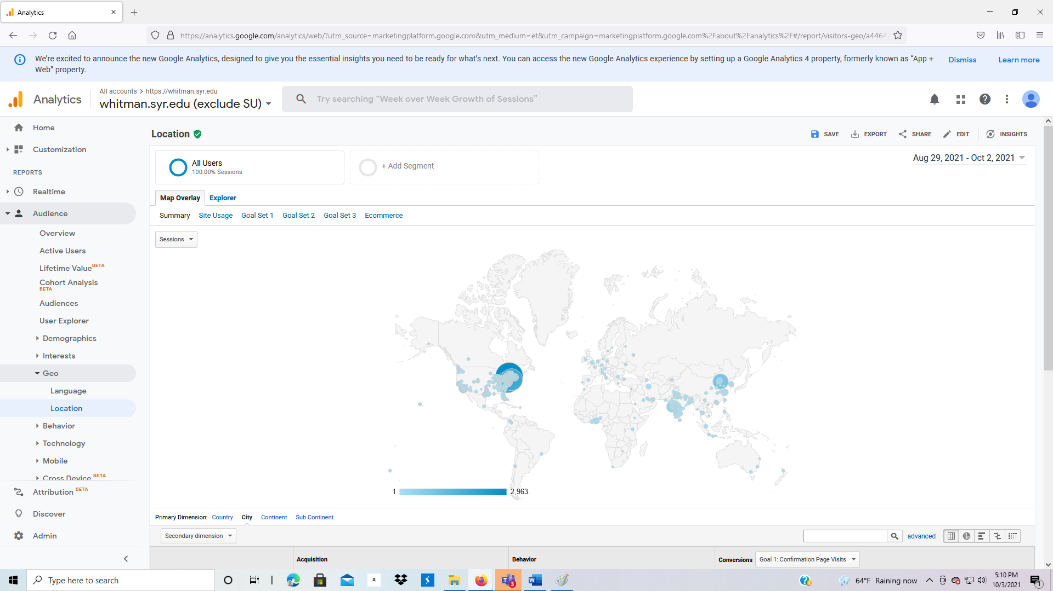

1. To the lower right of the picture, and to the right and above the data, are five options. The five options are Data, Percentage, Performance, Comparison, Pivot. We have been viewing data; now click on Percentage.

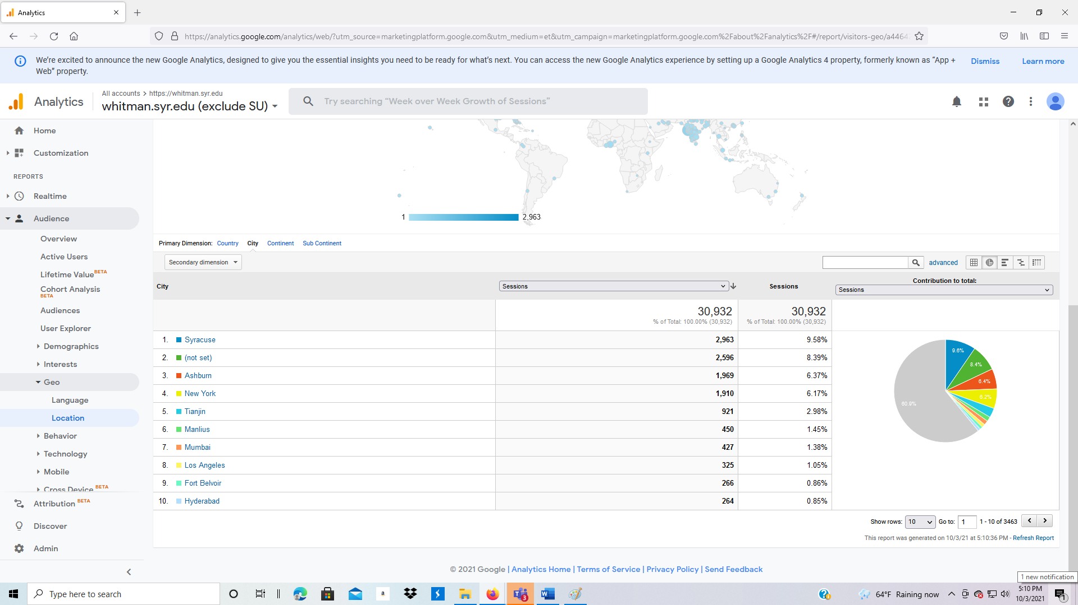

1. Next, click on Performance.

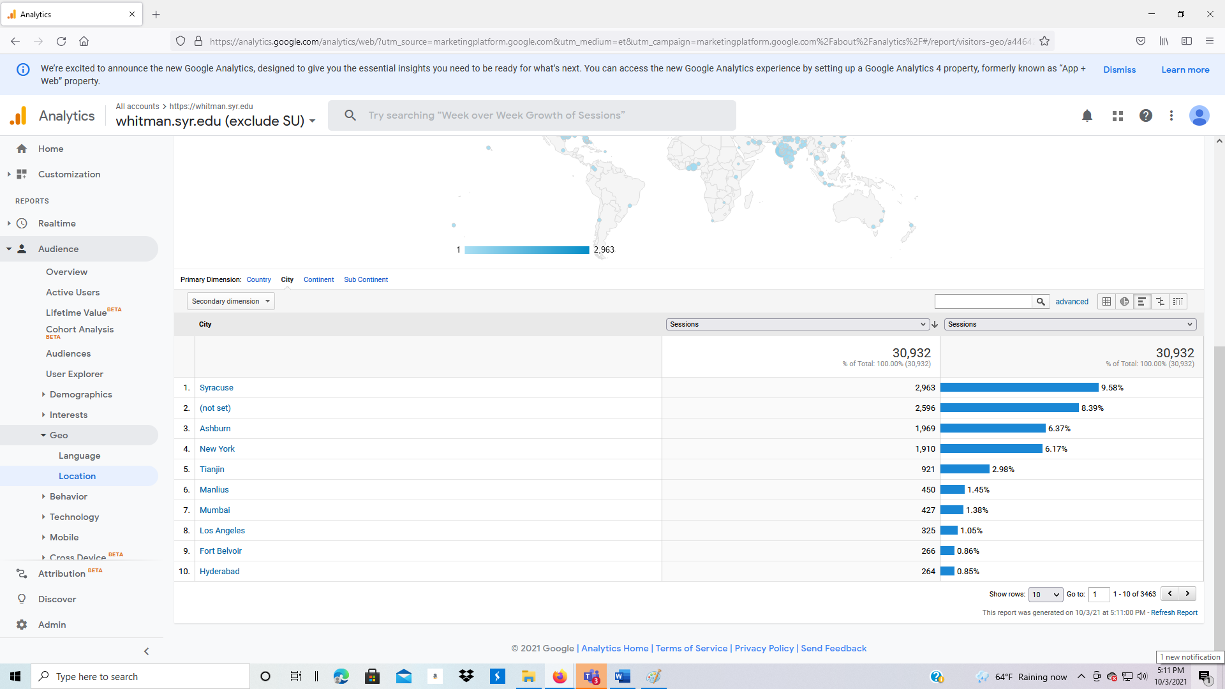

1. Scroll back to the top of the page. Instead of Map Overlay, click on Explorer (to the right of Map Overlay).

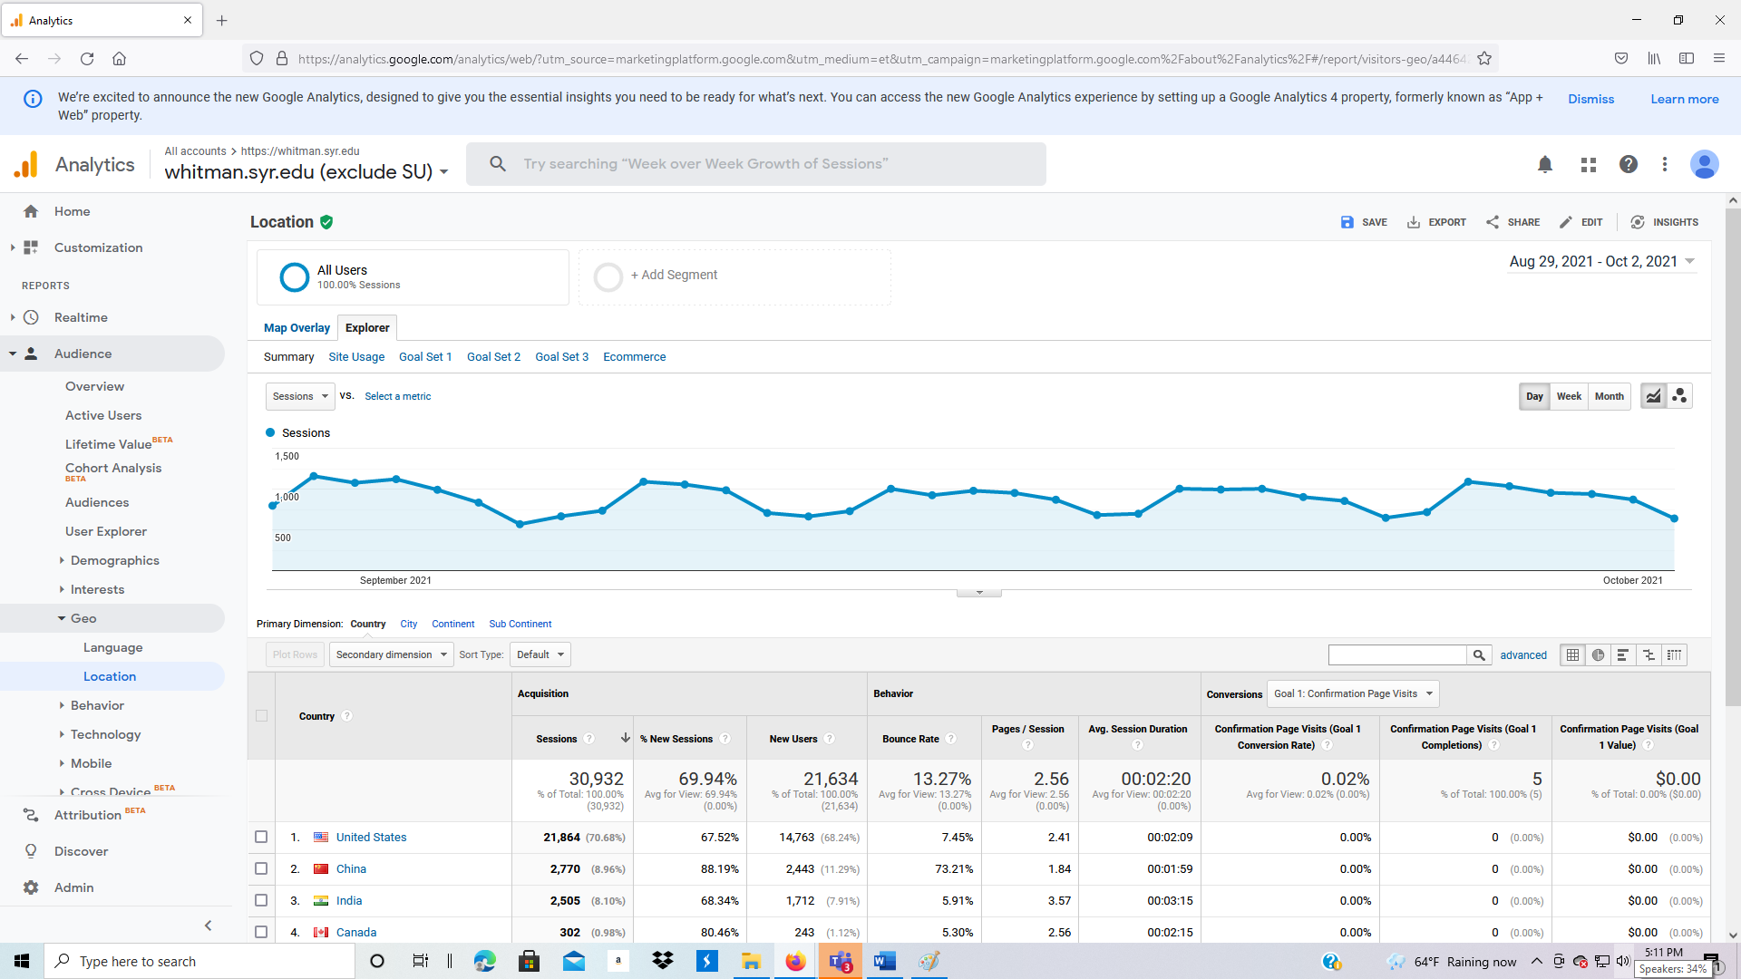

1. Notice that there is a box with All Users above the words Map Overlay. Click on the box. It allows you to filter to specific data, such as bounced sessions, etc.

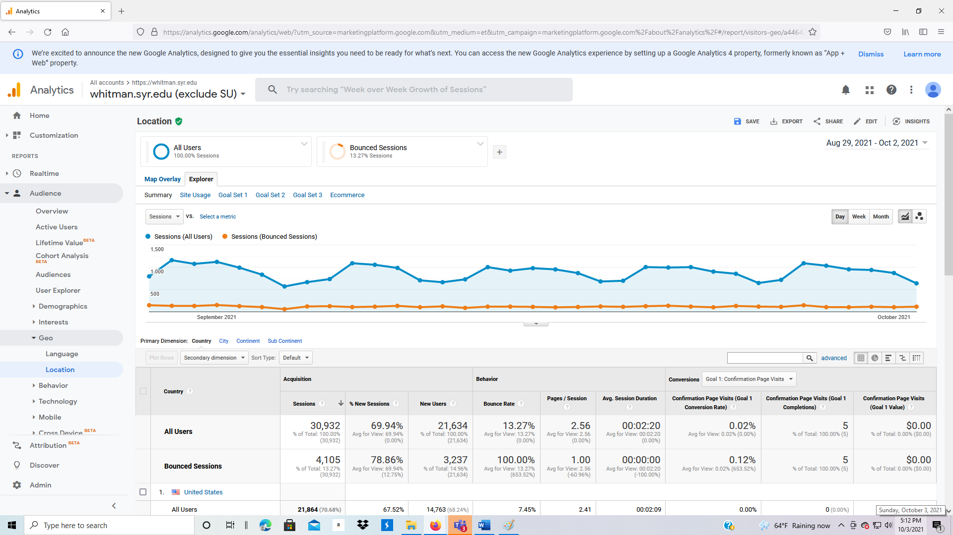

**3.2.8 Audience: Behavior**

1. Click on Audience > Behavior.
2. Click on New vs. Returning – why should you be interested in the difference?

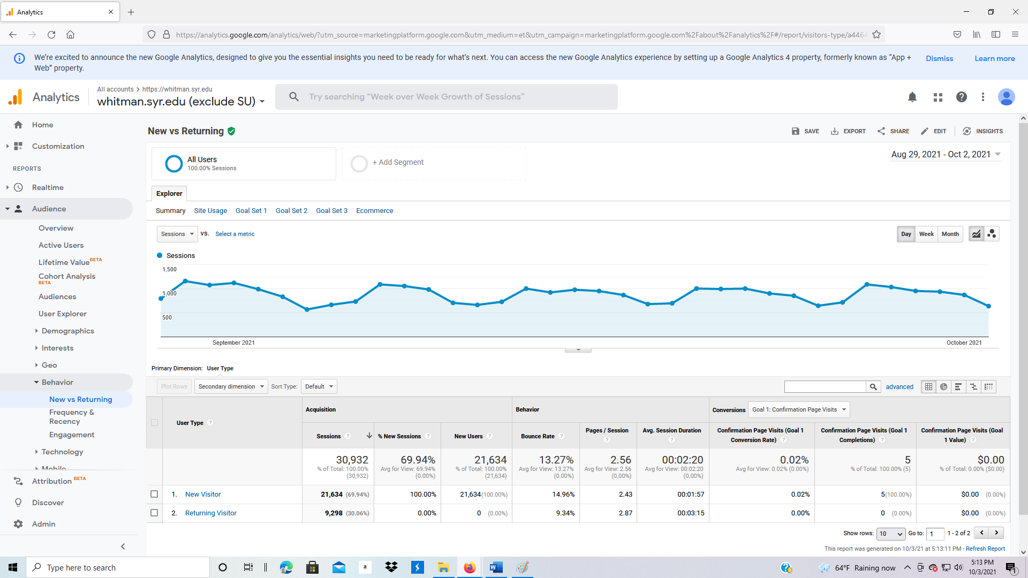

1. Click on Frequency & Recency.
   1. Frequency is how often someone visits.
   2. Recency measures the time since their last visit.
2. In the example below, how many people visited the site five times during this period?

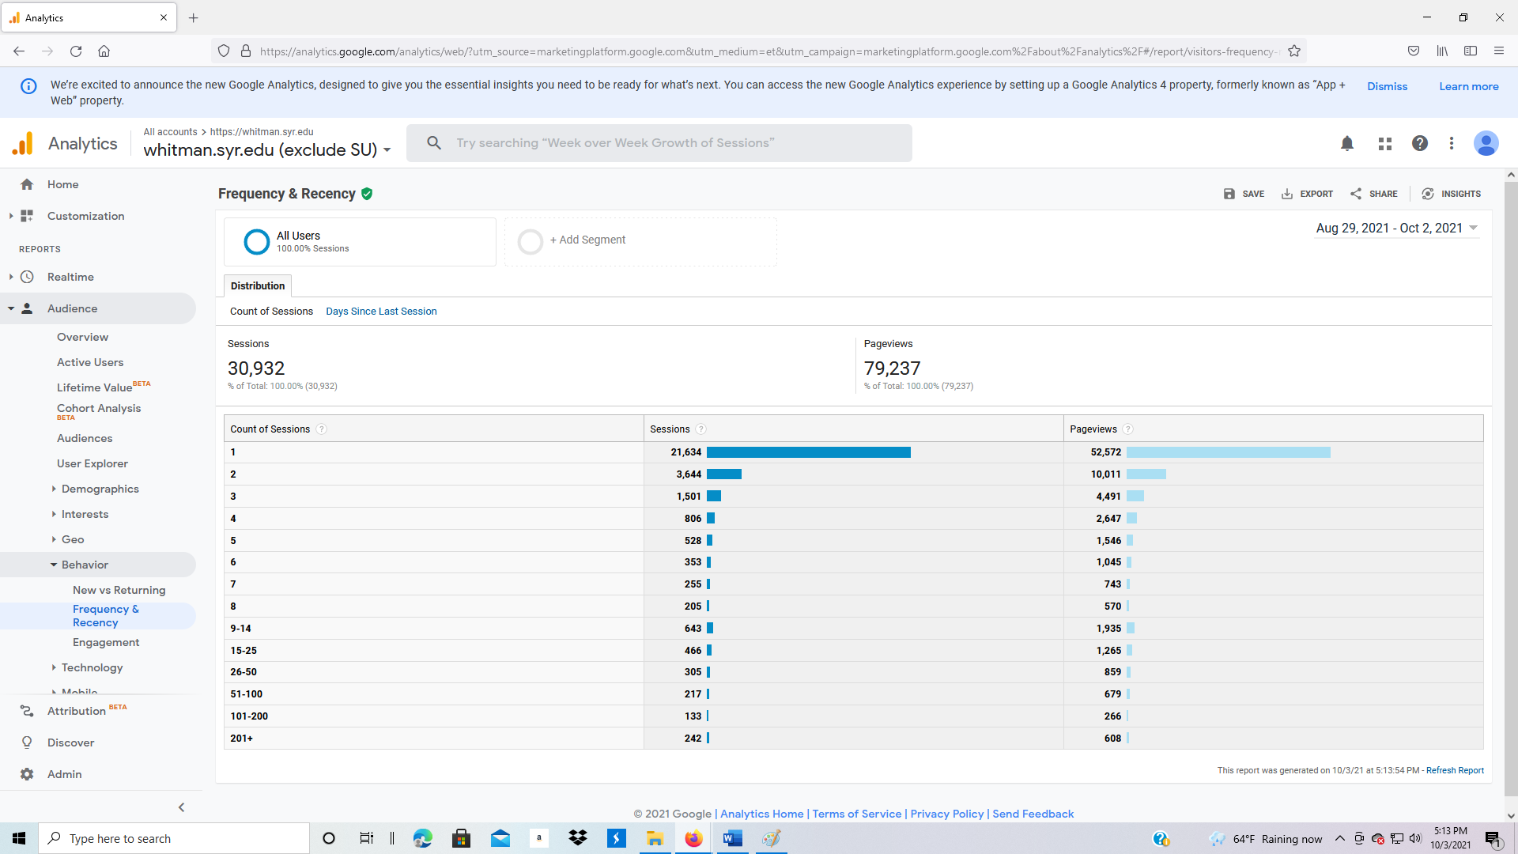

1. Change from Count of Sessions (Frequency) to Days Since Last Session (Recency).

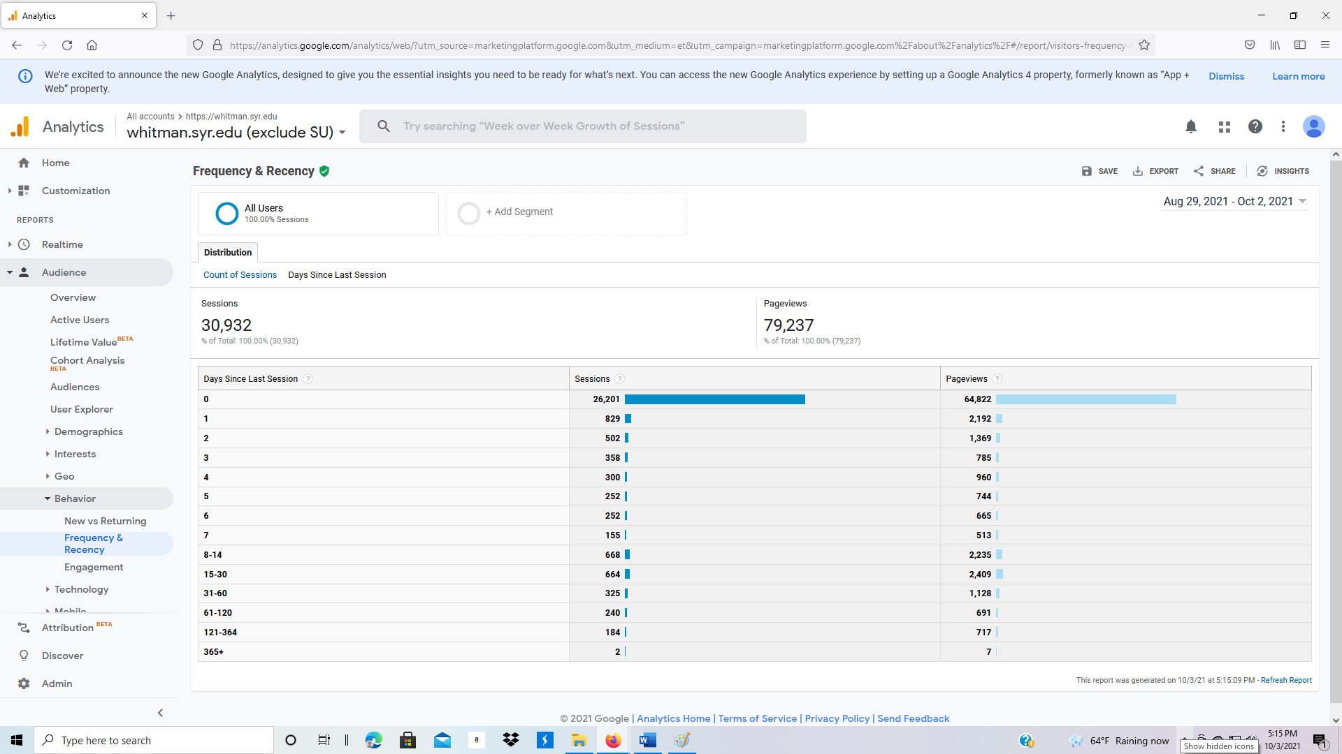

1. Click on Engagement. This displays the length of time a visitor is on your website.

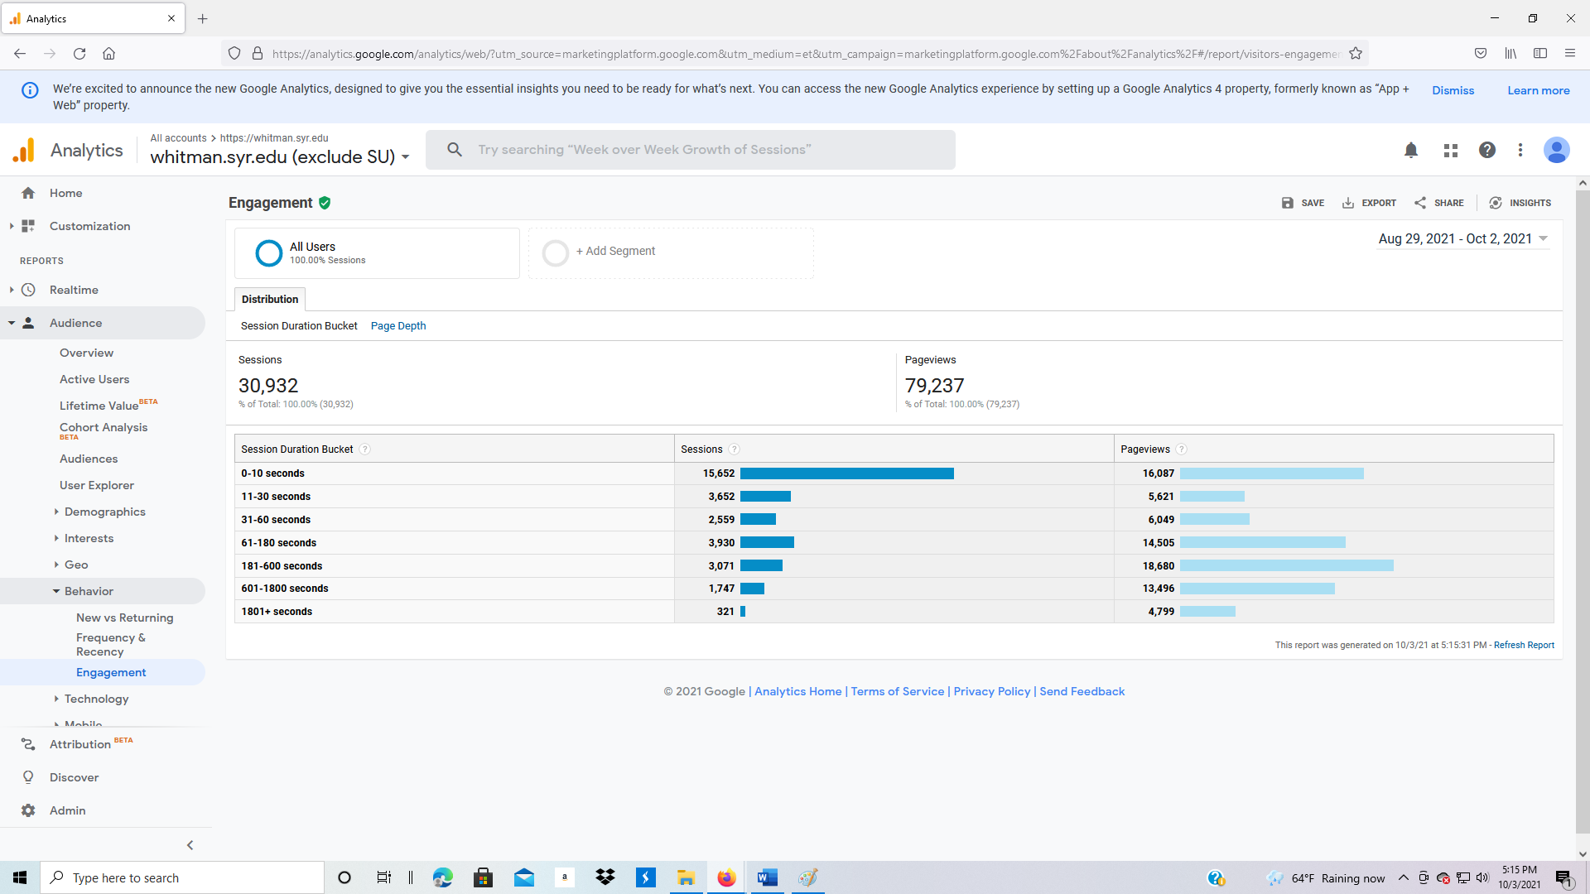

1. What is the difference between Sessions and Pageviews?
2. Scroll to the top of the page. Under Distribution, click on Page Depth.

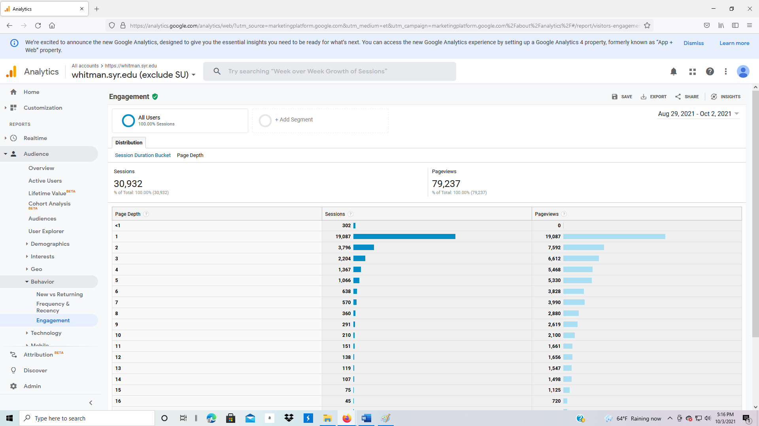

**3.2.9 Audience: Technology**

1. Browser & OS: Why is it important to know your customer’s browser?

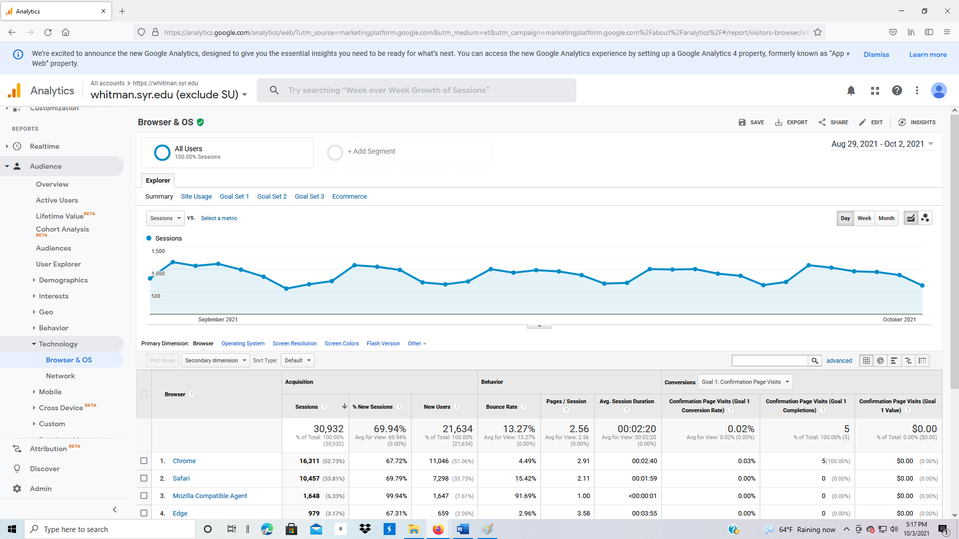

1. Now find Primary Dimension on your screen (under the graph). Change to Operating System, Screen Resolution, Screen Colors, Flash Version, and Other. Why are each important?

**3.2.10 Audience: Overview: Mobile**

1. Overview: displays desktop vs. mobile vs. tablet.

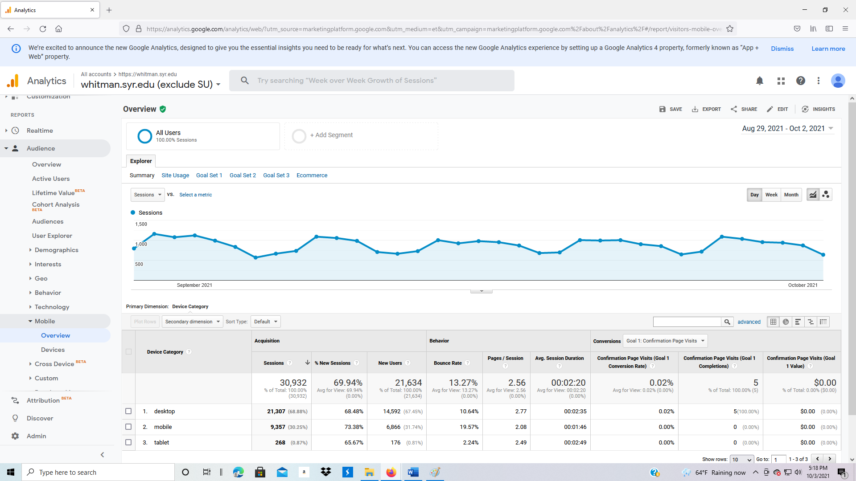

1. Devices: displays type of device, such as iPhone, iPad, etc.

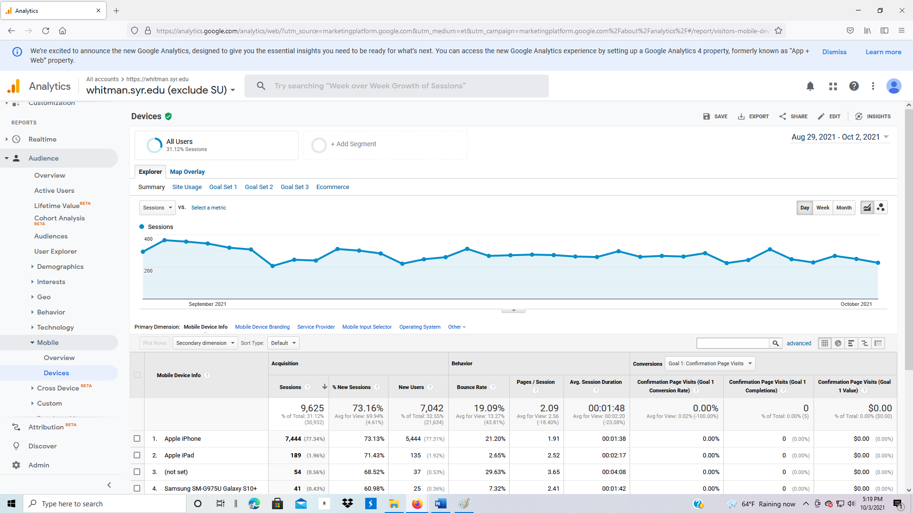

**3.2.11 Audience: Benchmarking**

Benchmarking compares your website traffic to websites in similar industries with similar volume.

1. Click on Audience: Benchmarking: Channels
2. At the top use the drop-down arrow next to Select industry vertical, and change to

Jobs & Education > Education > Colleges & Universities > All Colleges & Universities

1. Set Country/Region to All
2. Set Size by daily sessions to 1000-4999

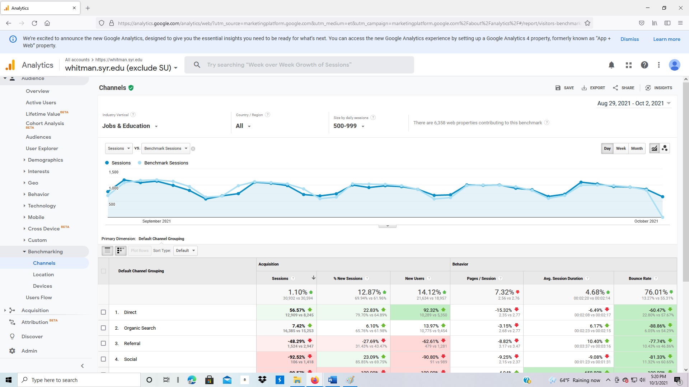

1. Click on Audience: Benchmarking: Location

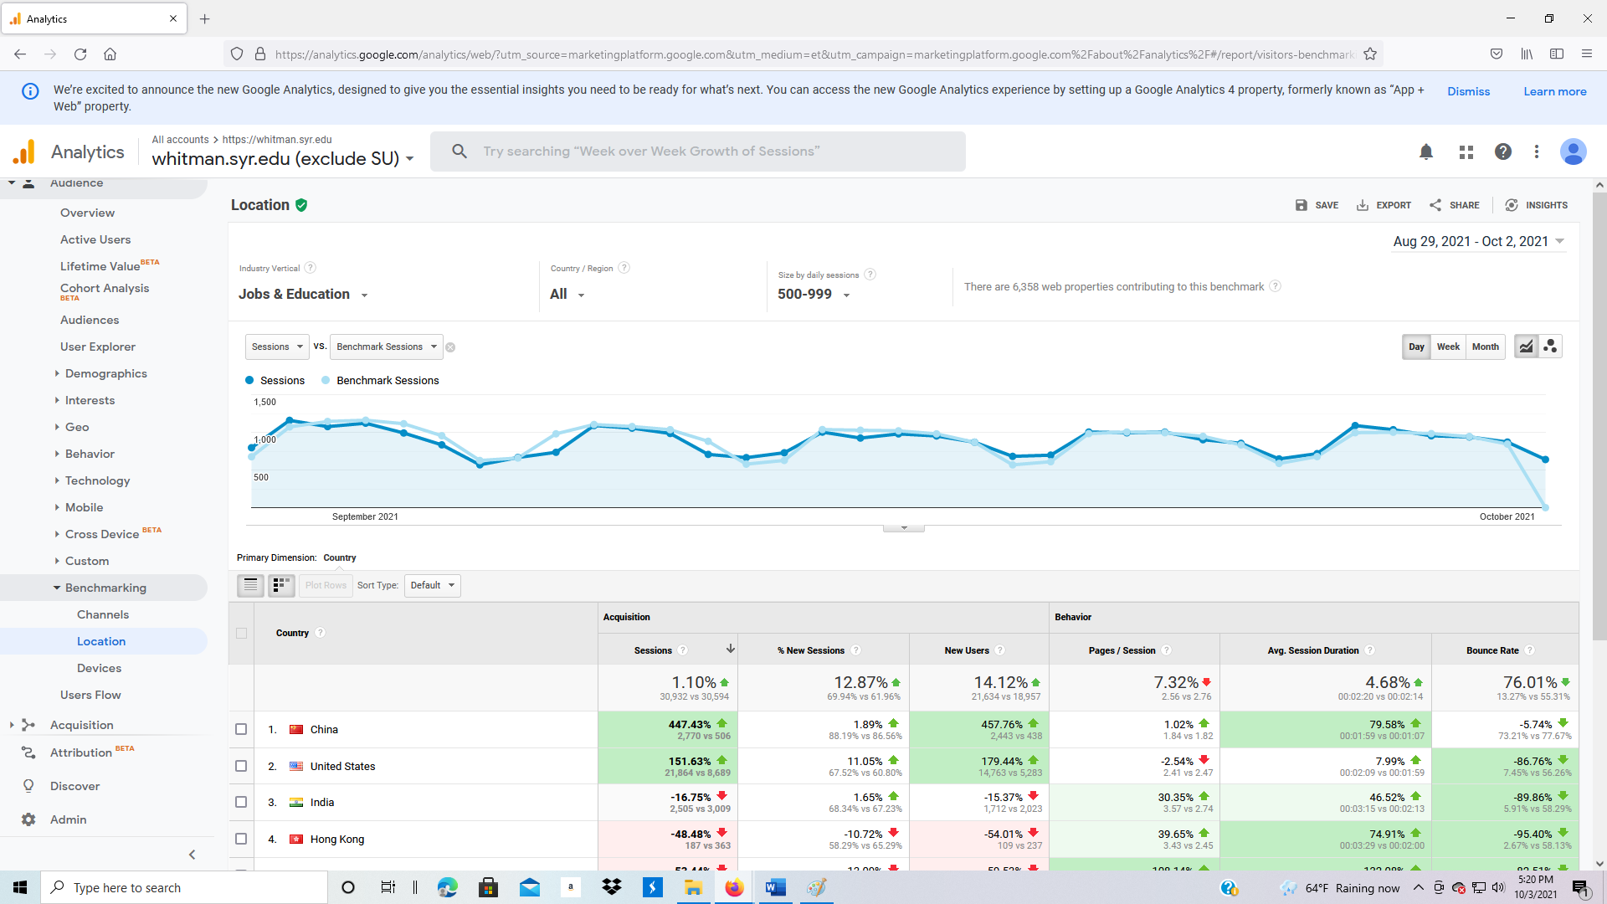

1. Click on Audience: Benchmarking: Devices

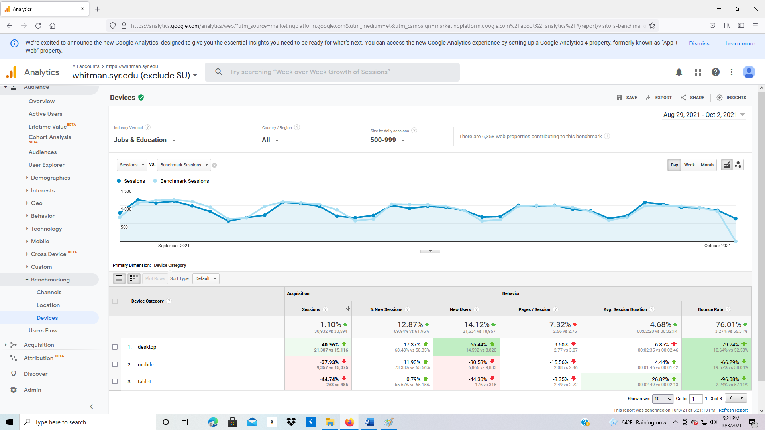

**3.2.12 Audience: Users Flow**

1. Click on Audience > Users Flow. The Users Flow shows the entry and exit points for all users on the system. The system shows the country of origin, first web page, and last page viewed.

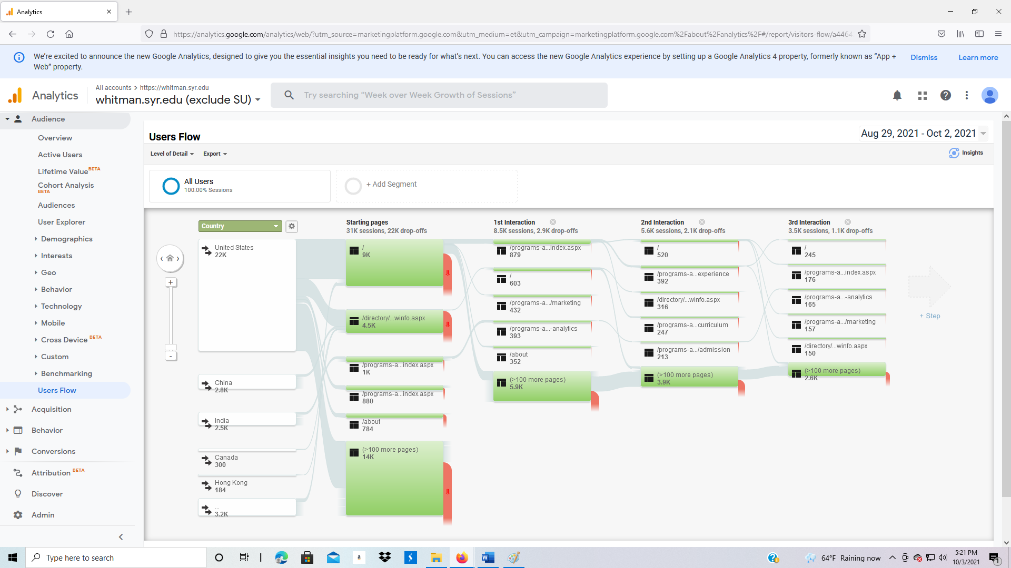

Traffic flow is highlighted in green. Drop-offs are highlighted in red. Move your cursor over each area to identify additional information.

1. Click on China, then click on “Highlight traffic through here.” Which web page has the highest traffic from China?

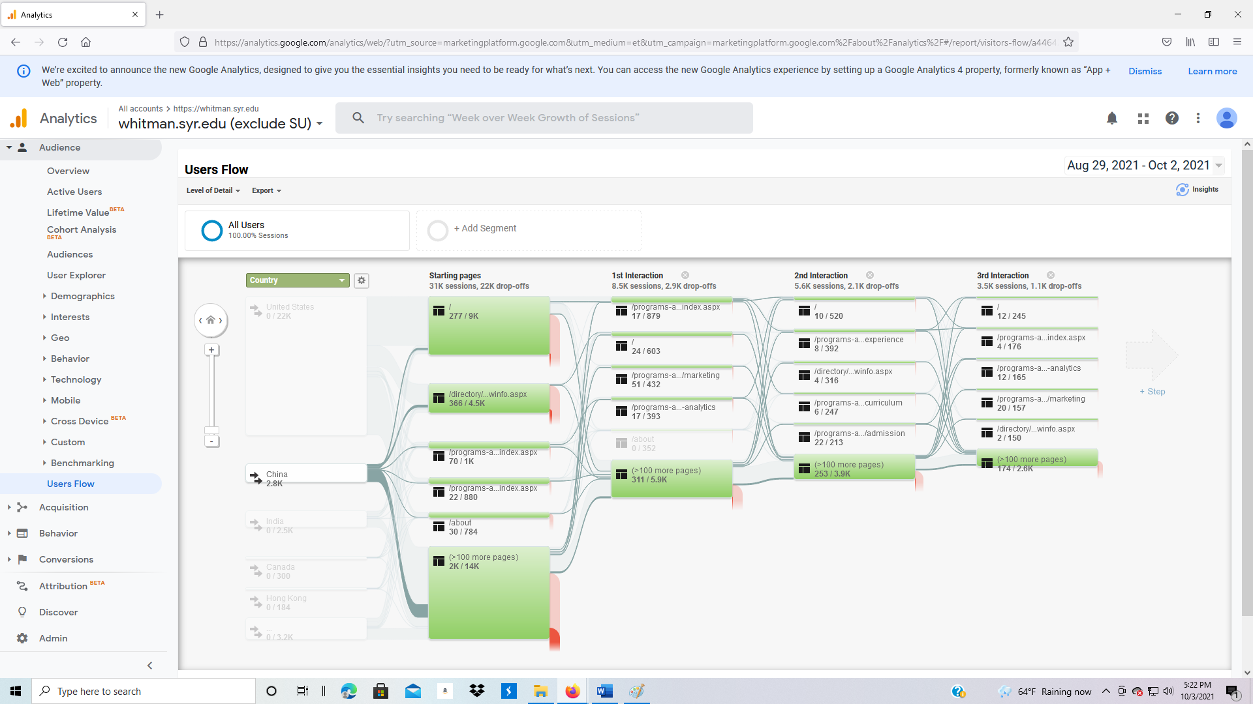

* + 1. **Acquisition**

Acquisition shows how traffic arrives at your website.

1. Overview: On the left, click on Acquisition and Overview. What’s the difference in the categories?
   1. Organic search: someone finds you via a search engine, no advertisement
   2. Direct: someone types in your URL into a browser
   3. Referral: another website has a link to your web page
   4. Social: a social media platform has a link to your web page
   5. Email: an email has a link to your web page

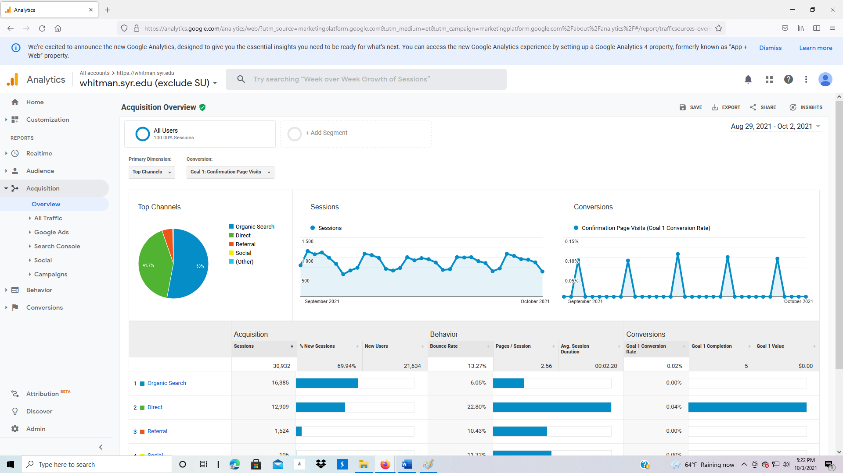

**Acquisition: All Traffic**

1. Next, click on Acquisition, All Traffic, Channels.

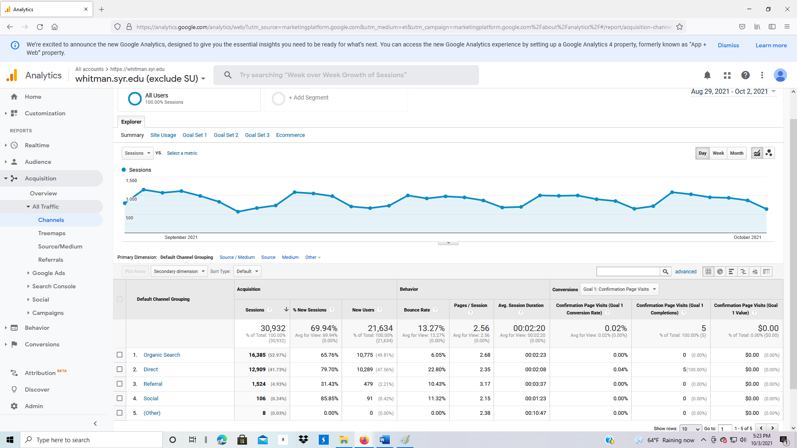

1. Change the Primary Dimension to Source/Medium. Can you interpret what these are? What is the difference between organic and referral?

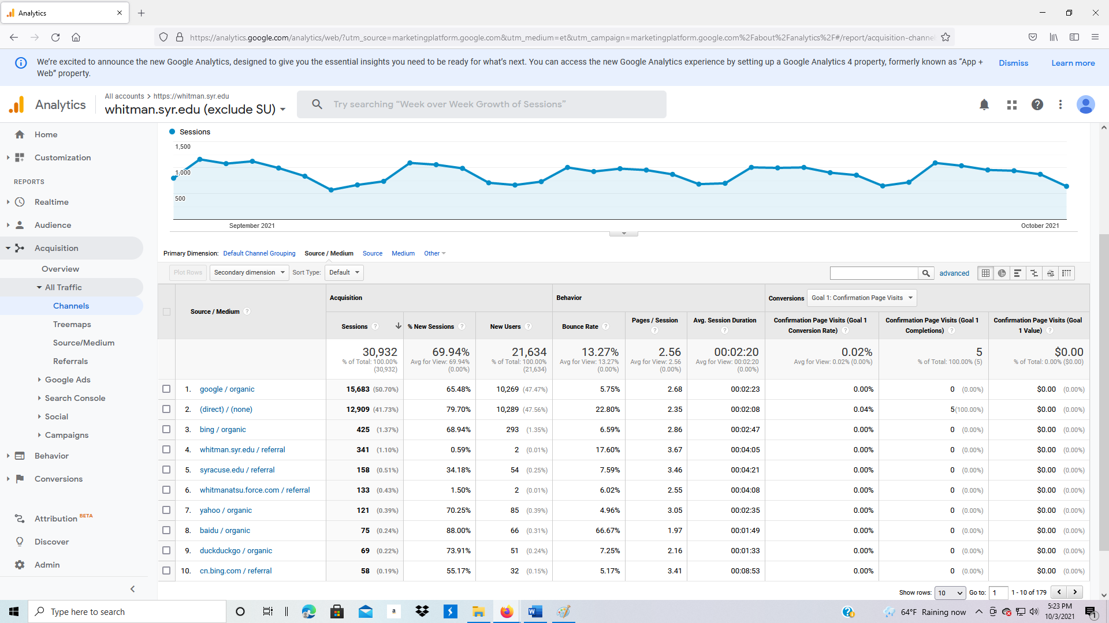

1. Change Primary Dimension to Source.

Source is Google, direct, bing, baidu, yahoo, facebook.com

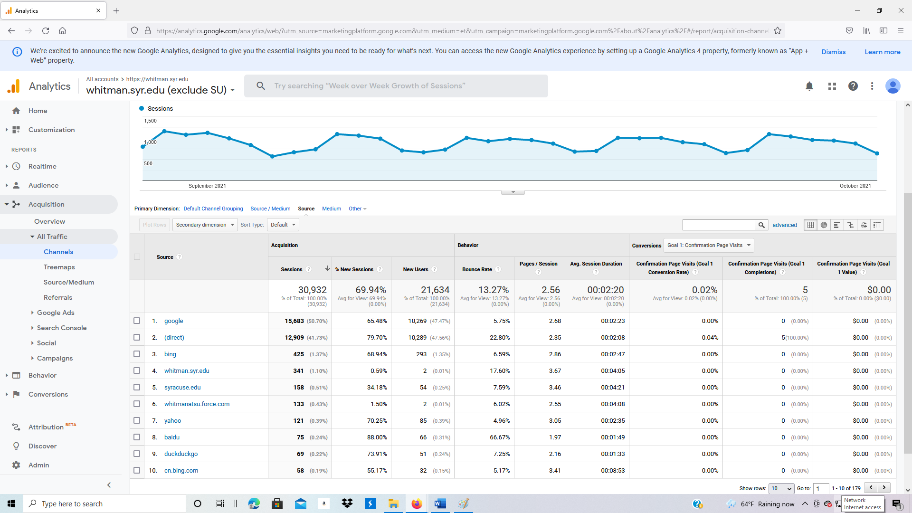

1. Finally, change Primary Dimension to Medium.

Medium is organic, referral, etc.

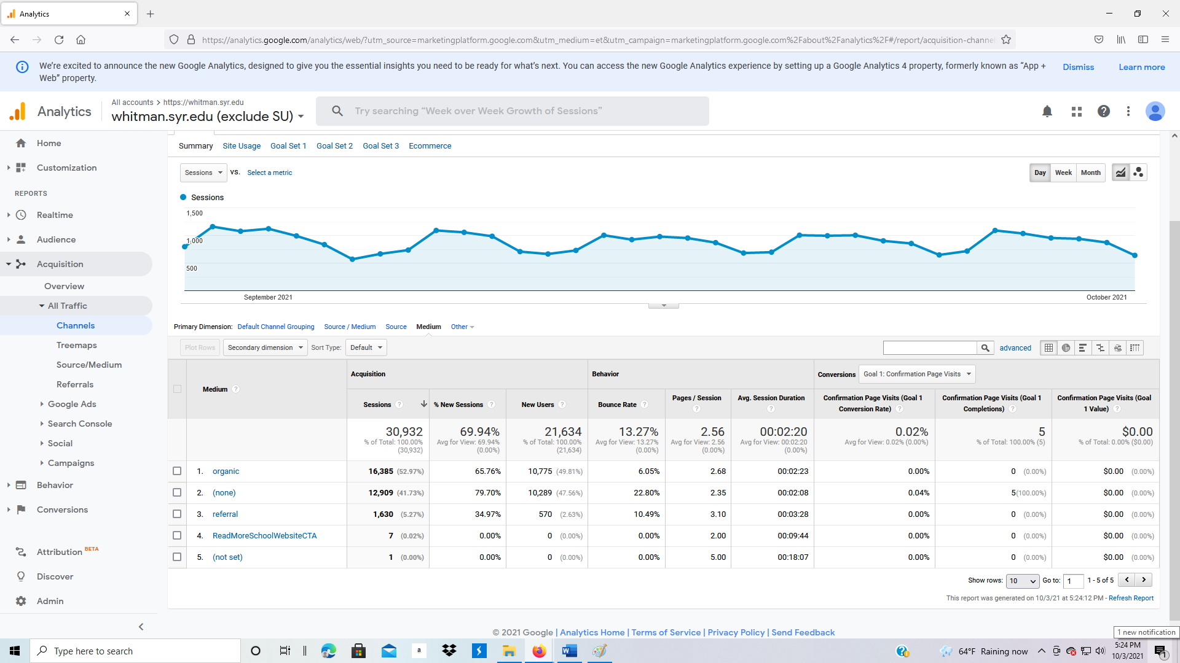

**3.3.2 Acquisition: Google Ads**

Advertising which occurs on Google is through Google Adwords.

1. Click on Acquisition: Google Ads, Campaigns on the left side of the screen. Note that the cost is misleading. The cost is all money spent during the period, not just on this campaign.
2. Set the date range from 1/1/2011 to today.

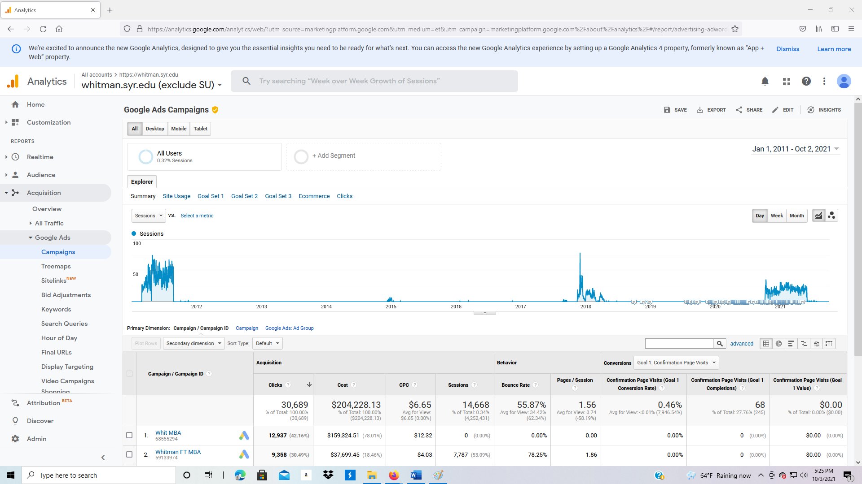

1. Change the date range to go from 1/1/2011 to 8/31/2011.

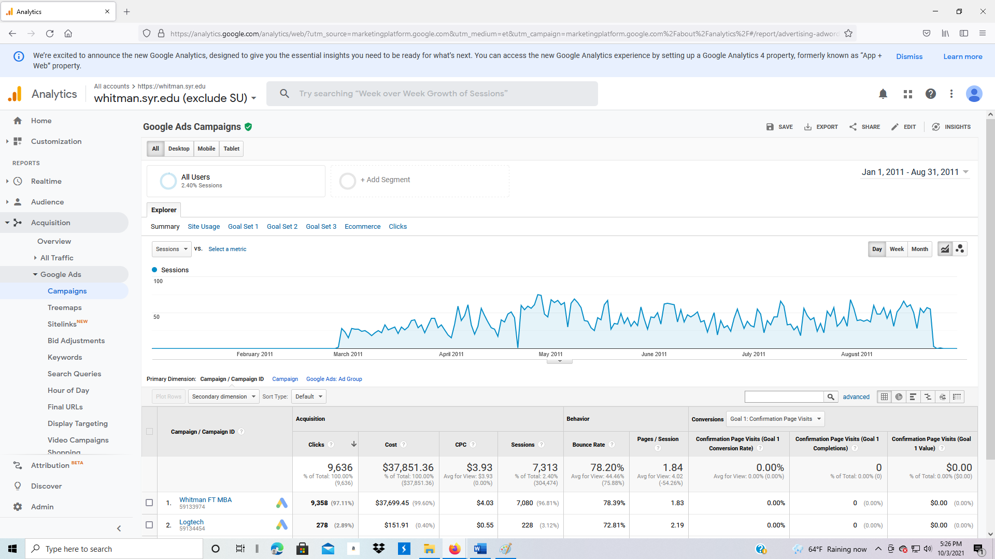

1. Under Campaign/Campaign ID, click on Whitman FT MBA
2. Under Google Ads: Ad Group, click on Ad Group #1
   1. (content targeting) means a display ad on another website
   2. “MBA” and “Top MBA” are key word combinations
3. What was the cost per click for the key word MBA?
4. What was the cost per click for the key words “Top MBA”?

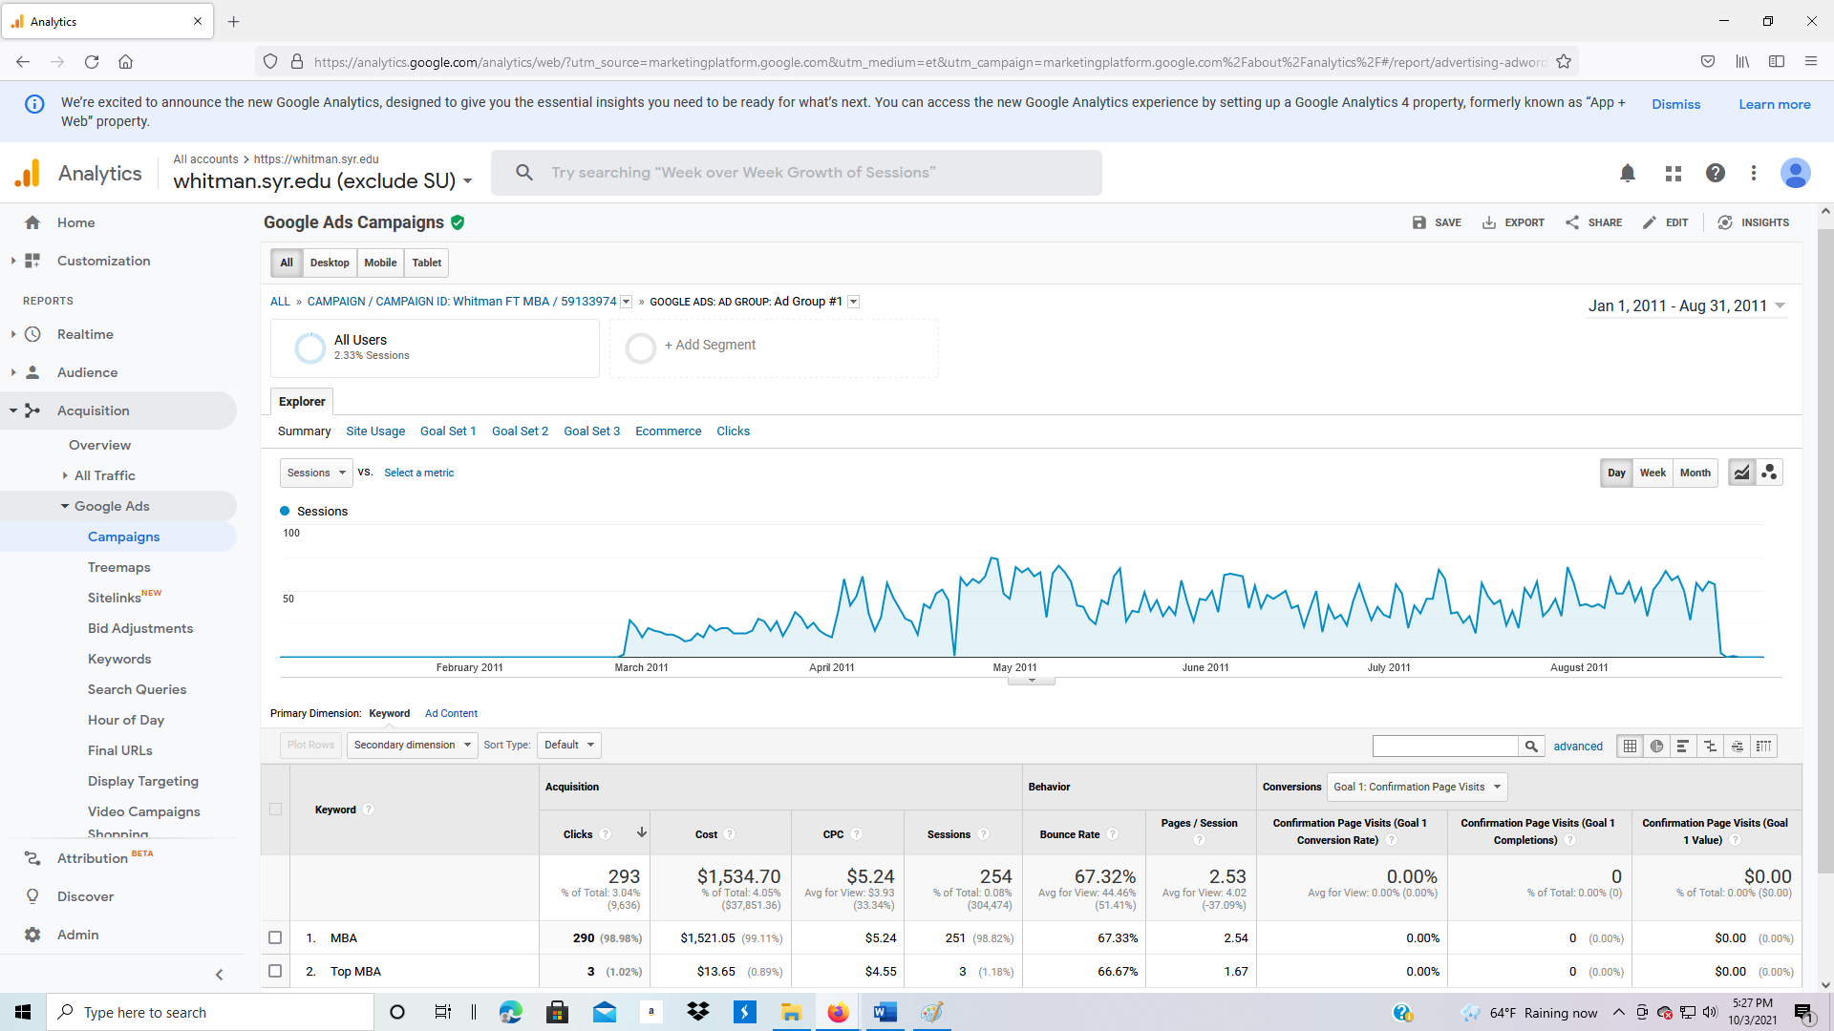

1. Now switch to Google Ads, Bid Adjustment.
2. This screen shows metrics for each type of device (computer, mobile, tablet).
   1. Which device has the lowest cost per click?
   2. Which device has the highest bounce rate?

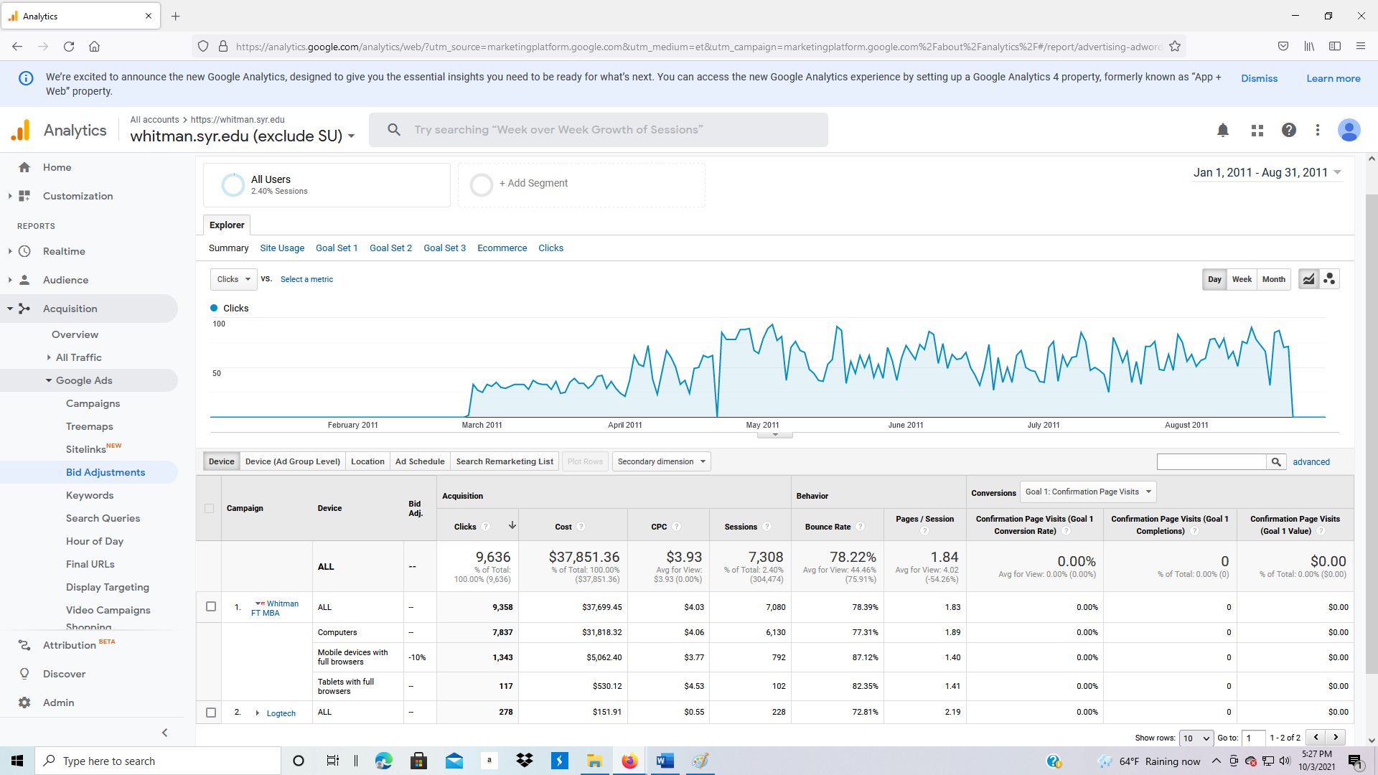

1. Click on Google Ads, Keywords.

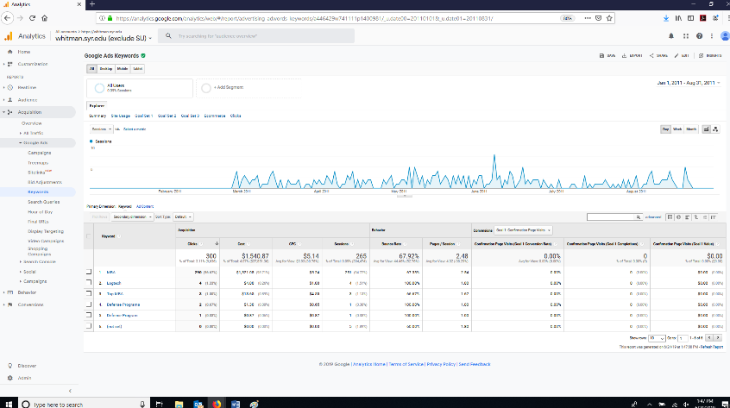

1. In the middle, left part of the screen, change Primary Dimension to Ad Content.

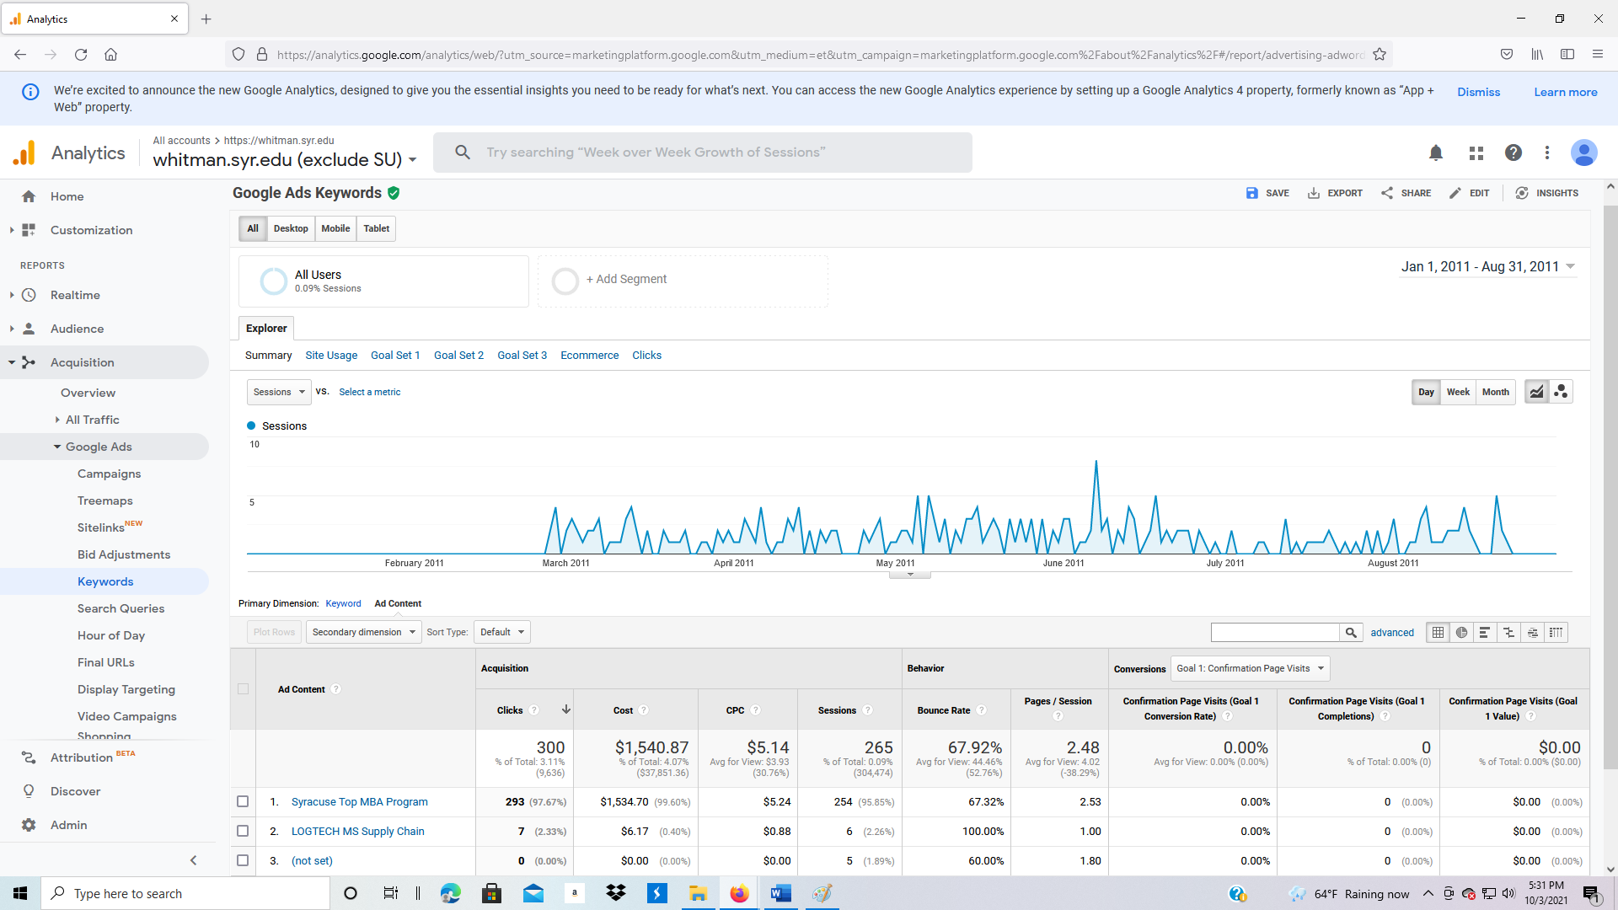

1. Under Ad Content, click on “Syracuse Top MBA Program,” then “Whitman FT MBA.”
   1. How much was spent on this advertisement campaign?
   2. What was the cost per click?
   3. What was the bounce rate?
   4. What was the pages/session?

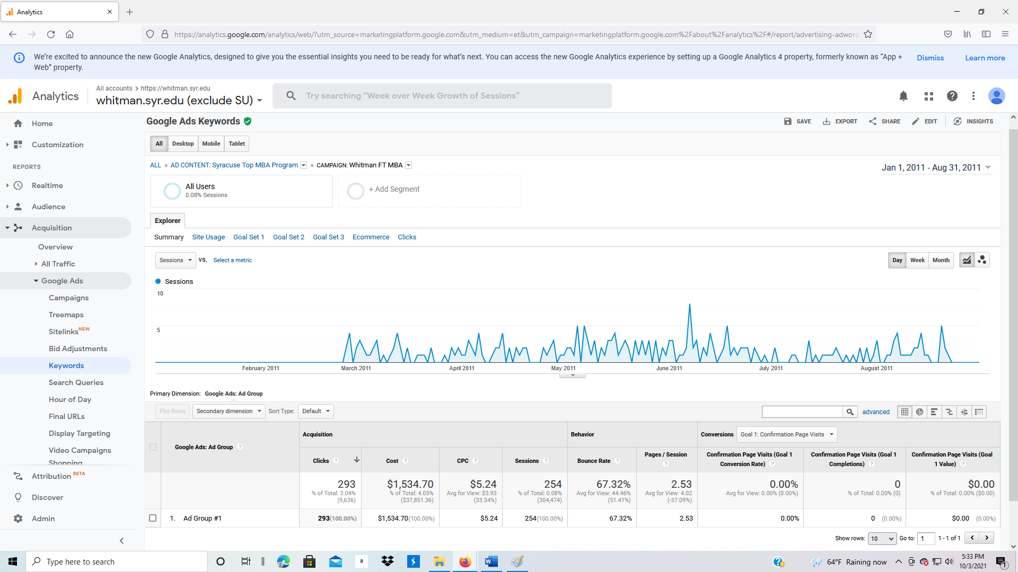

1. Click on Google Ads, Search Queries.

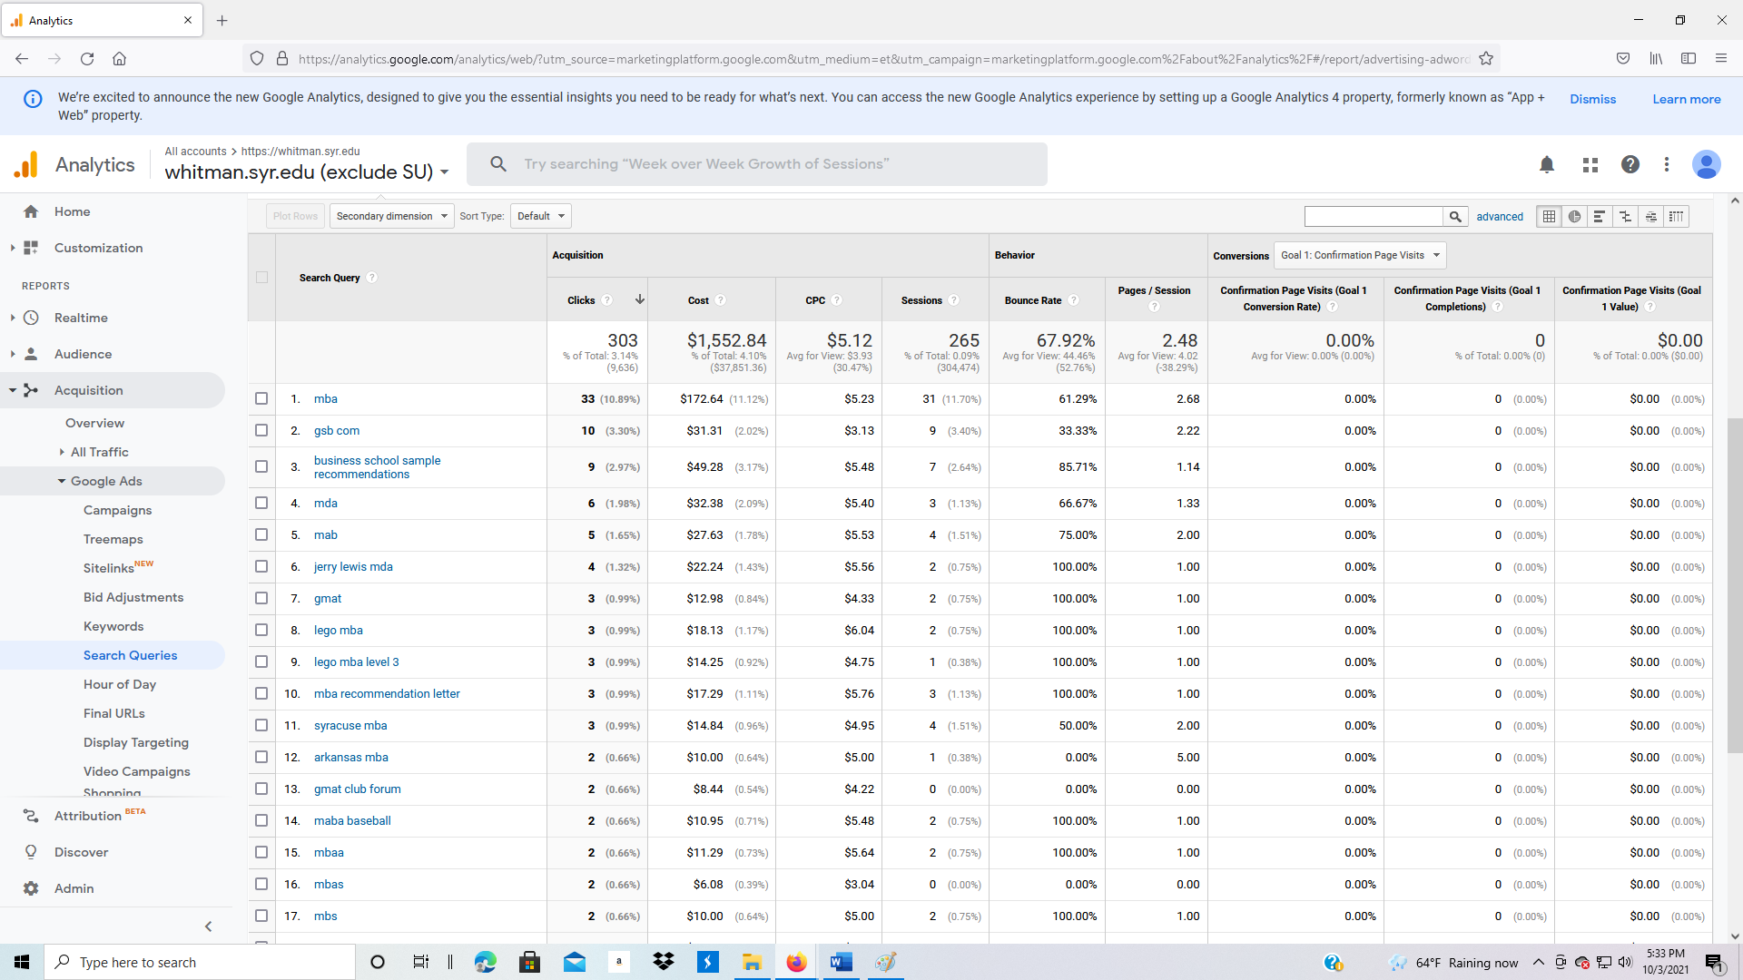

1. In Primary Dimension, below the graph, click on Query Match Type.
   1. Broad match: Broad match lets a keyword trigger your ad to show whenever someone searches for that phrase, similar phrases, singular or plural forms, misspellings, synonyms, stemmings (such as floor and flooring), related searches, and other relevant variations. (https://support.google.com/google-ads/answer/2407779?hl=en)
   2. Phrase match: Phrase match lets a keyword trigger your ad to show only when someone searches for your exact keyword phrase, or close variations of your exact keyword phrase, with potentially other words before or after that phrase. Close variations include misspellings, singular and plural forms, acronyms, stemmings (such as floor and flooring), abbreviations, and accents. (https://support.google.com/google-ads/answer/2407784?hl=en)
   3. Exact match: exact match!

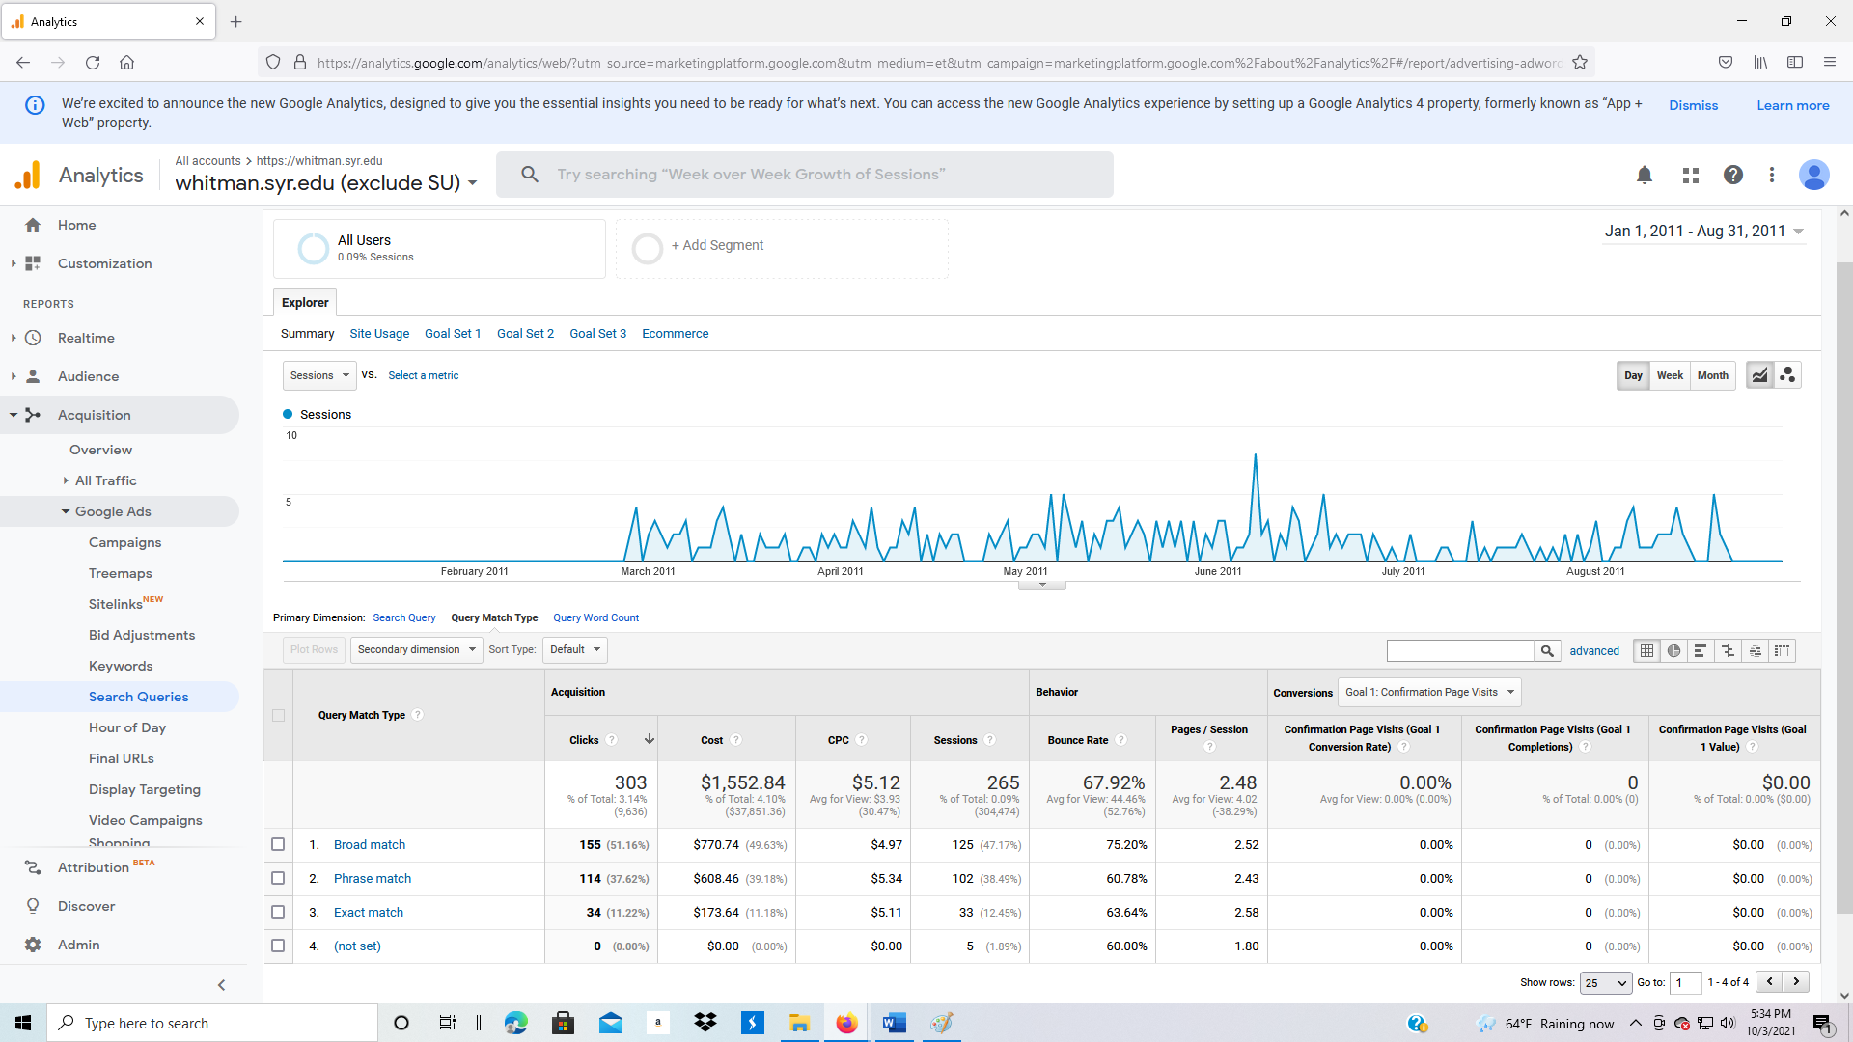

1. Change Primary Dimension to Query Word Count, then click in the Query Word Count column, click on 2.

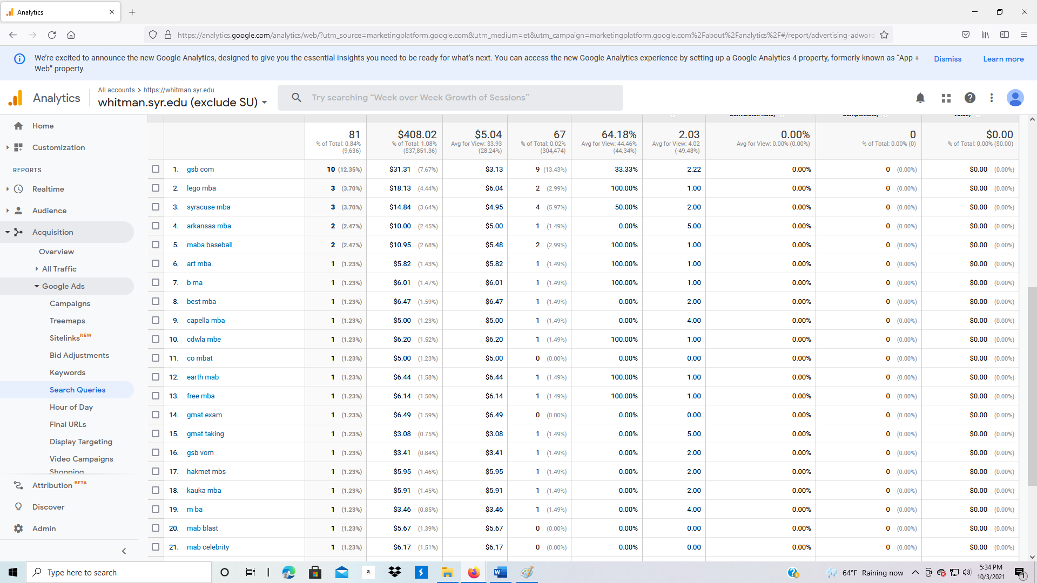

1. The Search Query column shows the combination of two key words.
2. Change to Google Ads, Hour of Day. This is time of day advertising. When is the highest level of traffic? Put your cursor over the ? next to Hour to identify the measure.

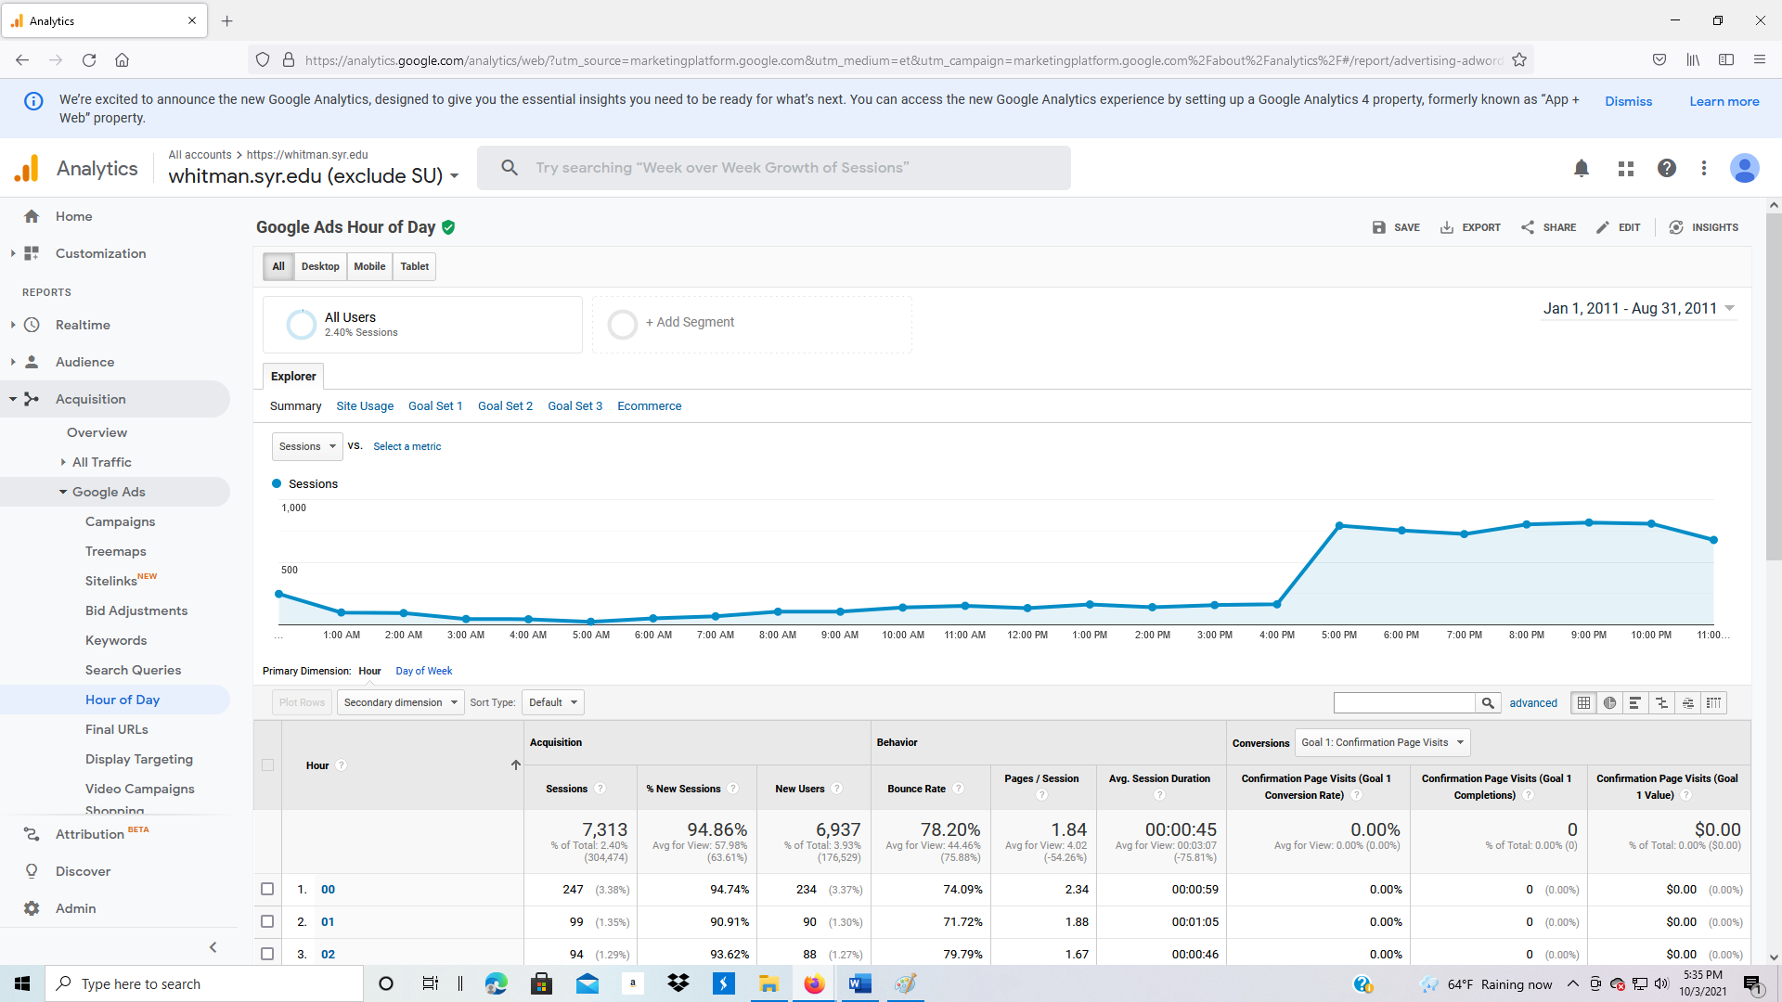

1. Change the primary dimension to Day of Week. Put your cursor over the “?” next to Day of Week in the table to identify what the 0 through 6 means.

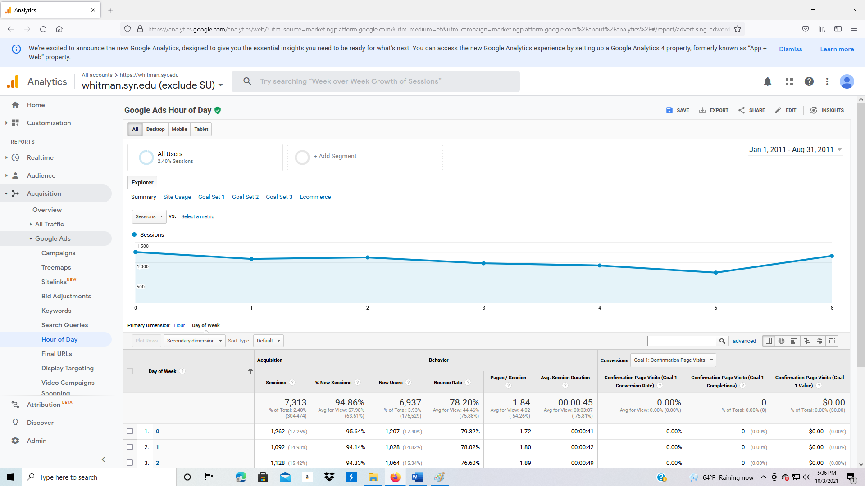

**3.3.3 Acquisition: Social**

1. Click on Social, Overview. This first page for social media identifies the source of traffic.

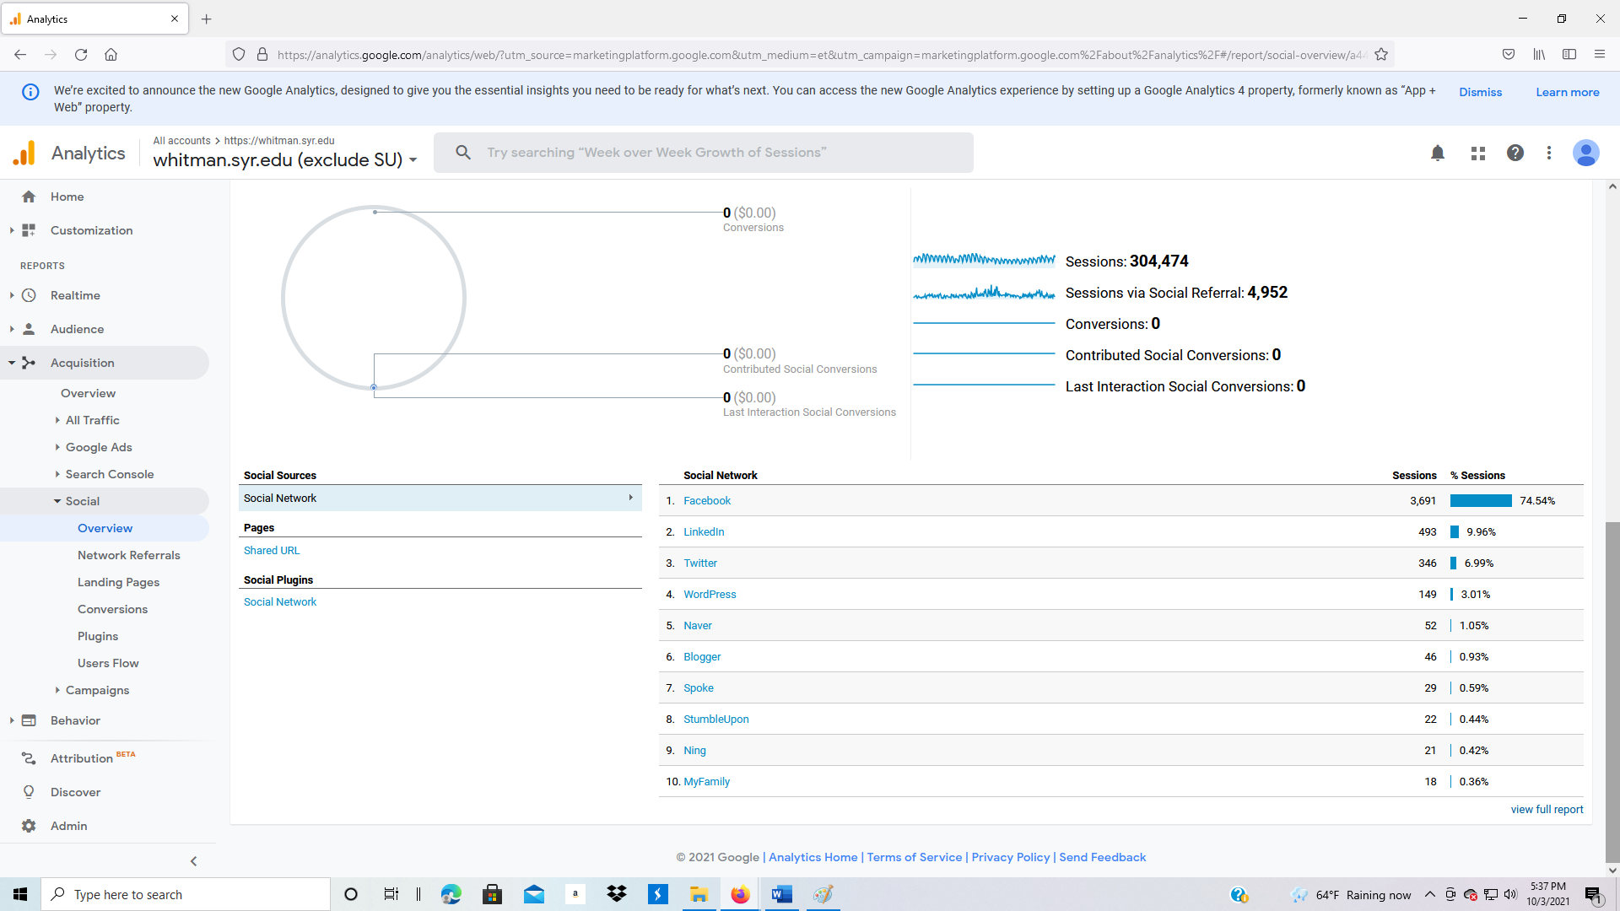

1. Click on Social, Network Referrals. What social media site sends the most traffic to the website?

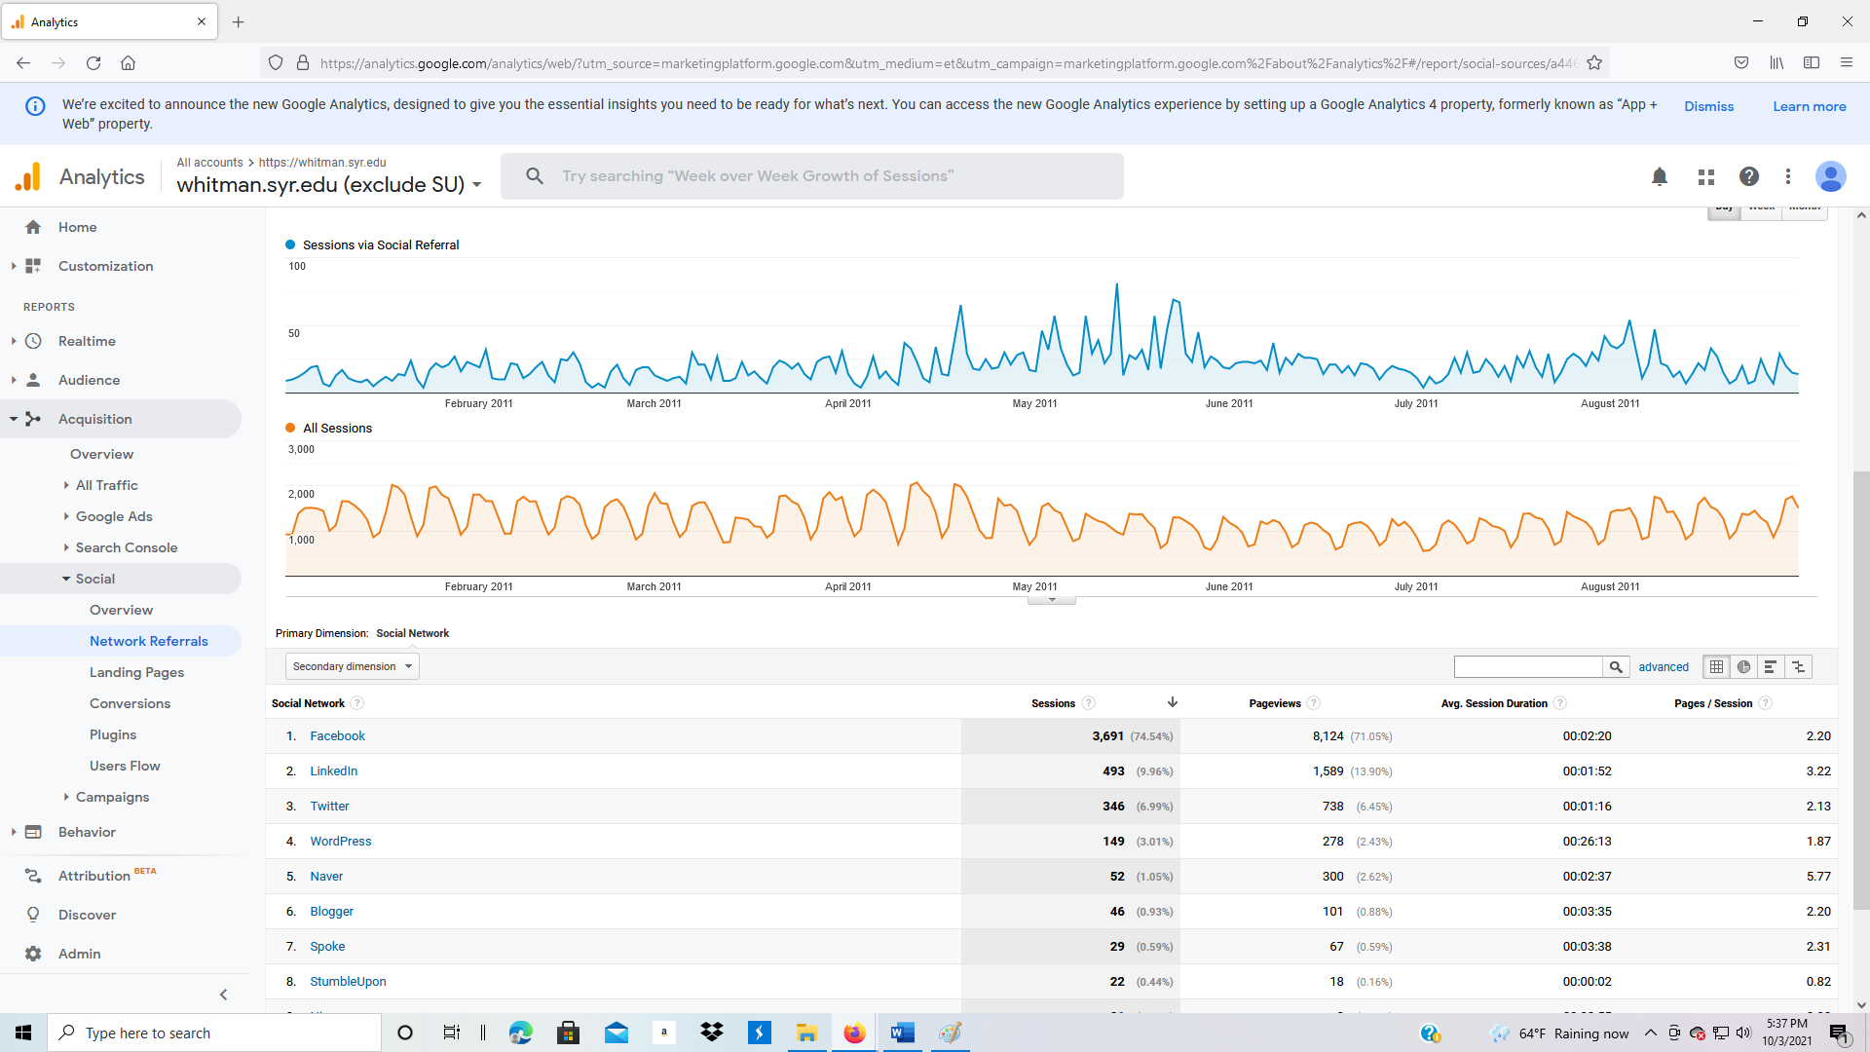

1. Click on Social, Landing Pages.

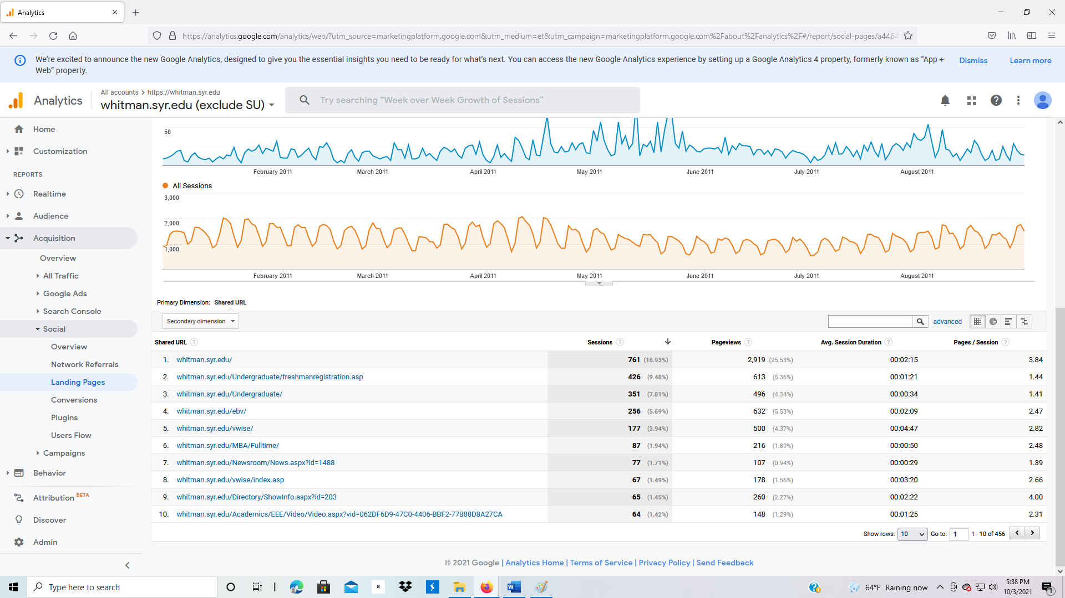

1. Click on Social, Users Flow to see a graphic representation of the traffic flow from social websites.

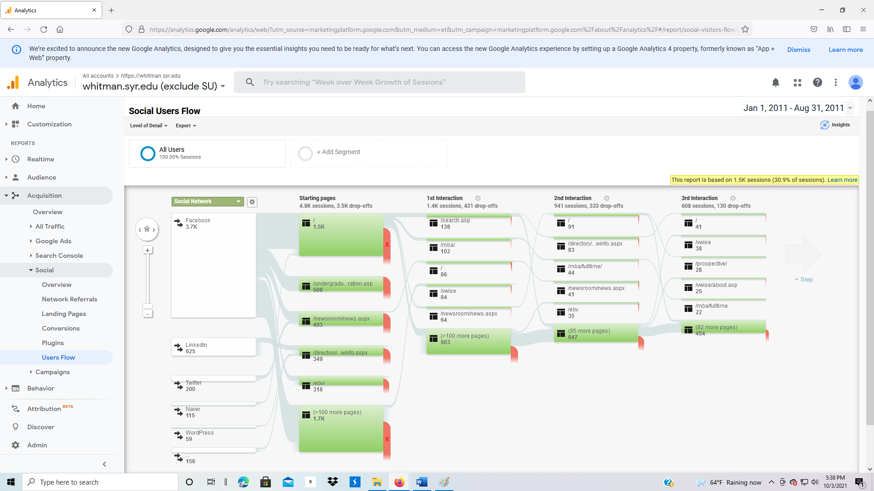

**3.3.4 Acquisition: Campaigns**

1. Next click on Acquisition, Campaigns, All Campaigns.
2. Let’s expand the time period of the data. In the upper right corner of the screen is the date range.
3. Click on the date.
4. A calendar will appear.
5. Click on the “from” date, then enter August 1, 2013 (8/1/2013).
6. Click on the “to” date, then enter August 1, 2016 (8/1/2016).
7. Click Apply.
8. In the search box below the graph and above the data, type in Delta, then click on the search button.

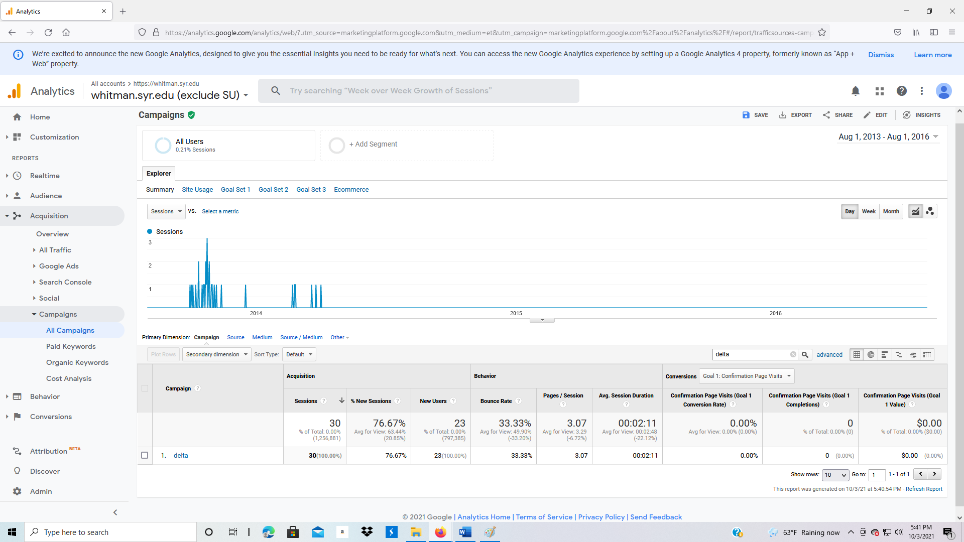

1. The “delta” campaign was an advertisement placed in Delta Airline magazine. What are some useful measures for the delta campaign?
2. How would you determine the exact start and end of this campaign?

**3.3.5 Acquisition: Paid Keywords**

Paid Keywords are used to drive traffic to your website. You bid on keywords with Google. Whenever someone searches on Google, your advertisement appears based on your bid compared to others.

1. Change the date range to the range January 1, 2011 through today.
2. Click on Paid Keywords.

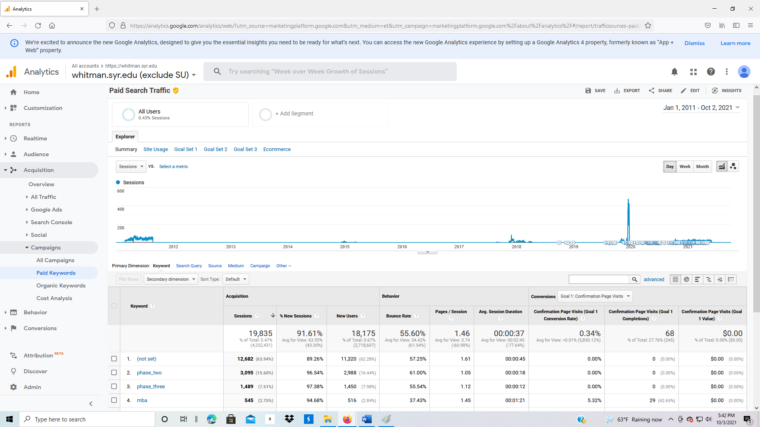

1. Next, on the left of the screen, click on Organic Keywords. Organic means keyword searches a visitor typed into a search engine that were not associated with an advertisement. How many different keyword combinations were used in this period?

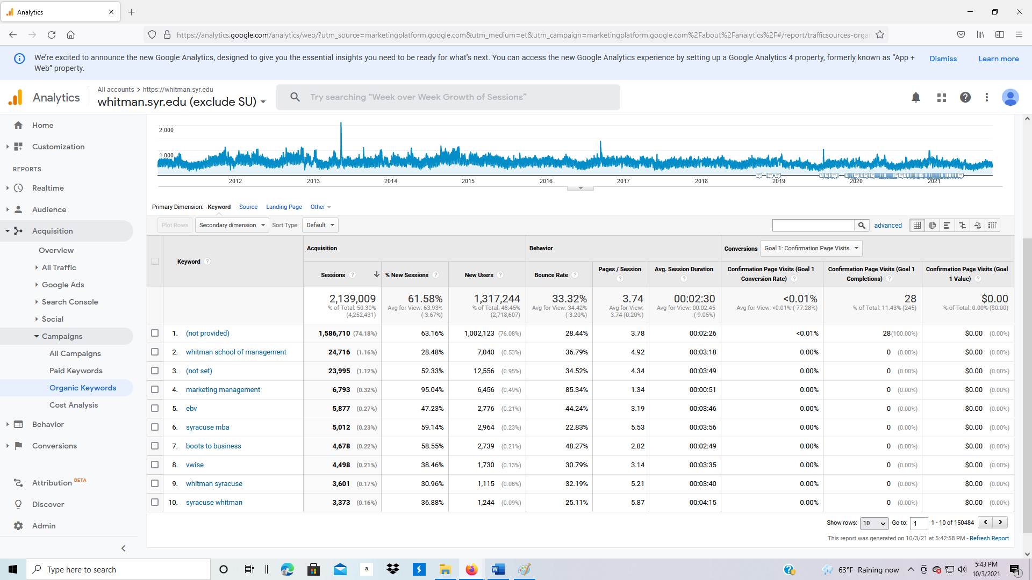

**3.4.1 Behavior**

The behavior section of Google Analytics measures the performance behavior of your website.

1. Click on Behavior: Overview. This shows the overall traffic to the website.

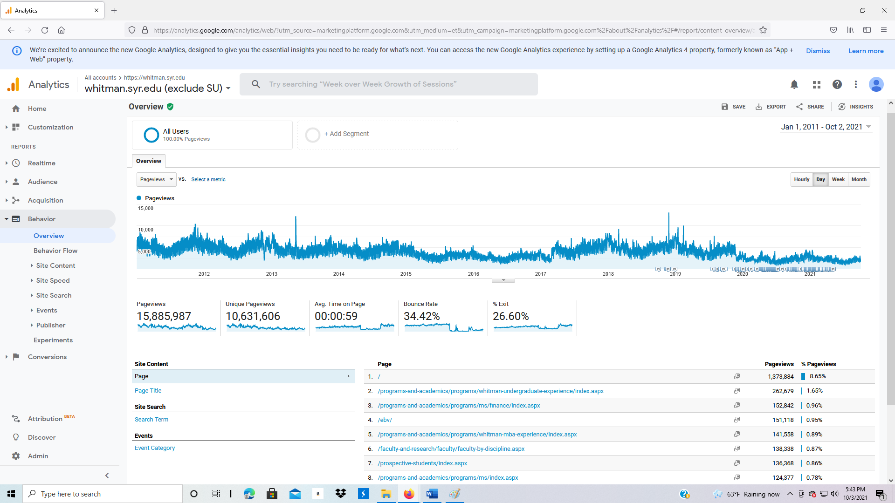

**Behavior: Behavior Flow**

1. Then click on Behavior: Behavior Flow on the left side.

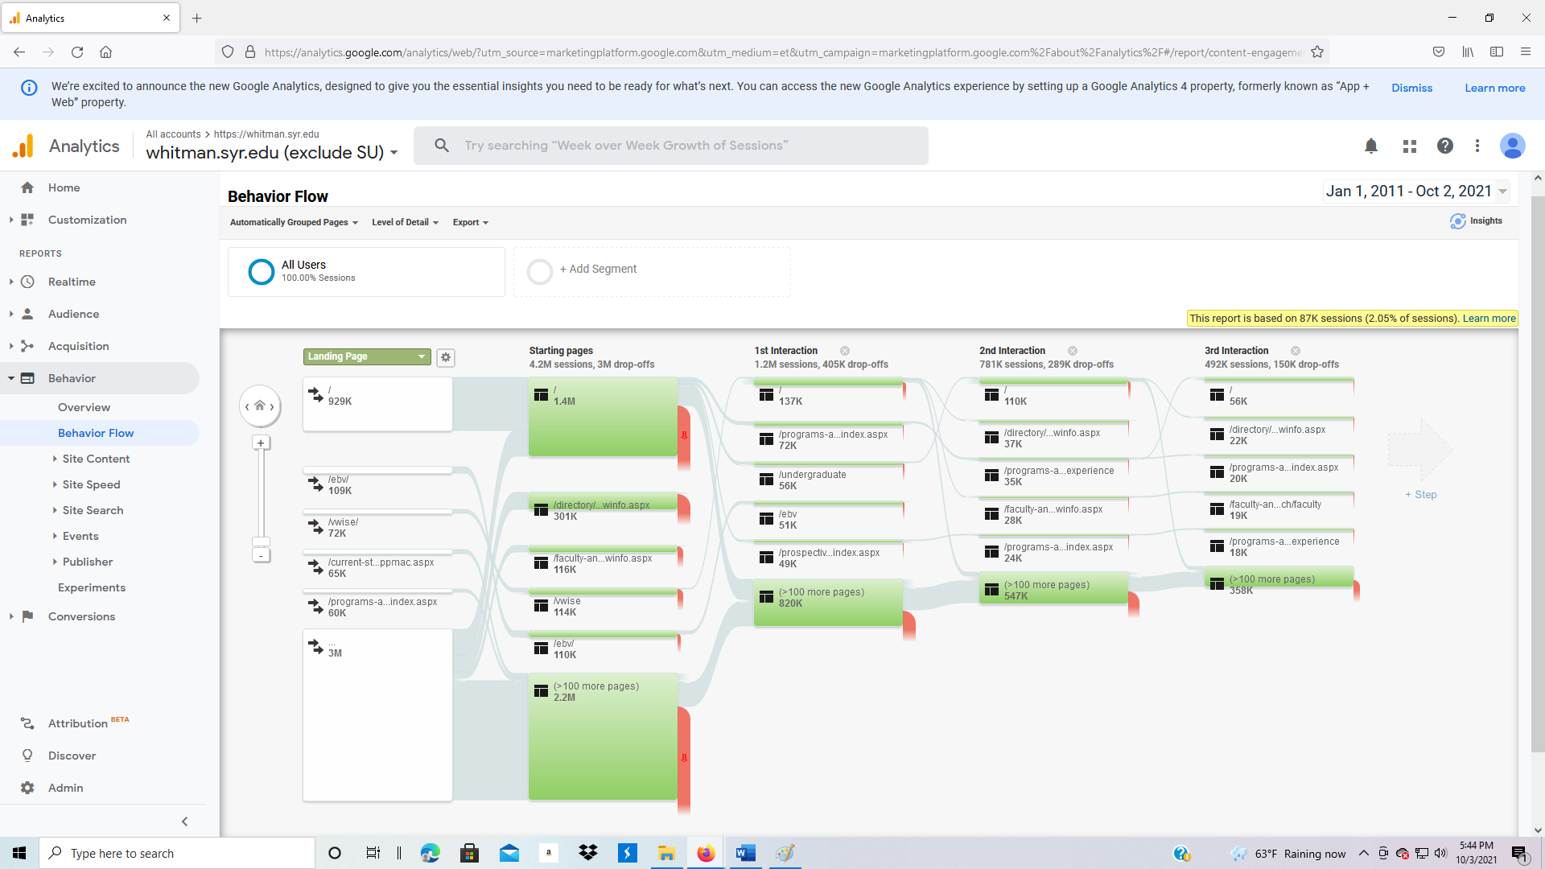

**Behavior: Site Content**

1. Click on Behavior: Site Content: All Pages.

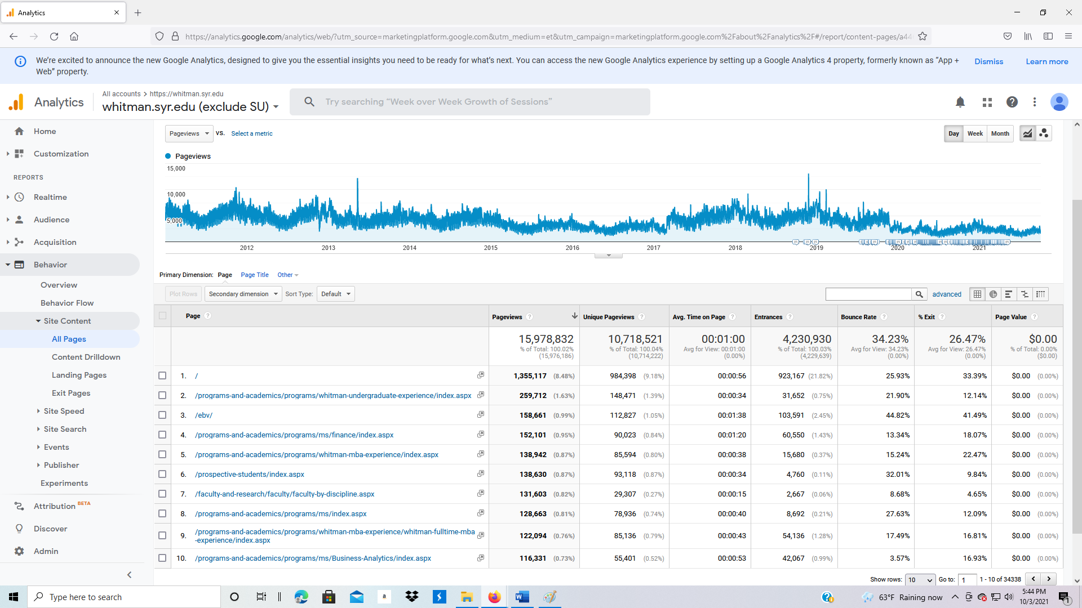

1. Click on Behavior: Site Content: Content Drilldown. This allows you to determine the pages that users followed.

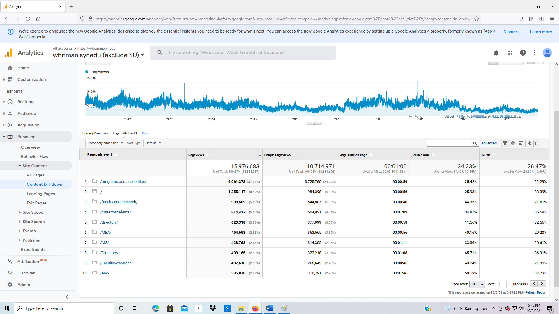

1. Click on Behavior: Site Content: Landing Pages. This is the list of starting pages for users.

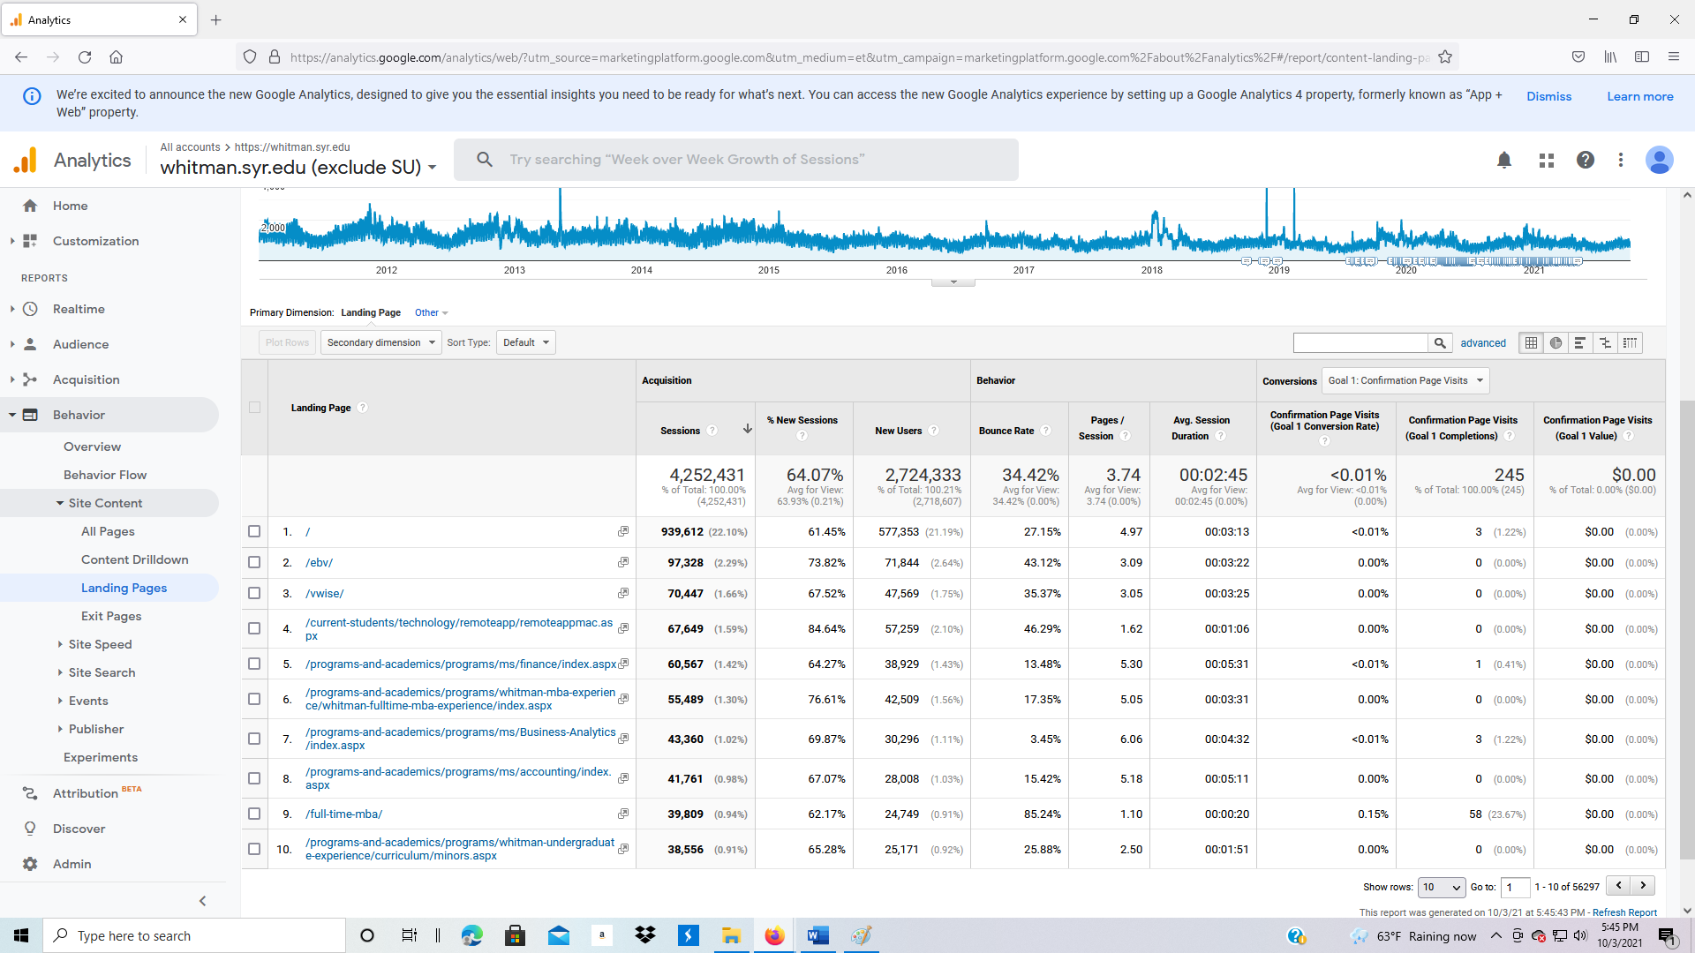

1. Click on Site Content, Exit Pages. Why is it helpful to understand the exit page?

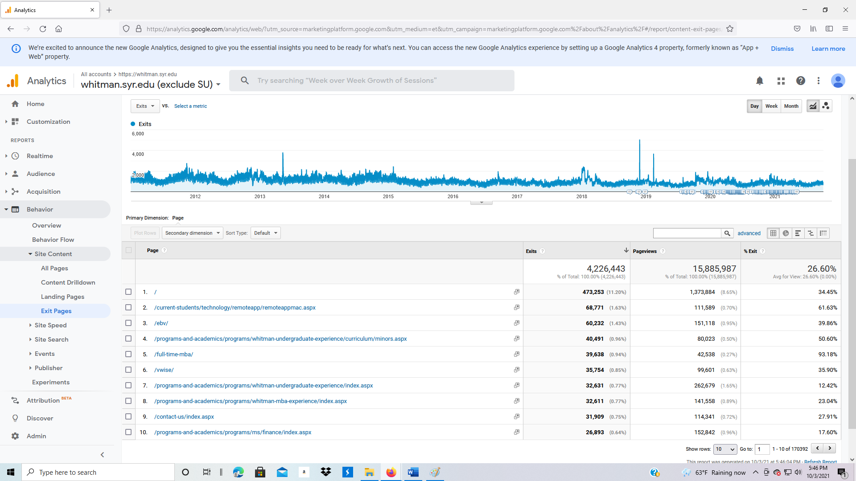

**Behavior: Site Speed**

1. Click on Behavior: Site Speed: Overview. What differences do you observe by Browser?

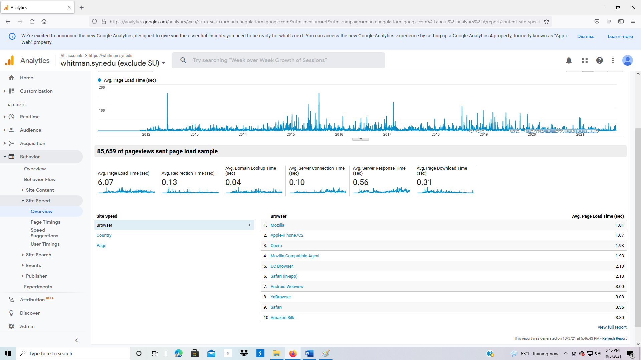

1. At the left/middle bottom of the screen, change Browser to Country. Which country has the fastest load time?

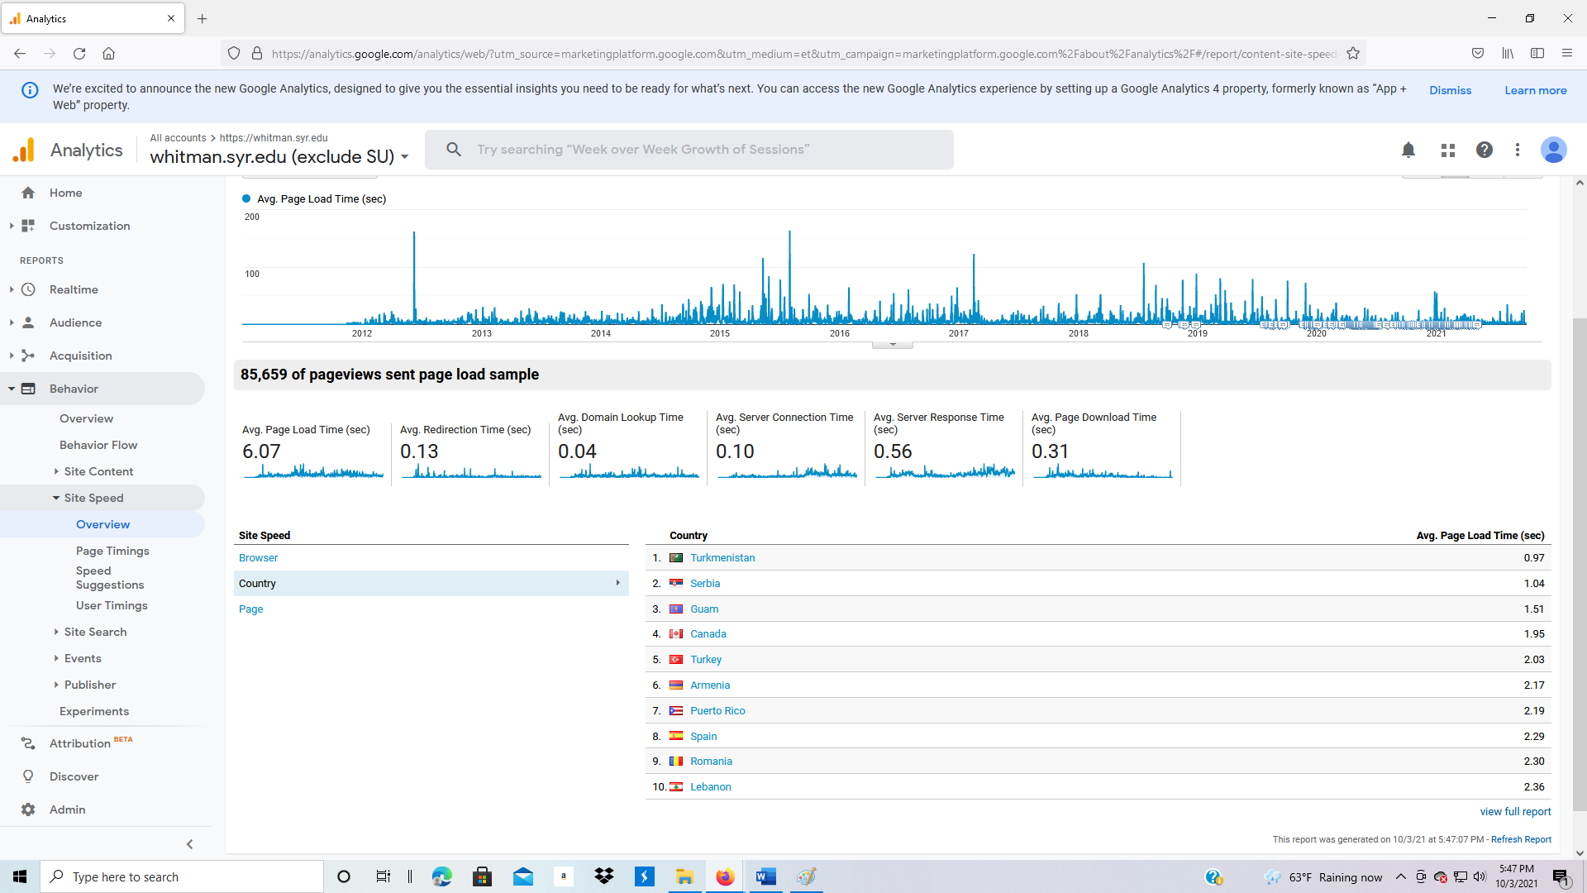

1. Change Country to Page. Which page has the fastest load time?

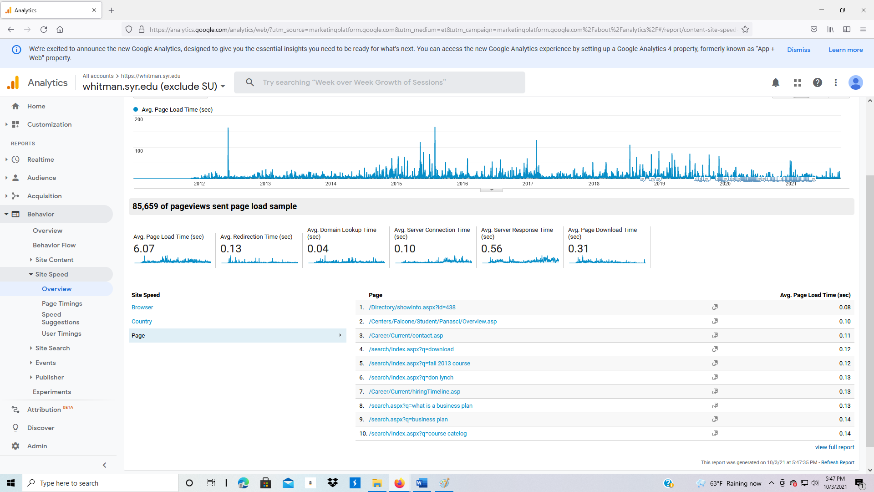

1. Click on Behavior: Site Speed: Page Timings. What do you notice about the main web page?

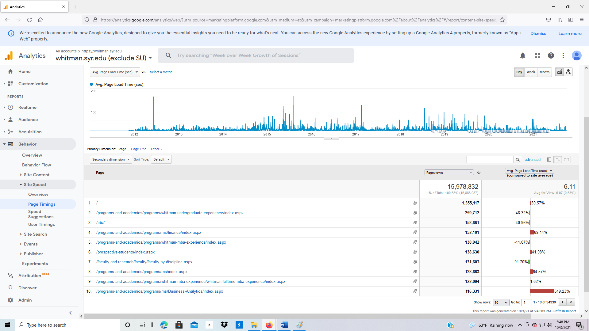

1. Click on Behavior: Site Speed: Speed Suggestions. Which pages are loading slowly?

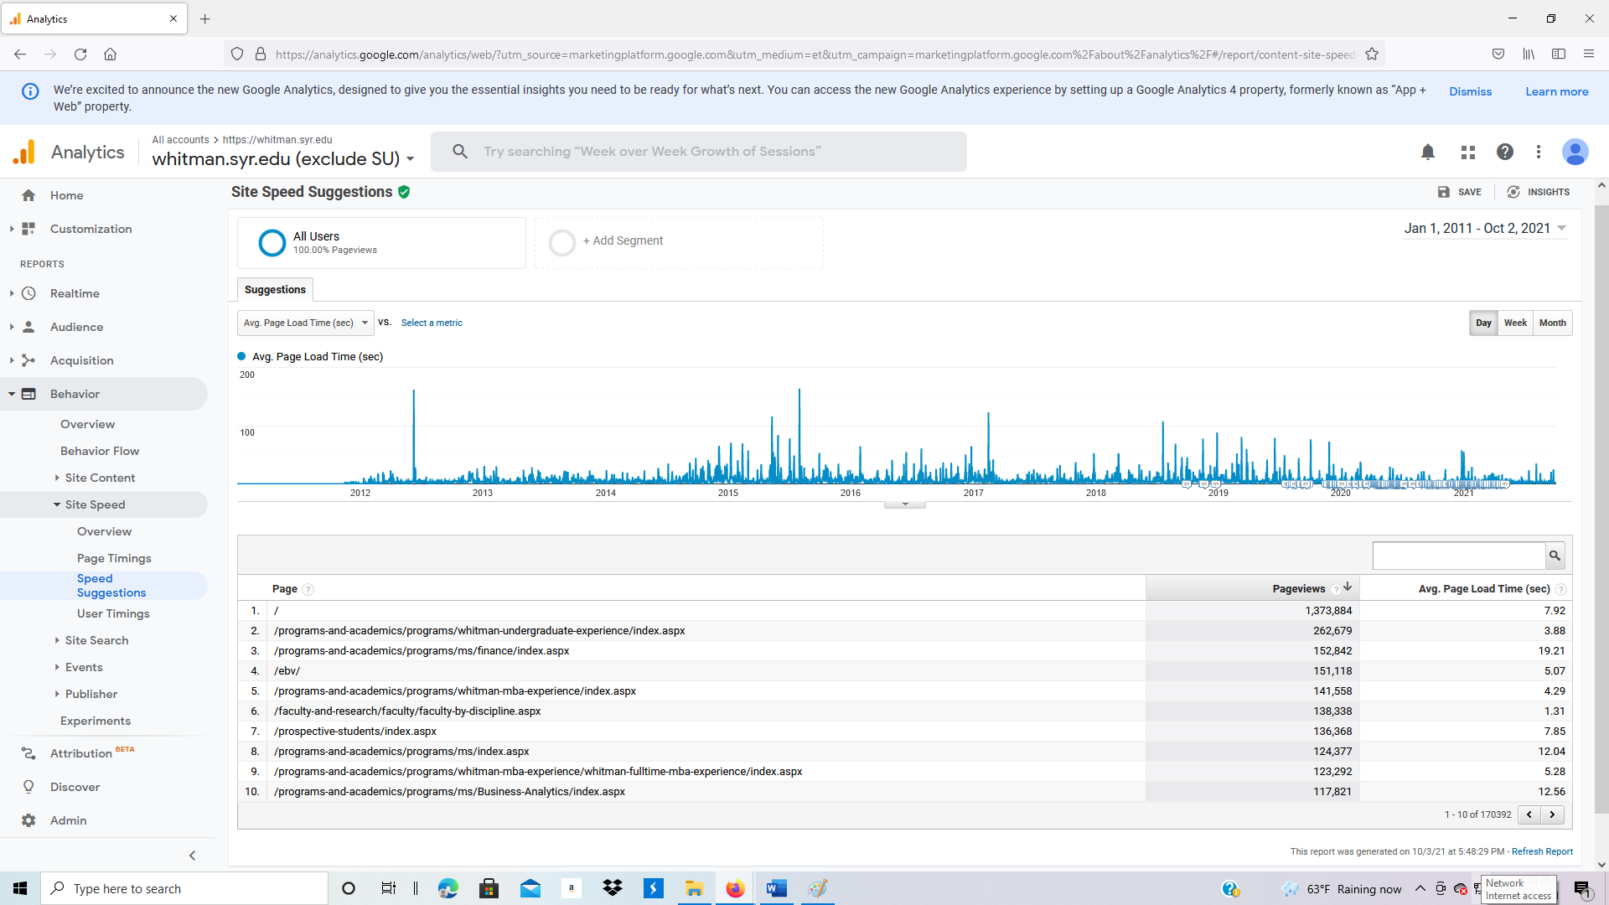

**Behavior: Site Search**

1. Site search measures how often users used the internal search button on your website.
2. Click on Site Search, Overview.

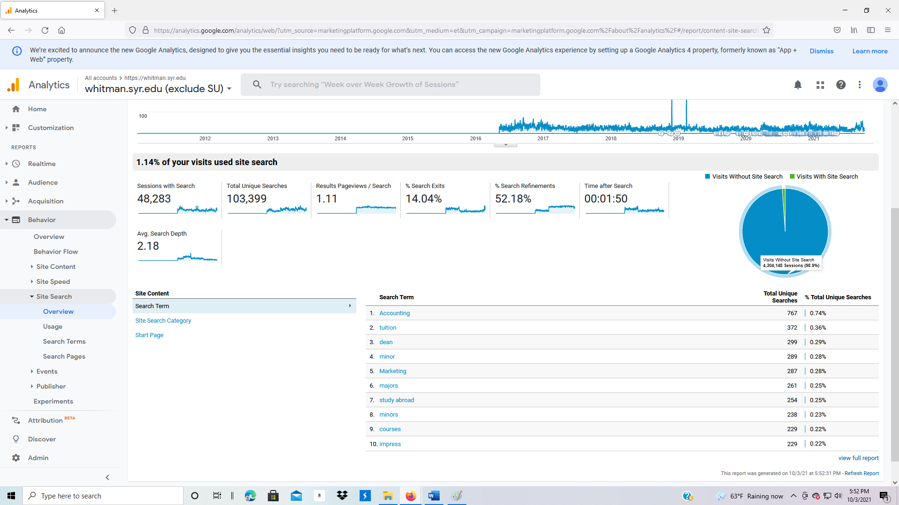

1. Click on Usage. This identifies the number of users who used the search button, versus those who did not.

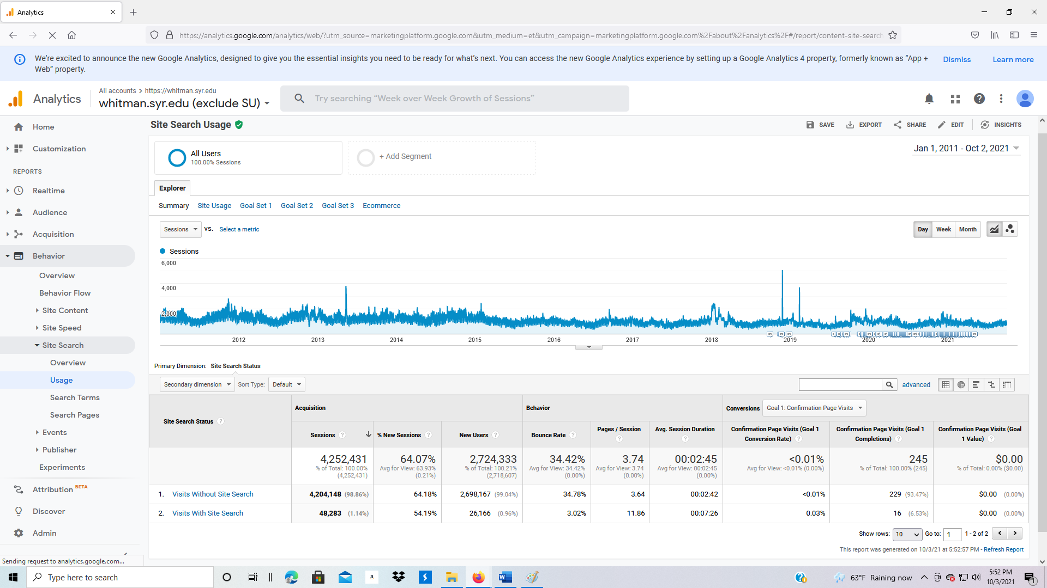

1. Click on Search Terms to identify what users are searching on after they arrive at your website.

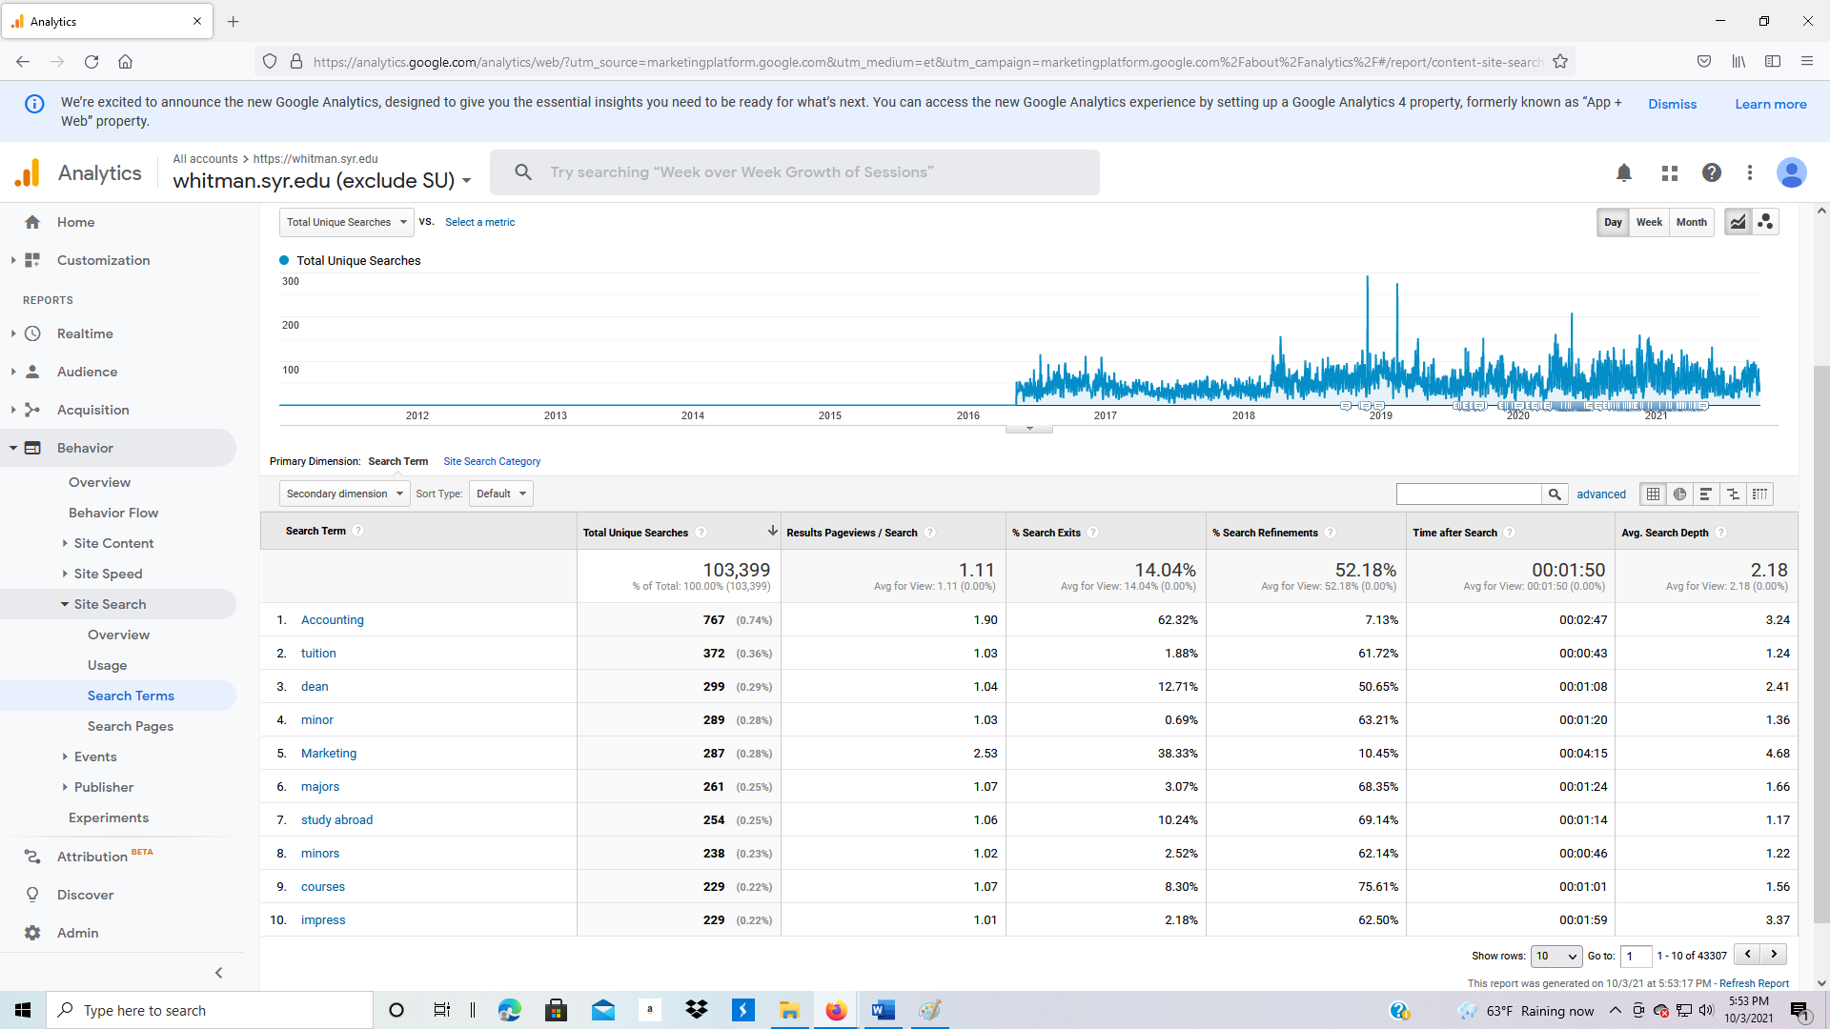

1. Click on Search Pages to identify what page they were on when they performed a search.

